Prevalence of Leptospira serovar Hardjo and epidemiological modeling of infections in smallholder dairy cattle in the Northern and Southern Highland of Tanzania
Shabani Kiyabo Motto^{1, 2*}, Gabriel Mkilema Shirima¹, Elizabeth Anne Jessie Cook^{3,4}, Barend Mark de Clare Bronsvoort^{5,6} and Enrique Hernandez Castro⁵
1. Department of Global Health and Bio-Medical Sciences, School of Life Science and Bio-engineering, The Nelson Mandela African Institution of Science and Technology, Arusha, Tanzania, 2. Tanzania Veterinary Laboratory Agency, Central Veterinary Laboratory, Dar es Salaam, Tanzania, 3. International Livestock Research Institute (ILRI), Nairobi, Kenya, 4. Centre for Tropical Livestock Genetics and Health, ILRI, Nairobi, Kenya 5. The Roslin Institute, University of Edinburgh, Easter Bush, UK and 6. Centre for Tropical Livestock Genetics and Health, The Roslin Institute, University of Edinburgh, Easter Bush, UK

Abstract
Problem Statement: Leptospirosis causes a serious fever and abortion in humans and the dairy industry respectively. Smallholder dairy farmers (SHDF) are among the group ranked at higher risk of contracting leptospirosis during milking, feeding, cleaning animal waste, disposing of aborted or placental materials. In recent years, the Northern and Southern Highland Zones of Tanzania become the foremost raising dairy cattle and milk-producing core areas. Despite many studies that have reported leptospirosis in various hosts yet the epidemiology of leptospirosis in dairy cattle especially in SHDF is not well studied. We conducted this study to explore the epidemiology of leptospirosis in smallholder dairy cattle.
Methods: We carried out a cross-sectional study among smallholder dairy cattle in Tanzania. Only 2045 dairy cattle were sampled for serological testing. We further interviewed farmers to get epidemiological information for predictive risk factors. The sera were tested for antibodies against Leptospira Hardjo serovars. Results: 13.1% of total animals showed seropositive and higher seropositive showed in Iringa 32.02% and Tanga 18.93% region. Considering multivariate analysis, animal age (OR = 1.292, 1.124 - 1.485, 95% CI), herds size (OR = 1.425, 1.215 - 1.671, 95%CI) were statistically significant to leptospirosis in cattle and the years of experience farmers in managing animals (OR = 1.194, 1.407 - 1.407, 95%CI). Keeping dairy cattle in Iringa and Tanga regions likely in a position of animal fond with leptospirosis at (OR = 4.267, 1.72 - 10.573, 95%CI) and (OR = 2.205, 0.968 - 5.022, 95%CI) respectively. Conclusion: The consequences of leptospirosis may be higher as the disease continues spreading and it is likely to cross to dairy farmers. As the test method used is limited to one serovar detection, it is important to typify the most common serovars circulating in cattle for appropriate vaccine of use to reduce risks.

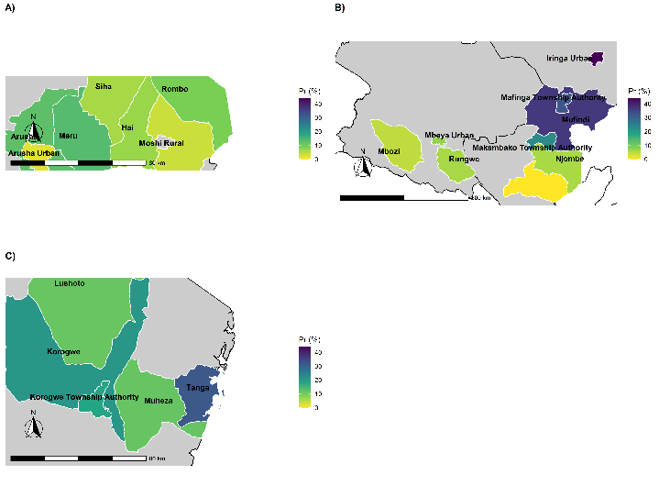
Figure 1: Map showing the spatial distribution of Leptospira serovar Hardjo seropositive from high raising dairy cattle regions. A) Districts of Arusha and Kilimanjaro regions, B) Districts of Mbeya, Iringa and Njombe region and C) districts of Tanga region
Reference
- Muller SK, Asenga LF, Matemba L, Misinzo G, Kazwala R. Seroprevalence of leptospira infection from agro pastoralist communities in Katavi ecosystem, Tanzania. Int J Infect Dis. 2014;21:180.
- Karimuribo ED, Swai ES, Kyakaisho PK. Investigation of a syndrome characterised by passage of red urine in smallholder dairy cattle in East Usambara Mountains, Tanzania. J S Afr Vet Assoc. 2008;79(2):89–94.
- Schoonman L, Swai ES. Risk factors associated with the seroprevalence of leptospirosis, amongst at-risk groups in and around Tanga city, Tanzania. Ann Trop Med Parasitol. 2009;103(8):711–8.
- Assenga JA, Matemba LE, Muller SK, Mhamphi GG, Kazwala RR. Predominant Leptospiral Serogroups Circulating among Humans, Livestock and Wildlife in Katavi-Rukwa Ecosystem, Tanzania. PLoS Negl Trop Dis. 2015;9(3):1–14.
- Njombe AP, Msanga Y, Mbwambo N, Makembe N. The Tanzania dairy industry : status opportunities and prospects. 7th African Dairy Conf Exhbition. 2011;(May):25–7.

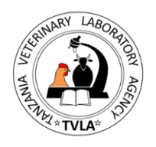

Biography
Shabani Kiyabo Motto is a master candidate at Nelson Mandela African Institution of Science and Technology (NM-AIST) and Livestock Research Officer (LRO) at Tanzania Veterinary Laboratory Agency (Central Veterinary Laboratory) Department of Microbiology (Molecular Section) in Dar es Salaam since 2016. His role is to promote animal health and welfare through animal disease diagnosis, surveillance of infectious and neglected tropical diseases, vector and food borne disease control to improve livestock production and enhance food safety and security for better human wellbeing. At the moment, Shabani is researching the epidemiology of leptospirosis infections in smallholder dairy cattle in highly raising farming system in the northern and southern highland of Tanzania.
Email: skymotto@gmail.com
Notes/Comments:

Presenting author details
Full name: Shabani Kiyabo Motto
Contact number: +255752393897
Twitter account: @skymotto
Linked In account: skymotto/ shabani-motto-3018a5107
Session name/ number:
Category: (Oral presentation/ Poster presentation)

