Tropical Coronary artery disease
Ramachandran Muthiah, Morning Star Hospital, Marthandam, Kanyakumari District, India.
Abstract The rising incidence of CAD is a new phenomenon in developing countries. The increasing burden of coronary artery disease (CAD) in tropical and subtropical belts of the Equator since it remains blurred and carries a grim prognosis. The worldwide burden is set to reach 47 million disability by the year 2020 as projected by World Health Organization . Several Western studies have demonstrated a significant role of various nutrients like fat, saturated fat and cholesterol in the causation of CAD. In contrast, the traditional Indian diet is low in fat content and, therefore cannot be the sole cause for the high prevalence of CAD in Indians. Plaque buildup in endocardium and coronary arteries, causing ischemic injury and arrhythmic episodes, is a vanishing mystery in its pathogenesis and emphasizing alternative routes for understanding and treatment of this enigmatic disease. Recently, an increase in the incidence of CAD was reported from southern states of India and other etiologies, the infectious or inflammatory conditions such as Endomyocardial fibrosis may provide an insight in its analysis. Recently, evidence of myocardial injury, as defined as an elevated troponin level, is common among patients hospitalized with COVID-19, caused by cardiac microvascular damage and systemic inflammatory response syndrome (cytokine storm) with increased risk of a poor prognosis..The important steps to prevent and decrease the risk of CAD is to reduce the chance of getting this disorder by epidemiological measures with an advice of blood thinning medications such as small daily dose aspirin, statins, nitrates and antibiotic in susceptible individuals.

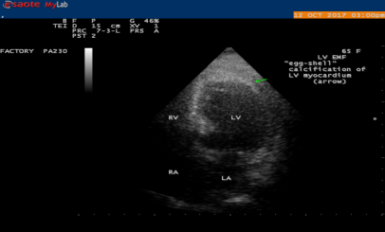

2D Echo showing the “egg-shell” calcification of Left ventricle (LV) (arrow), suggesting LV EMF (Endomyocardial fibrosis)

Publications
- Muthiah, R. (2021) Isolated Acute Rheumatic Pancreatitis—A Case Report. Case Reports in Clinical Medicine, 10, 52-77
- Muthiah, R. (2019) Infective Endocarditis in Tetralogy of Fallot Complicating Brain Abscess—A Case Report. Case Reports in Clinical Medicine, 8, 105-126
- Muthiah, R. (2018) Native Aortic Valve Endocarditis—A Case Report. Case Reports in Clinical Medicine, 7, 483-504.
- Muthiah, R. (2018) Tropical Coronary Artery Disease and Arrhythmogenic Potentials—The Changing Pattern towards Endomyocardial Fibrosis—An Analysis. Case Reports in Clinical Medicine, 7, 397-429
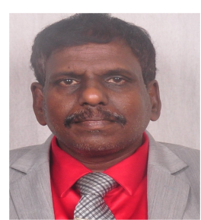
- Muthiah, R. (2018) Isolated Patent Ductus Arteriosus in an Elderly Female, Aged 65 Years—A Case Report. Case Reports in Clinical Medicine, 7, 352-379

Biography : Ramachandran Muthiah, Consultant Physician & Cardiologist, Zion hospital, Azhagiamandapam and Morning star hospital, Marthandam, Kanyakumari District, India. Completed M.D. in General Medicine in 1996, D.M. in cardiology in 2003 under Tamil Nadu Dr.MGR Medical University, Chennai, India. Worked as medical officer in Rural health services for 5 years and in teaching category as Assistant Professor at Madras medical college, Coimbatore medical college, Thoothukudi medical college and Professor at Dr.SMCSI Mission hospital & Medical college, Karakonam, Trovandrum and Azeezia Medical college, Kollam. Published many papers in Cardiosource, American College of Cardiology Foundation, Case Reports in Clinical Medicine (SCIRP) and Journal of Saudi Heart Association.
Name/Address: Ramachandran Muthiah
Palaninta vilai, keezhkulam-629193, kanyakumari district, Tamil nadu state, India
(landline-+914651 203014,
mobile +91 7598755201)
Category: Oral
Passport No:P8925619

