Global Transport Networks and Infectious Disease Spread: A Theoretical Application of Discrete Choice Model for Decision Making for Trafficking for Commercial Sexual Exploitation
Jacob Oluwoye, PhD
Alabama A&M University, USA

Abstract (300 word limit)
Transportation deals with the movement of people and goods, using various means of locomotion (walking, bicycles, buses, trams, trains, ferries, taxis, motor cars, trucks, ships, aircraft, pipelines) on transport networks (roads, rails, waterways, airways) which have terminals (parking areas, depots, stations, ports and airports) and transfer points (bus stops, stations, goods yards). Disease-causing organisms can now move faster, further and in greater numbers than it before. In recent years, human trafficking has been identified as a form of modern slavery, as a threat to human security, and as one of the greatest human rights challenges of our time. Human trafficking may be a humanitarian drawback of a worldwide scale, however quantitative analysis on the problem barely exists and investigating and controlling infectious diseases is a complex enterprise that has long been assisted by mathematical modeling. Furthermore, the prevalence of human trafficking is difficult to measure; however, the number of international organizations has estimated that traffickers exploit a majority of human trafficking victims without moving them from one country to another. From the on top of discussions, one will see that human trafficking involves the acting Associate in Nursing tried an act of enlisting and transportation of persons (both male and female) inside or across borders. HIV/AIDS programs area unit advanced as a result of the illness is advanced. It affects all aspects of human society from the cultural sphere to the spiritual, political, and economic spheres. The infected and affected area unit several in variety, numerous in nature, and widespread throughout the planet. People confront risks in everyday life. All forms of social life have elements of risk. This paper is the first attempt to describe the theoretical applied discrete-choice modeling of prevalence and predictors of HIV risk behaviors among trafficking victims for Commercial Sexual Exploitation (CSE). The paper concludes that the theoretical application may help policymakers to better target anti-trafficking efforts.

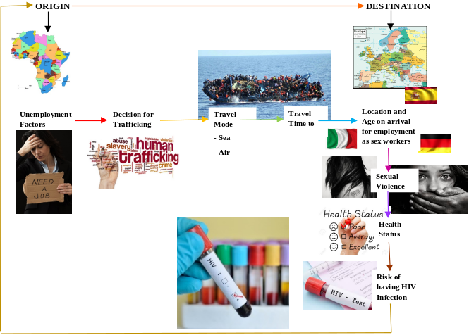
Image

Publications
- Oluwoye, J. 2006 Application of statistical methodology and model deign to socio behavior of HIV transmission. Chapter 2, Biomathematics- Modeling Simulation, pp 37-58.
- Oluwoye, J 2001 Spatial Interaction and Socio-Behavior of HIV Transmission. Part V, Applicable Mathematics-Its Perspectives and Challenges, , pp. 399-407.
- Oluwoye, J 2007 Land Transport and HIV Vulnerability: A Conceptual Framework of Vulnerability of Road Users, Road and Environment. Research Journal of Medical Sciences, vol 1: 1.pp 9-12.
- Oluwoye, J. and Akinmoladun, O. 2007 A Mathematical Concept of Assessing the Social Class Basis of Transmission of HIV Segregation. Research Journal of Medical Sciences, vol 1: 3.pp 165-167.
- Oluwoye, J. and Gooding, E (2008). “HIV Substance Abuse and Demographic Characteristics of Minority Women who Reside in Pubic Housing: A Preliminary Case Study of City of Huntsville, Alabama”. Paper presented at National Association of African American Studies, Feb 11-16, Baton Rouge, Louisiana.

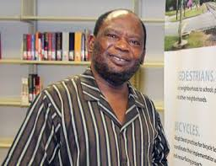
Biography (150 word limit)
Jacob Oluwoye has been an active researcher in transportation, public health and the built environment field since the late 1990’s and currently researching on a topic entitled Transport Networks and Infectious Disease Spread. He has his technical expertise and leadership experience on multidisciplinary study of HIV/AIDS and Aging with the goal of carry out comparative study of Life satisfaction among younger and older HIV-infected populations. Jacob have been collaborating on national and international public health, transportation, econometrics and environmental issues. He possess a depth of experience in the area of focus/control groups, econometrics and the use of geographic information system for the built environment. With extensive experience in the built environment and urban/community model building, including road/road environment pollution exposure modeling and mapping /modeling greenhouse gas emissions from transport effects,
Email: joluwoye@aamu.edu

