Sulfotopes from Trypanosoma cruzi glycoproteins, acting as major or minor antigens, are involved in parasite infection, and immunopathogenesis of experimental Chagas disease
¹Luciana L. Soprano, ²Alicia S. Couto and ¹Vilma G Duschak. ¹Research Department, National Institute of Parasitol, Dr M Fatala Chaben, (INP), ANLIS-Malbràn, Health Secretary , ²CHIHIDECAR, UBA, Buenos Aires, Argentina

Abstract
Statement of the Problem.Chagas disease (ChD) constitutes a major endemic health problem in Latin America. The presence of sulfate-bearing-glycoproteins has been identified in Trypanosoma cruzi, they are targets of specific immune responses and subjects chronically infected with T. cruzi mount specific humoral immune responses to sulfated glycoproteins. Cruzipain (Cz), a major antigen. containing a C-terminal domain (C-T), is responsible for the immunogenicity of the molecule in natural and experimental infection Synthetic anionic sugar conjugates containing N-acetyl D glucosamine-6-sulfate (NAcGlc6-SO3) mimics the N-glycan-linked sulfated epitope (sulfotope) displayed in the C-T. IgG2 antibody levels specific for sulfotopes are inversely correlated with Chagas disease severity. Another sulfated glycoprotein with serinecarboxypeptidase (SCP) activity was studied. Methodology & Theoretical Orientation: Native SCP co-purifies with Cz from Concanavalin-A affinity columns. The Cz-SCP mixture was desulfated, ascribing the cross-reactivity between both molecules to the presence of sulfated groups. SCP-N-glycosydic chains were analyzed by UV-MALDI-TOF-MS. Immunobloting of lysates from the different parasite stages were confronted with SO3-specific antibodies; in vivo effects of sodium chlorate on Cz-sulfation and tissue damage in C-T-immunized-mice muscle-tissues were evaluated. Findings: I) The presence of short-sulfated high-mannose-type oligosaccharidic chains was confirmed in SCP II) sulfotopes participate in trypomastigotes infection of cardiac cells; iii) sulfotopes generate muscle tissue damage in BALB/c mice, in absence of infection. iv) sulfotopes from Cz and other sulfated glycoproteins participate in parasite infection and immunopathogenesis. v) Sulfotopes and their specific antibodies are responsible for the ultrastructural abnormalities observed in the outcome of the experimental ChD disease vi) a band with apparent molecular weight similar to SCP was highly recognized in trypomastigotes: vi) SCP is a minor antigen recognized by most of chronic-Chagas-disease-patient´s sera. Conclusion & Significance. The shared sulfotopes between Cz and SCP, and the enhanced presence of sulfotopes in trypomastigotes, are involved in parasite-host relationship, in immunopathogenic and infection processes

Image
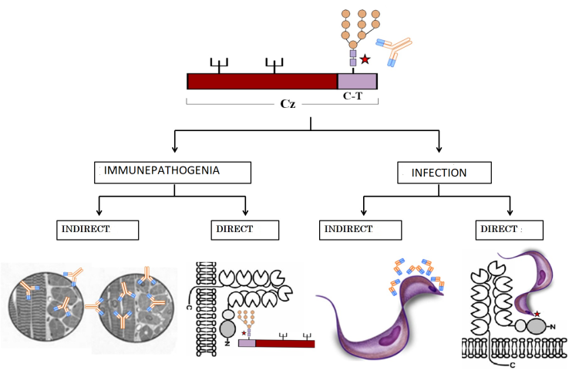
Recent Publications

1 Acosta et al(2008) Sulfates are main targets of immune responses to cruzipain and are involved in heart tissue damage in BALB/c immunized mice. International Immunology 20: 461- 470.
2 Couto et al., (2012) An anionic synthetic sugar containing 6-SO₃-NAcGlc mimics the sulfated cruzipain epitope that plays a central role in immune recognition. FEBS J. 279(19):3665-79.
3 Ferrero et al., (2014). Effects of sodium chlorate in the sulfation process of Trypanosoma cruzi glycoconjugates. Implication of sulfated motifs in cellular invasion. Acta Tropica 137 161-173.
4 Soprano et al., (2018) Trypanosoma cruzi serinecarboxipeptidase is a sulfated glycoprotein, and a minor antigen in human Chagas disease infection. Med Microbiol Immunol. 207(2):117-128
5 Soprano et al., (2018).Input of NAcGlc6SO₃ epitopes (sulfotopes) present in Trypanosoma cruzi glycoproteins, andtheir specific antibodies, in the infection and immune pathogenesis of experimental Chagas disease. International Journal of Infectious Diseases, Vol. 73, p113–114

Biography
Vilma G Duschak, Dr in Biochemistry (1989), UBA. CONICET Researcher, Argentina since 1994. Post-grade in Medicine Chile University (1990); Cooperation: Instituto-Cs-Biomédicas- San Pablo-University-Brasil (2005), Universite-Jules Verne-Amiens- France (2007), Bernhard Notch Inst. of Tropical Medicine, Hamburg, Germany (2010-2011). Editorial Advisory Board Member, Bentham Science Publishers. USA. Awards and distinctions: 6. Publications: more than 40, Assistance to more than 100 National and international Congresses. Directed Thesis: 5. Roche Diagnostics International Meeting expert, New York, USA (2016). Evaluator of research projects from ANPCyT, CONICET and UBA (Argentina), OTKA (Hungary) and European Union international projects, Brussels (2018).
Email: vduschak@conicet.gov.ar

