Perspectives On Ethical Nursing Practice In Disaster During The Hajj 2015

Asrar Alrajhi, RN, M.Nurs¹
Abdulellah Al Thobaity, RN, PhD¹
Virginia Plummer, RN, PhD¹
¹School of Nursing and Midwifery, Monash University, Victoria, Australia.

Image: Three major themes emerged from the analysis. Some participants recount as follows:

Abstract
Nursing care that observes ethical practice would be critical during a disaster. Disaster nurse is a branch of nursing practice that specialises in dealing with all kinds of catastrophes. Disaster nurses need to be prepared in dealing with ethical issues that arise during disasters. This research aimed to explore the ethical perspectives among emergency nurses who responded to disasters events in Saudi Arabia. Qualitative, descriptive, exploratory method was developed using semi-structured, face to face interviews as a data collection. Five open-ended questions were used in the interview to discuss the nurses’ competency and commitment in terms of the ethical challenges associated with providing care to victims during disasters. The interviews were held in two hospitals located in Mecca city with eight nurses from June to July 2016 who have been involved in the collapse of the crane and stampede disasters that occurred in Mecca city, 2015. All the collected data were transcribed and translated appropriately. The responses of the participants were then analysed thematically to understand their level of ethical preparedness for disasters. Themes and subthemes were used in order to explore the nurses’ levels of competency and commitment in the face of ethical challenges during a disaster. The three themes are nurses’ ability and experiences, disaster intensity and the realities of practice. The nurses’ levels of ethical competency and commitment in this study may serve as a guide to design disaster courses based ethical preparation as well as providing a basis for further research.
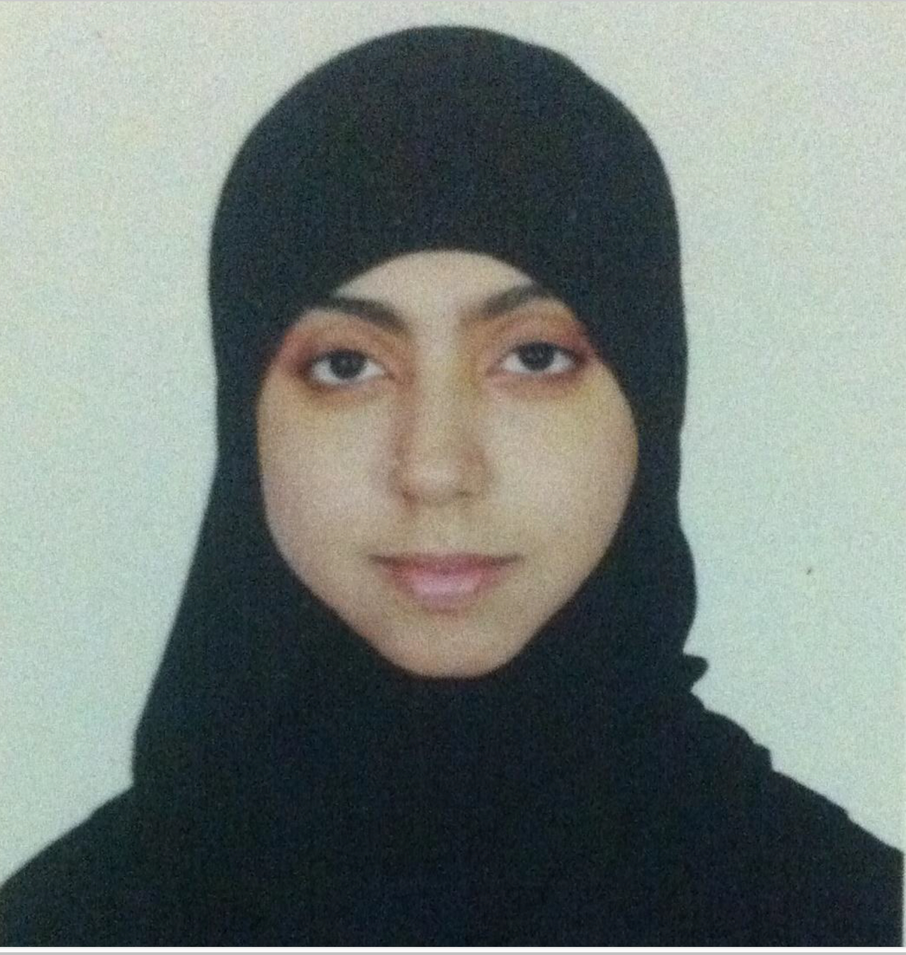
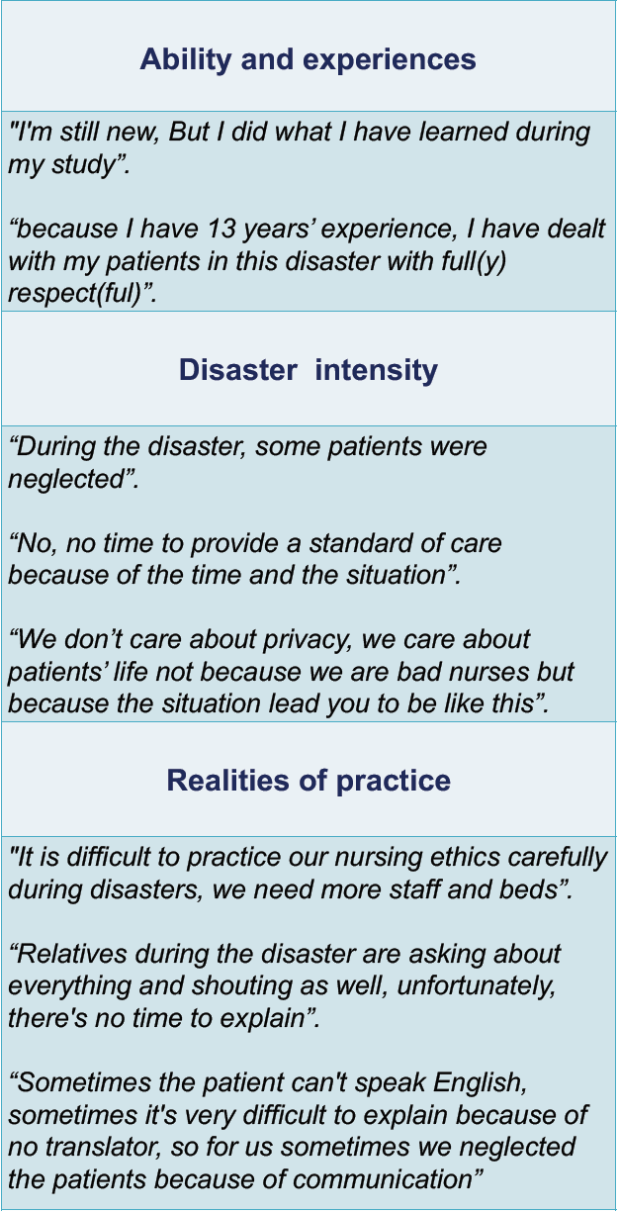
Asrar Alrajhi has her expertise in Nursing field, she worked as a nurse for around 10 years in the critical care area. During her bachelor study in Sweden, she focused on the handover/handoff among critical care nurses then she graduated from the Master degree focusing on Disasters and emergency nursing management from Australia. Due to this, she studied the perspectives On Ethical Nursing Practice In Disaster During The Hajj 2015 in Saudi Arabia.

Email: asrar_alraghi@hotmail.com

