Understand the complexities and development in order to improve emergency medical status

Ramak Attarinezhad, MS student of nursing, IRAN

Statement of the Problem:
The properness of function of different parts of Emergency Medical Services will
be resulted in a quick and timely dispatch of ambulances to patients and preventing deaths as well as lack of disability in damage. The success of this set depends on various factors such as the ability of those responsible, trained personnel, equipment, coordination and communications systems. Today, in the city's health care system, generally the first treatment for critical patients is carried by pre-hospital emergency and the more accurate and faster care for patients by EMS, the less deaths and disabilities caused by diseases and public confidence in the system increases..
Since the trauma and damages resulting from accidents are the most common cause of death among people ages fourth decade as well as known as the third leading cause of death in all ages, emergency medical services on trauma has given special emphasis. Given the major role of emergency medical services in ensuring the health of people during accidents and the need for improved basic services prompted us to study the complexities and factors involved in improving the look of a medical emergency. Methodology & Theoretical Orientation: The study was a systematic review. At first, we needed to gather studies related to our upcoming study. Therefore, a set of keywords related to research, such as medical services, hospital emergency rooms, trauma was obtained.
Finally the collected essays in the period from 1990 to 2015 were studied and compared, and ultimately the final results in classified parts were shown as following. Conclusion & Significance: Since the emergency medical centers and emergency medical centers of hospitals considering their sensitive role in providing immediate medical care to patients, needed to therapeutic interventions at all times the day and all days of the year are one of the necessary and inevitable pillars of public hospitals.. However, according to the results of recent decades, it has recognized that in the most countries pre-hospital care as the first group encountered with critically ill patients transferred to hospital, equal to international standards . One of the most important as a catalyst for overcoming the problems caused by personnel skills and need for retraining employees has been mentioned that this in addition to affects the ability of new personnel, is also an important factor for employees with experience that can increase both their motivation and performance. However, these educations (trainings) should be oriented and based on personnel requirements and in addition to their functional skills, consider interactive manner with patients.
Image
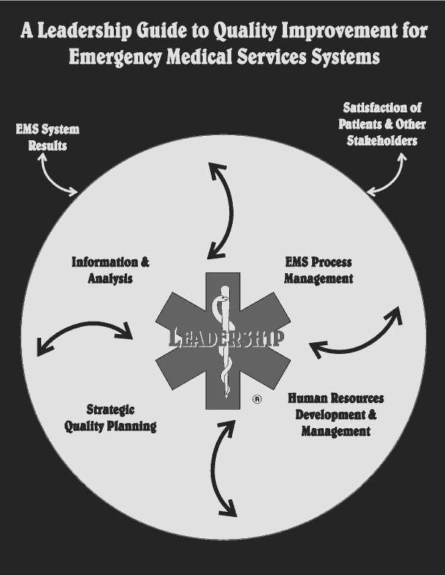
Recent Publications (minimum 5)
- Van Rooyen, M.J., Development of pre hospital emergency medical services: strategies for system assessment and planning. Pacific health dialog, 2002. 9(1): p. 86-92.
- Morganti, K.G., et al., The evolving role of emergency departments in the United States. 2013: Rand Corporation.
- Schuur, J.D., et al., Quality measurement in the emergency department: past and future. Health Affairs, 2013. 32(12): p. 2129-2138.
- Buckley, B.J., et al., Impact of an express admit unit on emergency department length of stay. The Journal of emergency medicine, 2010. 39(5): p. 669-673.
5. Pitts, S.R., et al., Where Americans get acute care: increasingly, it’s not at their doctor’s office. Health affairs, 2010. 29(9): p. 1620-1629.

 Biography
Ramak Attarinezhad is a nurse, Who is studying for her master of science in nursing. She is interested in search and evaluation her knowledge in different related emphasis in nursing education. With review of many responsive constructivists articles creates new pathways for improving healthcare quality as well as evoluation in emergency medicine practices that result proper approaches That she presents.

Email: ramakattarinejad@gmail.com

Notes/Comments

