Mass Casualty in Holy City of Karbala, IRAQ
A hospital experience

Emad Geddoa FICS, MD, DLS
Consultant General Surgeon, Imam Hussain Medical City, Kerbala, Iraq
Ameer Gelewkhan MD. MB.Ch.B
Safeer AL-Hussain Hospital Manager/ Kerbala/Iraq
Ihsan ALshoek FRCS
Consultant General Surgeon, Wexham Park Hospital, Slough, Berkshire, UK

Abstract:

Statement of the Problem:
Kerbala is regarded as one of the Holiest cities for the Muslim nations due to the fact that the grandson of prophet Muhammed, Imam Hussain is buried there. The total area of Kerbala is about 5034 square km. It is almost in the centre of Iraq, with a total population of 1.267 million. The estimated number of annual visitors/pilgrims to Kerbala is between 58 to 62 million, and the number is rising. Arbaeen event is the greatest human gathering where 20 to 24 million pilgrims attend Kerbala over a confined peak period of 10 to 12 days, to commemorate the martyrdom of Imam Hussain which took place 1337 years ago. Offering standard casual healthcare services face a huge challenge to all those involved over a short period of time.

Methodology & Theoretical Orientation: On an ordinary day Safeer Al-Hussain Hospital is staffed with 238 employees. During the Arbaeen period
this number is supported by other partners: Imamia Medics International (IMI) (95), Karbala University (medicine & nursing) (75), Iraqi delegates from other hospitals (146), international volunteers (253).

The number of patients seen in 2015 during the Arbaeen period (10-12 days) at Safeer AL-Hussain were 919,682 patients.

Finding: The total number of hospital staff at Safeer ALHussain during Arbaeen Gathering at Kerbala were 806 serving 919682 patients in 12 days period of time. These patients are divided as follows: Iraqi patients 477886, Arabic patients 245732, and other 532762.
Number of emergency operations done at the hospital (12 days)
Super major 45, Major 13, Minor 9.

Conclusion:
- Offering standard health care faces huge challenge to all the healthcare professionals involved.
- Proper planning is required to perform even better.

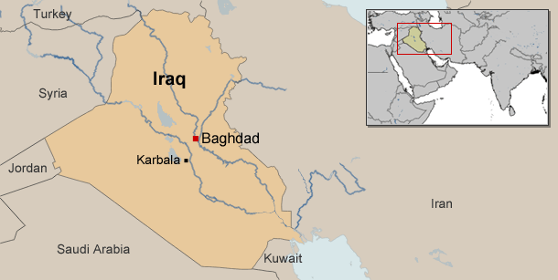

Figure1: Kerbala city/ Iraq

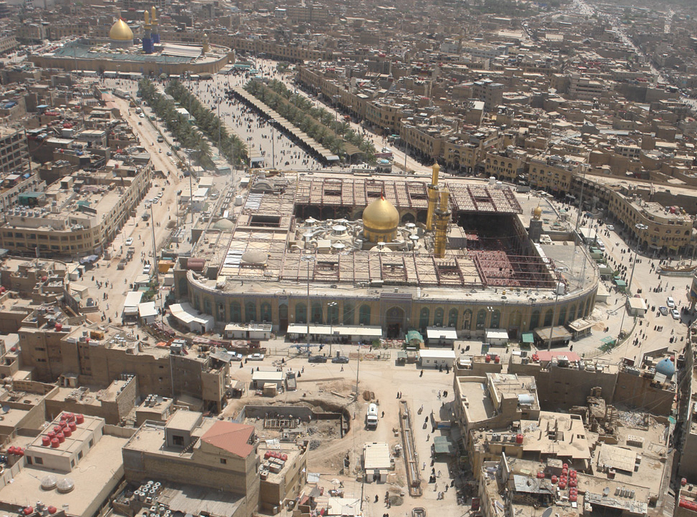
Figure 2: Kerbala city centre on normal days
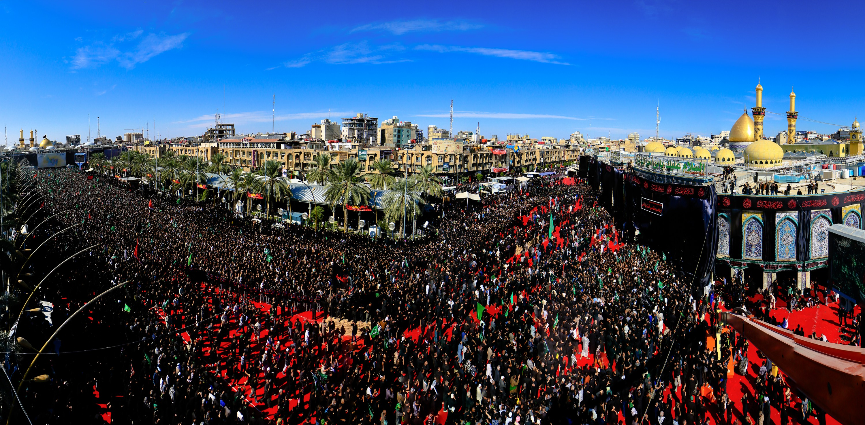
Figure3: Arbaeen Gathering at Kerbala December 2015

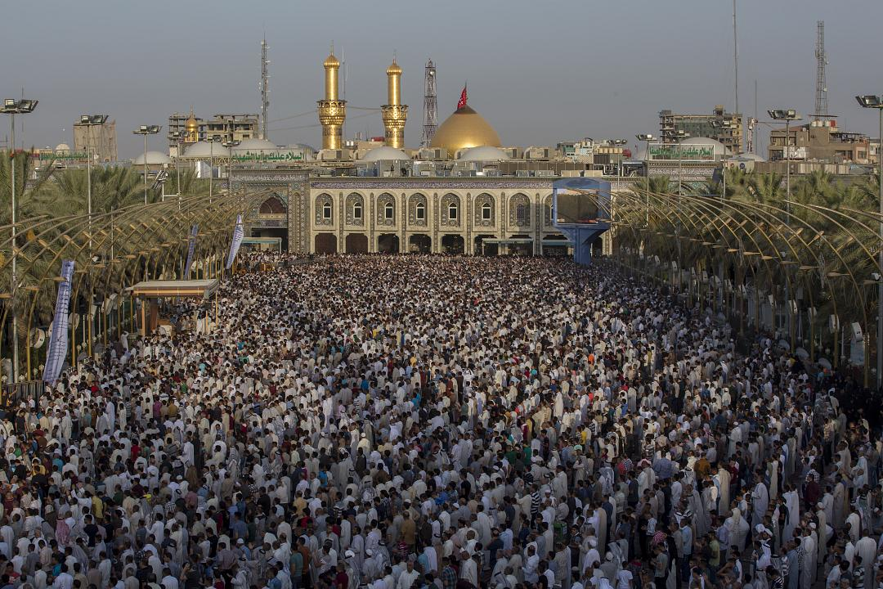
Figure3: Arbaeen Gathering at Kerbala December 2015

Emad Geddoa is a consultant General Surgeon graduated from Iraq in 1993 and settled in London where he trained for general surgery. Mr Geddoa has decided to go back and work in Kerbala, the city where he born, in 2013 and since then he is a senior lecturer at Kerbala Medical School in addition to his work at Imam Hussain Medical City/ kerbala as a general and colorectal Surgeon.

The most recent Publications:

1.Global patient outcomes after elective surgery: Prospective cohort study in 27 low-, middle- and high-income countries. Published by the British Journal Anaesthesia (2016) 117 (5): 601-609.

2. Antibiotics Use in patients underwent appendecectomy at North Middlesex Hospital/ London: A retrospective analysis. Departments of Endoscopy/ General Surgery, North Middlesex University Hospital. Accepted by the Kerbala Journal of medicine / kerbala/Iraq.

3. Impact study of the Surgical Apgar Score to benefit postoperative outcome: a pilot multicentre randomized controlled trial. London Surgical Research Group. Published by the Ann R Coll Surg Engl. 2014 Jul;96(5):352–358.
4. The use of botulinum toxin-A in the management of neck and anterior chest wall flushing: pilot study. Emad Geddoa1, Hosam E Matar2,Trevor Rudrah Franco Paes.Department of Vascular and General Surgery, The Hillingdon Hospitals NHS Foundation Trust, Mount Vernon Hospital,Northwood. Published by the International Journal of Dermatology Dec 2013 (pages 1547–1550).

5. Spelenic Laceration after Endoscopic Retrograde Cholangio- Pancreatography. E Geddoa, N Qureshi, N Foden, D Stoker Departments of Endoscopy/General Surgery, North Middlesex University Hospital,Sterling Way,Edmonton N18 1QX. Published by laparoscopic endoscopic journal.V27(2); 2014.

EMAIL: abujaafer14@yahoo.co.uk

