Mass Casualty in holy City of Karbala, IRAQ
A hospital experience

Emad Geddoa FICS, MD, DLS
Consultant General Surgeon/ Imam Hussain Medical City Kerbala/Iraq
Ameer Gelewkhan MD. MB.Ch.B
Safeer AL-Hussain Hospital Manager/ Kerbala/Iraq

Abstract:

Statement of the Problem: Karbala is a place where Imam Hussain (the grandson of prophet Muhammed) has been buried. Therefore, it counts the holiest city for Shia Muslims all over the world. The total area of Kerbala is about 5034 square km. It is almost in the centre of Iraq, with a total population of 1.267 million. Estimated number of visitors per year to Kerbala is between 58 to 62 million, and the number is increasing. Arbaeen Gathering is the top visiting period where about 20 to 24 million of visitors are attending to kerbala within a holy period of time (10-12 days) each year. This is believed to be the commemoration of Imam Hussain martyrdom about 1377 year ago. Offering standard health care faces huge challenge to all and everyone in that short period of time.

Methodology & Theoretical Orientation: Safeer Al-Hussain Hospital
Is staffed with 238 employee. During the Arbaeen period (10-12 days) the number of patients seen in 2015 was 919,682 PATIENTS.
The hospital staff (238) were supported by other partners: Imamia Medics International (IMI) (95), Karbala University (medicine & nursing) (75),
Iraqi delegates from other hospitals (146), international volunteers (253).

Finding: The total number of hospital staff during Arbaeen Gathering at Kerbala were 806 serving 919682 patients in 12 days period of time. This divided as follows: Iraqi patients 477886, Arabic patients 245732, and other countries patients 532762.
Number of emergency operations done at the hospital (12 days)
Super major 45, Major 13, Minor 9.

Conclusion:
- Offering standard health care faces huge challenge to all and everyone.
- Proper planning is required to perform even better.

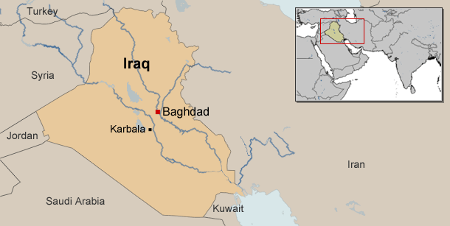

Figure1: Kerbala city/ Iraq
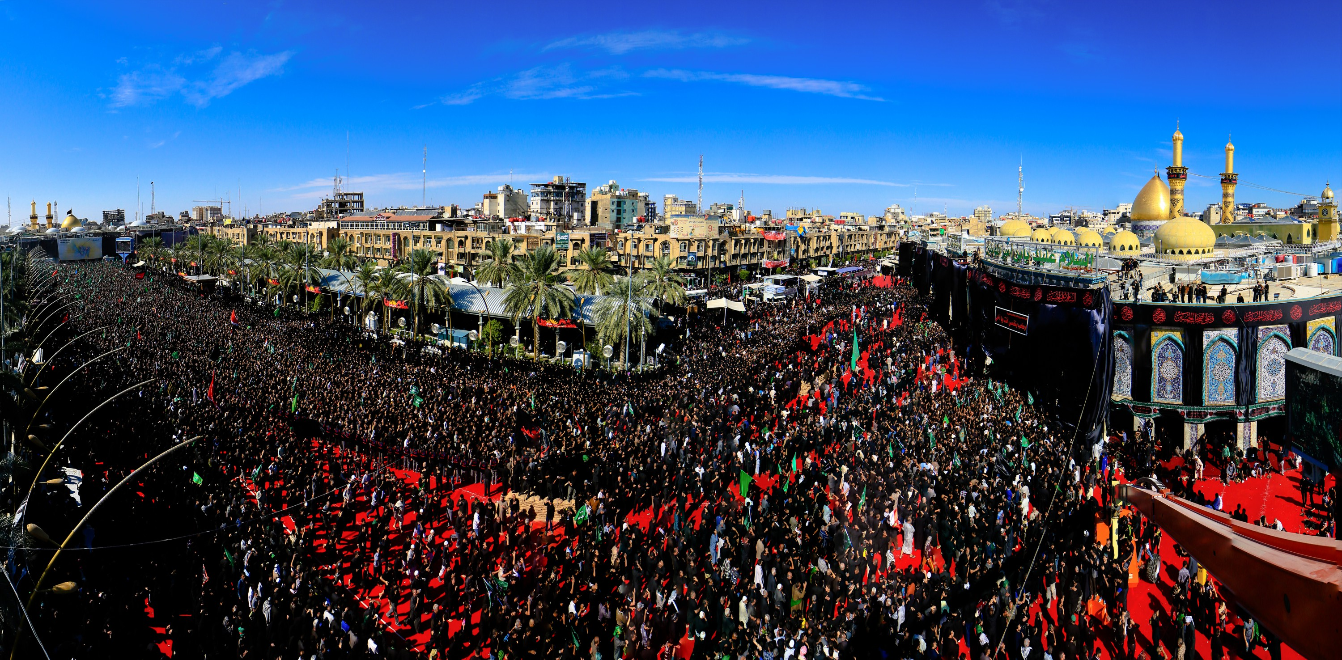
Figure2: Arbaeen Gathering at Kerbala December 2015

Emad Geddoa is a consultant General Surgeon graduated from Iraq in 1993 and settled in London where he trained for general surgery. Mr Geddoa has decided to go back and work in Kerbala, the city where he born, in 2013 and since then he is teaching surgery as a senior lecturer at Kerbala Medical School as well as his work at Imam Hussain Medical City/ kerbala as a general and colorectal Surgeon.

The most recent Publications:

1.Global patient outcomes after elective surgery: Prospective cohort study in 27 low-, middle- and high-income countries. DOI: 10.1093/British Journal of anesthesia (BJA) /aew316 (November 2016).

2. Antibiotics Use in patients underwent appendecectomy at North Middlesex Hospital/ London: A retrospective analysis. Departments of
Endoscopy/ General Surgery, North Middlesex University Hospital.
Published by the Kerbala Journal of medicine volume 4 2015.

3. Impact study of the Surgical Apgar Score to benefit postoperative outcome: a pilot multicentre randomized controlled trial. London SurgicalResearch Group. Published by ANNALS OF THE ROYAL COLLEGE OF SURGEONS OF ENGLAND · JULY 2014.
4. The use of botulinum toxin-A in the management of neck and anterior chest wall flushing: pilot study. Emad Geddoa1, Hosam E Matar2,Trevor Rudrah Franco Paes.Department of Vascular and General Surgery, The Hillingdon Hospitals NHS Foundation Trust, Mount Vernon Hospital,Northwood. Published by the International Journal of Dermatology Dec 2013 (pages 1547–1550).

5. Spelenic Laceration after Endoscopic Retrograde Cholangio- Pancreatography. E Geddoa, N Qureshi, N Foden, D Stoker Departments of Endoscopy/General Surgery, North Middlesex University Hospital,Sterling Way,Edmonton N18 1QX. Published by laparoscopic endoscopic journal.V27(2); 2014.

EMAIL: abujaafer14@yahoo.co.uk

