Postoperative analgesic efficacy of ear acupuncture in patients undergoing abdominal hysterectomy: a randomized controlled trial
Mohamed E Abuelnaga , MD, Egypt

Abstract:
Background: Numerous studies have revealed that acupuncture can increase the somatic pain threshold. Electro-acupuncture (EA) can help pain-relieving with minimal physiologic disturbance. Various painful disorders, as well as pain following various surgeries, like cesarean section, gastrostomy, and enterectomy were managed properly with acupuncture. Acupuncture can help in postoperative pain reduction by altering the brain's chemistry, increasing endorphins and neuropeptide Y levels, and reducing serotonin levels. Therefore we studied the postoperative analgesic effect of EA in patients undergoing abdominal hysterectomy. Methods: A randomized, prospective clinical trial study was carried out on 56 women undergoing hysterectomy under spinal anesthesia. Patients were allocated randomly to receive either spinal anesthesia and electric ear acupuncture (EEA group) or spinal anesthesia alone (control group). EEA was done by fine needles to anatomically defined 4 points of the ear: Shen Men Point, thalamus Point 26, Analgesia Point 3, and Uterus Point 58, and connected to EA therapeutic apparatus. After finishing surgery, the fine needles were substituted by permanent press needles to be removed after 24 hours. The primary outcome was the postoperative 24 hours morphine consumption by patient-controlled analgesia, while secondary outcomes included Postoperative pain scores and postoperative 1st request of analgesia. Findings: Total morphine consumption in the first 24 postoperative hours was obviously reduced in the EEA group versus the control group (mean±SD:6.214± 2.1319mg vs 15.714± 3.3428mg, d= -3.3886, 95% Confidence interval=-4.2061,-2.5712, p-value =0.000). The postoperative pain scores were significantly reduced in the EEA group in comparison to the control group, with a delayed 1st request of postoperative analgesia. Conclusions: Auricular acupuncture is a useful analgesic adjuvant as it reduced postoperative analgesic requirements following abdominal hysterectomy. It provided more patient satisfaction regarding postoperative pain control without any hazard.

Image
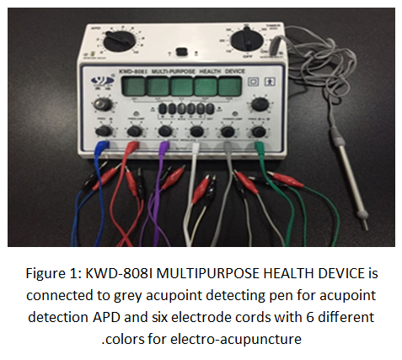
Recent Publications:
- Lin JG, Lo MW, Wen YR, Hsieh CL, Tsai SK, Sun WZ. The effect of high and low frequency electroacupuncture in pain after lower abdominal surgery. Pain 2002; 99: 509-14
- Kim KS, Nam YM. The analgesic effects of capsicum plaster at the Zusanli point after abdominal hysterectomy. Anesth Analg 2006; 103: 709-13
- Tsang HC, Lam CS, Chu PW, Yap J, Fung TY, Cheing GL. A randomized controlled trial of auricular transcutaneous electrical nerve stimulation for managing posthysterectomy pain. Evid Based Complement Alternat Med 2011; 1-9.‏
- Wu Hc, Liu YC, Ou KL, Chang Y H, Hsieh C L, Angela HCT.et al. Effects of acupuncture on post-cesarean section pain. Chinese medical journal 2009; 122: 1743-48
- De Freitas ATG, Lemonica L, De Faveri J, Pereira S, Henao MDB. Preemptive analgesia with acupuncture monitored by c-Fos expression in rats. Journal of Acupuncture and Meridian Studies, 2016, 9.1: 16-21
- Dingemann J, Plewig B, Baumann I,Plinkert P K , Sertel S.Acupuncture in post-tonsillectomy pain. Hno 2017; 65: 73-9.




Biography
Mohamed Abuelnaga has expertise in evaluation and a passion for improving health and wellbeing. He is interested in the management of perioperative pain. He has built his experience after years of learning, research, teaching, and administration. He was graduated with a medical doctorate in anesthesia and intensive care and an Egyptian fellowship in pain management.
Email: Mohamed_abuelnga@med.suez.edu.eg.

Notes/Comments:
Presenting author details
Full name: Mohamed Elsayed Abuelnaga
Contact number: +20 1004150671
Mail id: Mohamed_abuelnga@med.suez.edu.eg.
Category: Oral presentation

