Effect of Organic and chemical Fertilization on growth and yield seeds of fennel (Foeniculum vulgare L.) and it's active ingredients
Dler J. Ramzan sulaivani IRAQ
Thamir A . Zahwan PhD Tikrit IRAQ

Abstract

A field experiment was carried out during the winter season 2012-2013 in fields of Agriculture College - University of Tikrit, to study the effect of addition levels of Organic and chemical Fertilization on the special characterizes for the growth, yield seeds, volatile oils, and active ingredients of fennel (Foeniculum vulgare L.) by using Organic Fertilization (sheep manure ,cow manure) with three levels (0, 6 ton. hectar⁻¹ sheep manure, 6 ton. hectar⁻¹ ,cow manure) and chemical Fertilization (Boron) in the form of boric acid (17% B) with two levels (0, 0.05 mg.litter⁻¹) and it's interactions, The experiment carried out based on the system of testing the factorial experiment has been used according to randomized complete block design ( R.C.B.D) with three replications. The soil was plowed grazed soothed and divided into pallets of dimensions (2 x 2 m),the seeds were planted with lines between the line and the last (25 cm) and the distance between plant and another (25 cm), And then put the system of drip irrigation and distributed on all the panels ,placed (2-3) seeds in each hole at a depth (3-5 cm) and covered with a layer of light from the soil, the seeds were planted in (15/10/2012). Organic fertilizers were added to the experimental units before a week the planting, while the boron was added to the leaves of the plant until the full wetness ,The quality and quantity of volatile oils in the samples were diagnosed using Shimladzu's HPLC-type FLC-10A, 2000, with Spectrophotometer-Spd-6A-Uv and its speed of 1.2 min / ml.

The results can be summarized as fallow:

The treatment (M2) (6 ton. hectar⁻¹ cow manure) apparent highest average in an increasing percentage on characterizes, plant height (115.9) cm, the number of flowers umbels (95.3) umbel.plant⁻¹,Trans-Anethole (336.88) microgram.ml⁻¹ ,alpha- pinene (74.47) microgram.ml⁻¹. while the treatment (M1) (6 ton. hectar⁻¹ sheep manure) gave highest percent in the fresh weight (482) gram.plant⁻¹, Trans-Anethole (250.9) microgram.ml⁻¹.

The addition boron during (B1) (0.05 mg. litter⁻¹) treatments gave highest percent in the seeds yield (3753) kg.hectar⁻¹, Limonene ) 174.04) microgram.ml⁻,Fenchone) 77.55) microgram.ml⁻¹ .

Image
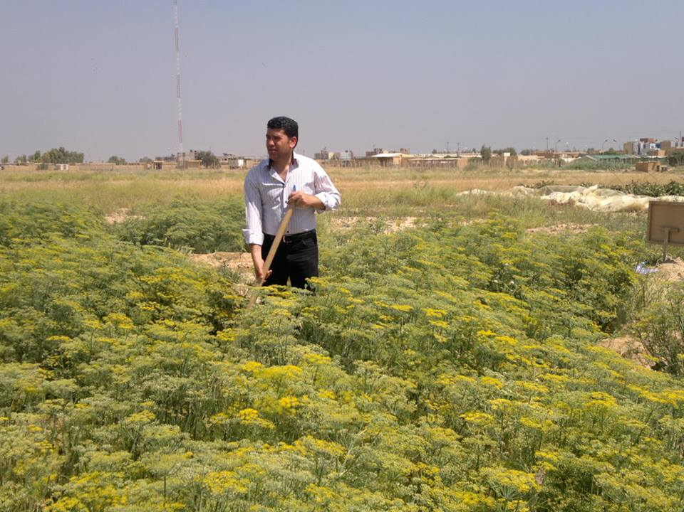

Recent Publications

1 Chang, K. S. and; Y. J. Ahn, 2002. Fumigant activity of E-anethole identified llicium verum fruit against Blattella germanica. pest management science 58(2), 161-166.

2 Havlin, J. L.; J. D. Beaton, S. L. Tisdale and W. L. Nelson 2005. Soil Fertility & Fertilizers: 7th Ed. An introduction to nutrient management. Upper Saddle River, New Jersey.USA.

3 Azzaz, N. A., E. A. Hassan and E. H. Hamad 2009. The Chemical Constituent and Vegetative and Yielding Characteristics of Fennel Plants Treated with Organic and Bio-fertilizer Instead of Mineral Fertilizer. Australian Journal of Basic and Applied Sciences, 3(2): 579-587.

4 Hans Raj and K. K. Thakral .2008. Effect of chemical fertilizers on growth, yield and quality of fennel (Foeniculum vulgare Mill.) Journal of Spices and Aromatic Crops, Volume 17 (2): 134-139.

5 Moradi,R., P. Rezvani Moghaddam, , M. Nasiri Mahallati, , A. Nezhadali, , 2011. Effects of organic and biological fertilizers on fruit yield and essential oil of sweet fennel (Foeniculum vulgare var. dulce) .Spanish Journal of Agricultural Research,Volume/Issue t. 9(2) p. 546-553.

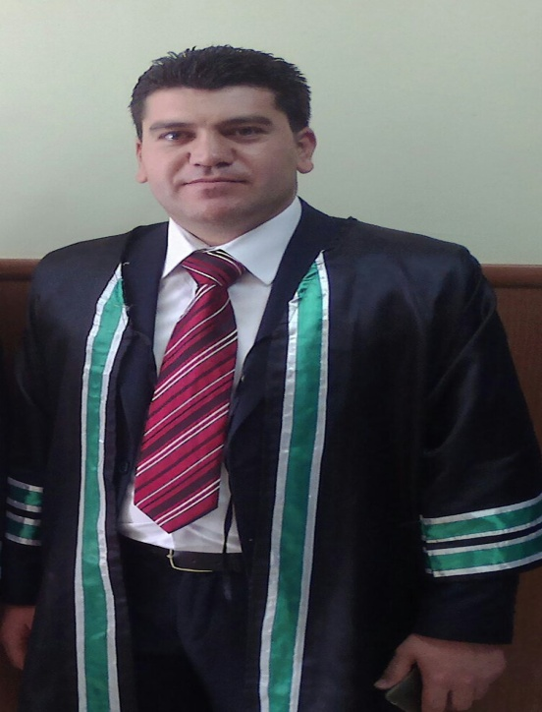 Biography

- Graduate of: the college of agriculture/university of duhok/on 2006.
- Bachelor study specialization: BSc. in Agriculture/Horticulture/with the graduation rate (66.68%).
- Master study specialization: MSc. in Horticulture (Medicinal and Aromatic plant) in college of agriculture/university of Tikrit/on 2014/ with the graduation rate (78.82%).
Email: dilkucher82@yahoo.com Contact No: 009647504818405

Notes/Comments:

