Practical Application of Energy Healing to Pain Management
Gloria Kaye, Ph.D., Energetic Healing Institute
Santa Barbara, California USA

Abstract
Energy Healing is an ancient phenomenon that can be traced back to Biblical times. The recent interest in energy healing and alternative medicine is growing, and more and more medical schools are including energy medicine in their curriculums. Dr. Kaye has taught her techniques to first year medical students and has been conducting healing sessions for over 50 years. Using infrared technology, a physicist was able to capture images of energy and heat being transferred from her hands to her clients.
In her presentation, students will learn the practical application of energy healing to a variety of medical conditions including acute and chronic pain as a result of injuries or trauma. Working energetically, students will learn how to positively affect pain levels. As the energy is transmitted, cells may respond in one of three or more of the following ways: Dispersal – unwanted cells may be dispersed. The intervention lends itself to numerous conditions such as: dispersal of arthritis, adhesions, infections, and bone spurs. Reorganization – traumas and injuries are frequently reduced as skeletal changes create physical balance. Pain associated with physical imbalances may be resolved. Regeneration – as new cells are regenerated, wounds, incisions, open sores and infections can frequently be affected.
This is an exciting, interactive presentation where participants will come away with informative, practical techniques for dealing with pain.

Image
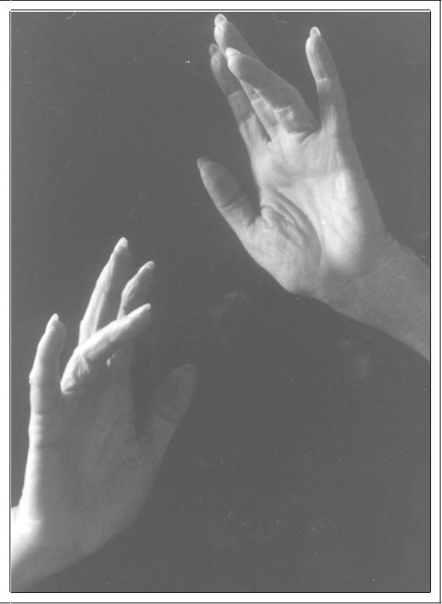
Recent Publications
- Patti Teel. The Montecito Healer Revisited. Montecito Journal, 13-20 Nov 2014.
- Jim Buckley. Coming & Going. Montecito Journal, March 24, 2005.
- Mark Patton. How to get Shaq out of a Toe Jam. Santa Barbara News Press, June 7 , 2002.
- Gloria Kaye, Ph.D., Alison Okada Wollitzer, Ph.D. and Lois Jovanovic, M.D. Comfort and Support Improve Painful Diabetic Neuropathy Whereas Disappointment and Frustration Deteriorate the Metabolic and Neuropathic Status Despite an Intensive Diabetes Care Program. Diabetes Care 2003 Aug; 26(8): 2478-2480. http://dx.doi.org/10.2337/diacare.26.8.2478

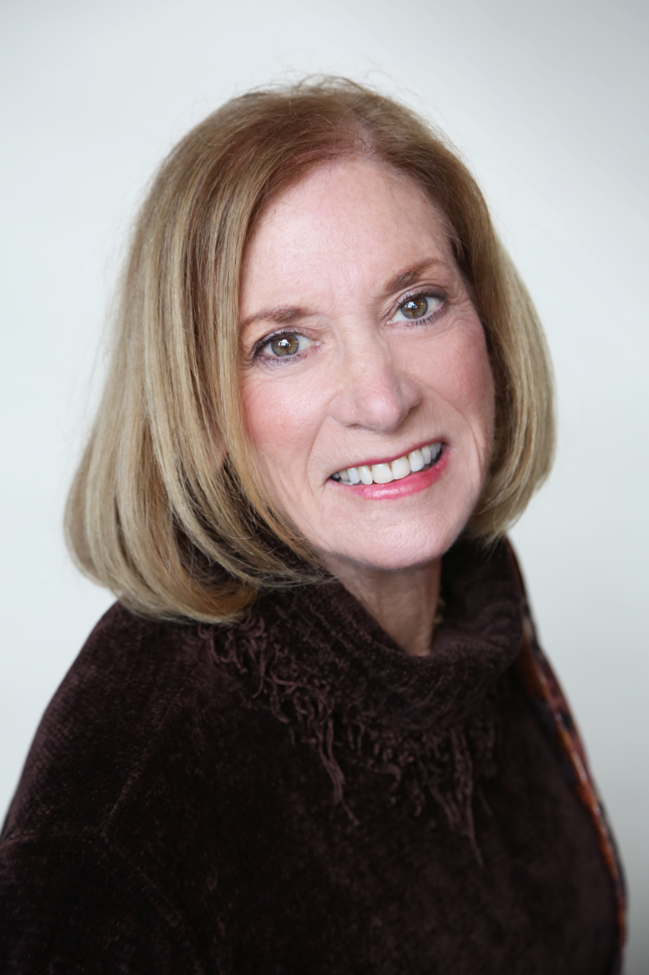 Biography
Dr. Gloria Kaye is dedicated to enlightening the public about energetic healing, and believes that her treatments effectively complement both alternative and medical models of treatment. Her work has been supported and documented by a number of well-respected physicians. In the 1980’s, Dr. Kaye received her Ph.D. in Clinical Psychology and Health Psychology, and proceeded to develop and administer a holistic center for senior citizens. In the early 1990’s, Dr. Kaye integrated pain management and healing into her practice. She lectured on Hands-On Healing to first-year medical students at UCLA School of Medicine in the late 1990’s. Through the combination of Hands-On-Healing and the practical application of yoga to medical complaints, Dr. Kaye has successfully treated clients with various medical conditions, including arthritis, backaches, migraines, muscle pain, inflammation, sprains, scoliosis and tendonitis. Her comprehensive approach to each case produces dramatic changes in flexibility, strength, and comfort.
Email: drgloriakaye@gmail.com

Notes/Comments:

