Identification of adjacent NNRTI binding pocket in multi-mutated HIV1-RT Enzyme Model, An in silico study
Ramish Faraz Kamil, M-Pharm, PWCOP , INDIA

Abstract
The Acquired Immunodeficiency Syndrome (AIDS) is an immunosuppressant disorder caused by human immunodeficiency virus. Correlation of this disorder to the immunity suppression mirrors out on the affected individual’s immune system. Since HIV-1 RT plays a key role in progression & development of disease, targeting it seems to be an appealing approach. In the current study a 3D-model of HIV-1 RT enzyme having multiple mutations as K103N, Y181C and Y188L was developed through homology modeling approach. Molecular dynamic simulations were performed to stabilise the model. A structural comparison was carried out between wild protein crystal structure (2BAN) and generated triple-mutated model to understand the deviations in the NNRTI binding pocket. Since the NNRTI Pyridinone derivatives compound126 and compound VC1 were proposed to have good range of activity against multi-mutated HIV-1RT enzymes with selected mutations, these are selected as probing ligands. The generated enzyme model was docked with probing lignads to study the effects of multiple mutations on binding interactions. The study revealed selected multiple mutations develop steric hindrance, loss of connectivity and loss of aromatic interactions between NNRTI binding pocket residues and NNRTI derivatives. This may also prompt NNRTI derivatives to shift towards an adjacent region of NNRTI pocket which is close to the polymerase active site. The current study provides justification of the possible mechanisms of failure of NNRTI derivatives in multiple mutations and also proposes that the new adjacent site can be another option to develop a new promising class of anti- HIV derivatives having multiple mutations.

Image
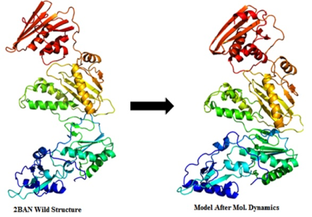
Recent Publications
(No Publications Yet)

 Biography

R. F. kamil has completed his Masters in Pharmaceutical Chemistry in the year 2015. He worked as a research trainee at Department of Medicinal and Process Chemistry CSIR-CDRI Lucknow. He has been working as an assistant professor at Department of Pharmaceutical Chemistry PWCOP Maharashtra India since 2015.
Learning and application of molecular modeling techniques to study effects of multiple mutations on drug receptor interactions and finding possibilities to overcome the hurdles is his area of interest. His recent series of efforts is to find promising drug candidates that can be effective in case of multiple mutations so as to increase life expectancy of individuals suffering from HIV-1.
Email: ramish.kamil@gmail.com

Presenting author details
Full name: Ramish Faraz Kamil
Contact number: 8149929924
Linked In account:
Session name/ number:
Category: (Oral presentation/ Poster presentation)
Notes/Comments:

