Hepatoprotective effect of Phyllanthus niruri against the Paracetamol Induced Liver Toxicity in Albino Rats.
Mr Akshath
Dr Vijaya Kumar – Professor, Dept of Anatomy
Dr Sankaran- Associate Professor, Dept of Anatomy
Saveetha Medical College and Hospital
To investigate the mode of action of phyllanthus niruri (P. niruri) as a prophylactic hepatoprotective agent against paracetamol (PCM) induced liver toxicity in albino rats. Five groups of six animals in each group of wistar rats with a weight of 180- 210 gms were the experimental material. Group I - Served as normal control, administered sodium CMC for all the eight days. Group II rats were treated only with PCM at a dose of 2.5 gm/kg on 8th day. Group III animals were administered silymarin at a dose of 50 mg/kg for 8days and PCM at a dose of 2.5 gm/kg on 8th day, while group IV is the treated group which was given P. niruri aqueous extract at a dose of 200mg/kg followed by PCM of 2.5 gm/kg on 8th day. Group V rats were administered with P. niruri at a dose of 400mg/kg for 8days and PCM at a dose of 2.5 gm/kg on 8th day. Biochemical, hisological and immunohistological (IHC) examinations were performed. Histopathological picture is in line with the biochemical parameters and IHC study revealed that P. NIRURI acts by preventing the increase in NKT cells subsequently blocking FASL, by antiapoptotic and by increasing regeneration. Phyllanthus niruri aqueous extract at a dose of 400 mg/kg was more effective than at 200mg and silymarin 100mg
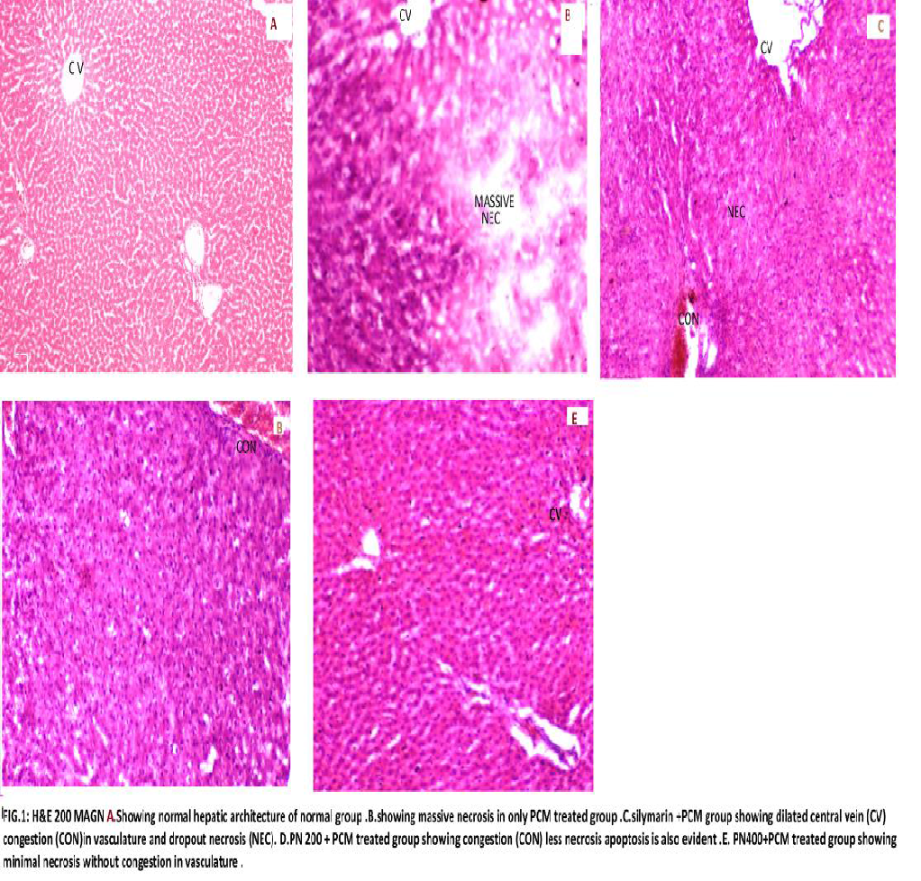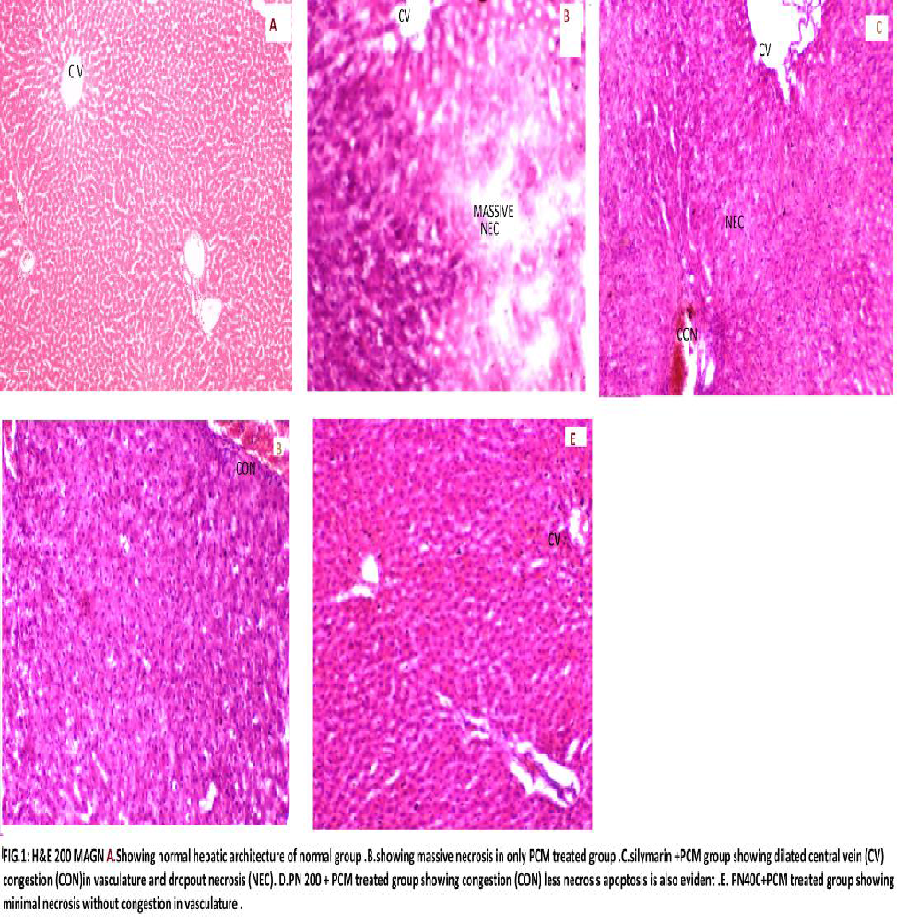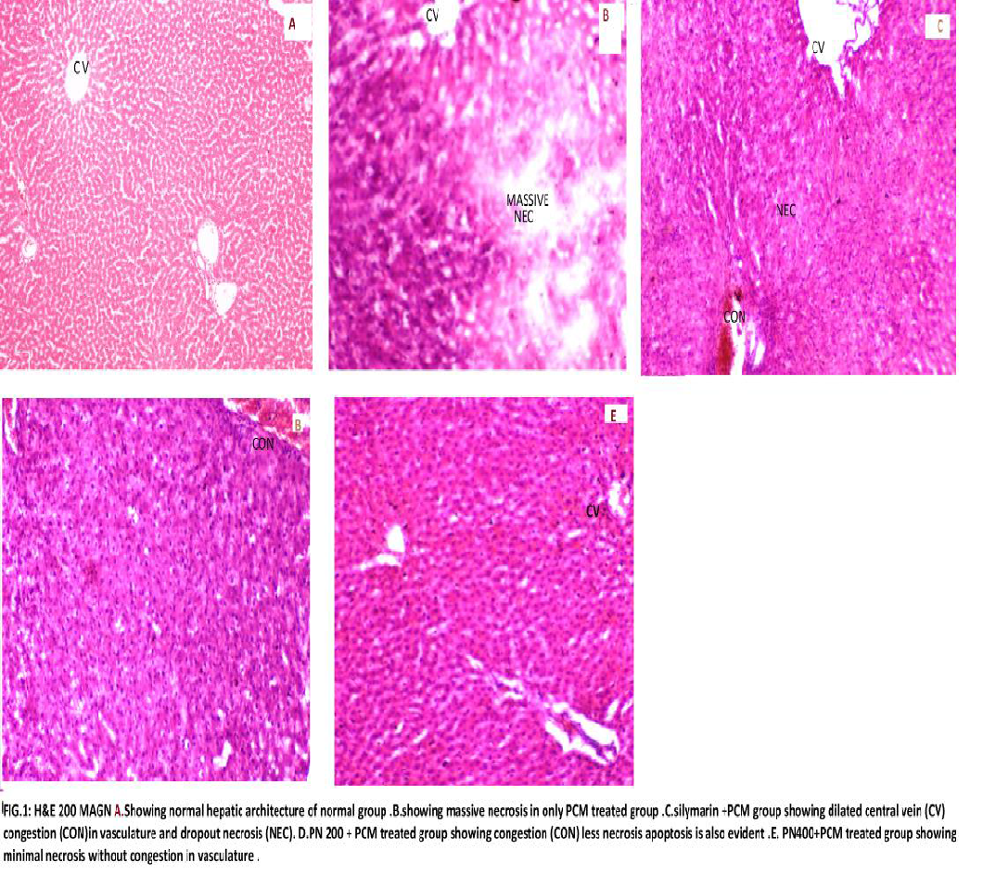

BIOGRAPHY

Myself Mr.Akshath,is currently pursuing my 1st year in MBBS in Saveetha Medical College,SIMATS. My research is on the hepatoprotective effect of phyllanthus niruri against the paracetamol induced liver toxicity in albino rats under the mentorship of Dr.Sankaran,Departmemt of Anatomy,SIMATS, chennai-602105,India.Aspirations motivate more than inspiration,and with that thought I have done my research on this topic as paracetamol is a widely used tablet and its necessary for its effects to be known.
Email:akshath.s.u@gmail.com

Presenting author details
Full name: Akshath .SU
Contact number: 8667664680
Category: presentation

