LOCALISATION OF GLIAL FIBRILLARY ACIDIC PROTEIN IN RAT MIGRAINE
MODEL WISTAR RATS
Mr.Bryan Joel Devaraj*, Dr P K Sankaran, Mr Yuvaraj.
Saveetha Medical College and Hospital

PURPOSE:

The trigeminal ganglion consists of pseudounipolar neurons surrounded by satellite glial cells and processes innervating craniofacial region. The gap junctions are transmembrane proteins formed between the cell membranes of adjacent cells and calcitonin gene related peptide are neuropeptides secreted by sensory neurons. Glial cells which surround the pseudo unipolar neurons directly modulate neuronal function and activity by changing the ionic concentrations in and around the neurons.

METHODOLOGY:

The rats were divided into two groups: Group 1(n=6): control rats, Group 2(n=6): nitro
glycerine treated rats 6mg/kg. Then immunohistochemical localization of glial fibrillary acidic protein in trigeminal ganglion was done in both groups after standardizing dilution ratio.

FINDINGS AND CONCLUSION:

GFAP was present in satellite glial cells surrounding the neuron and in the nerve fibers in control rats. In migraine model rats there was increased intensity of GFAP in the satellite glila cells and nerve fibers indicating its role in allodynia. Upregulation of GFAP in painful conditions like migraine and neuralgic conditions may be an important factor in activating surrounding neurons by releasing interleukins and TNF from the satellite glial cells. The antagonist to GFAP can block the inflammatory cascade and can be used in the treatment of migraine.

A 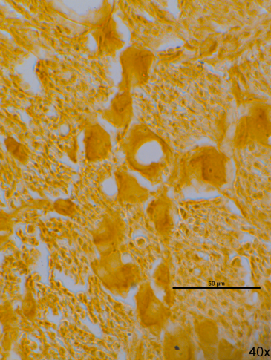 B 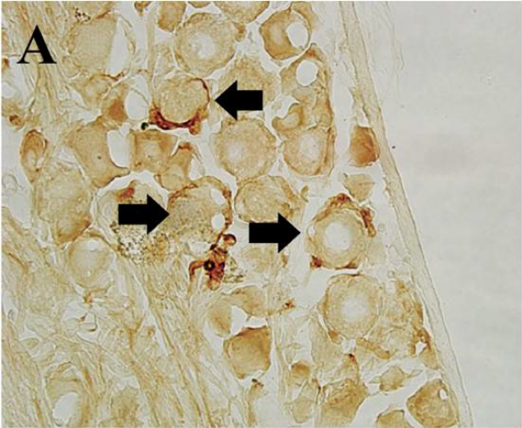

Fig A: GFAP LOCALIZATION IN SATELLITE GLIAL CELLS OF TRIGEMINAL GANGLION IN CONTROL RATS
Fig B: INCREASED INTENSITY OF GFAP IN MIGRAINE MODEL.



Myself Mr.Bryan Joel Devaraj, is currently pursuing my 1st year MBBS in
Saveetha Medical College , SIMATS . My area of research is drug
development: LOCALISATION OF GLIAL FIBRILLARY ACIDIC PROTEIN IN
RAT MIGRAINE MODEL WISTAR RATS under the mentorship of Dr.Sankaran ,
Department of Anatomy, SIMATS , Chennai , India 602105.

