Evaluation of microbial quality of ready-to-eat foods sold in Doha, Qatar

Shifa Zuhara and Ipek Goktepe
Department of Biological and Environmental Sciences,
Qatar University, Doha, Qatar

Abstract

Food safety is an integral part of environmental public health. According to Kunová et al. (2015), there has been many reports on ready-to-eat foods (RTEF) being the basis for foodborne outbreaks in recent years. In Qatar, 5.4% of the total communicable diseases reported from 2008 to 2011 was due to foodborne disease (SCH, 2013). There is very limited information regarding the microbial quality of food sold in mainly fast-food restaurants and cafeterias in Qatar. Therefore, this preliminary study was carried out to evaluate the microbial quality of ready-to-eat foods sold in select food establishments in Qatar. Chicken and burger sandwiches and green salads were collected on a monthly basis from select cafeterias and fast-food restaurants. The total aerobic, coliform, Salmonella spp., and Listeria spp. counts were determined using plate count agar (PCA), MacConkey agar (MCA), Violet red bile Agar (VRBA), Listeria Selective Agar (LSA), respectively. The results indicated that the APC counts of the chicken and burger sandwiches were considered unsatisfactory since their counts were above the set international standards (Health Protection Agency, United Kingdom,2009). For instance, the average total aerobic microorganism count for burger sandwich was 7.13 Log₁₀ CFU/g, which is much higher than the safety guideline set at ≥ 5 Log₁₀ CFU/g. Additionally, the total aerobic counts of green salads were determined to be 7.24 log₁₀ CFU/g which is higher than the set guideline of 6 Log₁₀ CFU/g. The total counts were ≥ 7 Log₁₀ CFU/g for Salmonella spp., coliform, and Listeria spp. which are also considered to be unsatisfactory levels. These results demonstrate that it is necessary to improve awareness on food handling and sanitation practices applied in these restaurants to avoid any future foodborne outbreak.

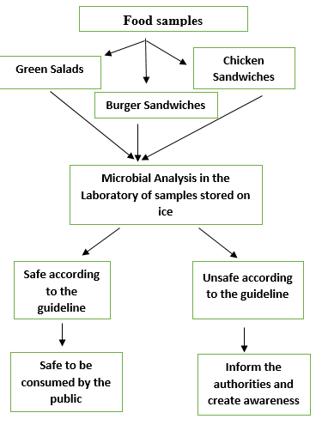
Figure 1: Flow chart showing the research plan for the project.

Recent Publications
- Bolton, D., Little, C., Aird, H., Greenwood, M., McLauchlin, J., Meldrum, R., & Grant, K. (2009). Guidelines for Assessing the Microbiological Safety of Ready-to-Eat Foods Placed on the Market. Health Protection Agency.
- Kunová, S., Kacániová, M., Kluz, M., & Lopasovský, L. (2015). Comparison of Microbiological Quality of Ready-to-eat Delicatessen product with respect to storage temperature. The Journal of Microbiology, Biotechnology and Food Sciences, 4(6), 560-563.
- Qatar Statistics Authority. (2013). Qatar Economic Statistics at a glance. Available at: http://www.qsa.gov.qa/eng/publication/economic publication/2012/Qatar%20Economic %20Statistics%20at%20Glance.pdf

Biography

Shifa Zuhara is a senior undergraduate student in the Environmental Sciences program in the Department of Biological and Environmental Sciences, College of Arts and Sciences at Qatar University. She is currently working on her graduation project dealing with evaluating the microbial quality of ready-to-eat foods sold in Doha, Qatar. She is planning to pursue an MS degree in Environmental Health after graduating in June 2017.

Email: ss1302976@qu.edu.qa

