Novel Quinolone derivatives compound (NQDC)-induced autophagic and apoptotic cell death in 5FU-resistant HT29 cells

Jai-Sing Yang, Researcher Fellow, Department of Medical Research, China Medical University Hospital, China Medical University, Taichung 404, Taiwan.

Abstract

In this study, Novel Quinolone derivatives compound (NQDC) suppressed viability in 5FU-resistant HT29 cells through inhibiting cell proliferation, causing cell cycle arrest and triggering apoptosis. In this study, we investigated the oral anti-cancer activity of NQDC and its mechanism in 5FU-resistant human colon cancer cells. Our results demonstrated that NQDC had an extremely low toxicity in normal oral cells and provoked autophagic cell death to form AVOs and autophagic vacuoles in 5FU-resistant HT29 cells by AO and MDC staining. DNA fragmentation and condensation occurred in NQDC-triggered 5FU-resistant HT29 cell apoptosis. Colorimetric assay analyses also showed that activities of caspase-3 and caspase-9 occurred in NQDC-treated 5FU-resistant HT29 cells. Overall, our findings indicate that NQDC is likely to induce autophagic and apoptotic death in 5FU-resistant HT29 cells.

Image
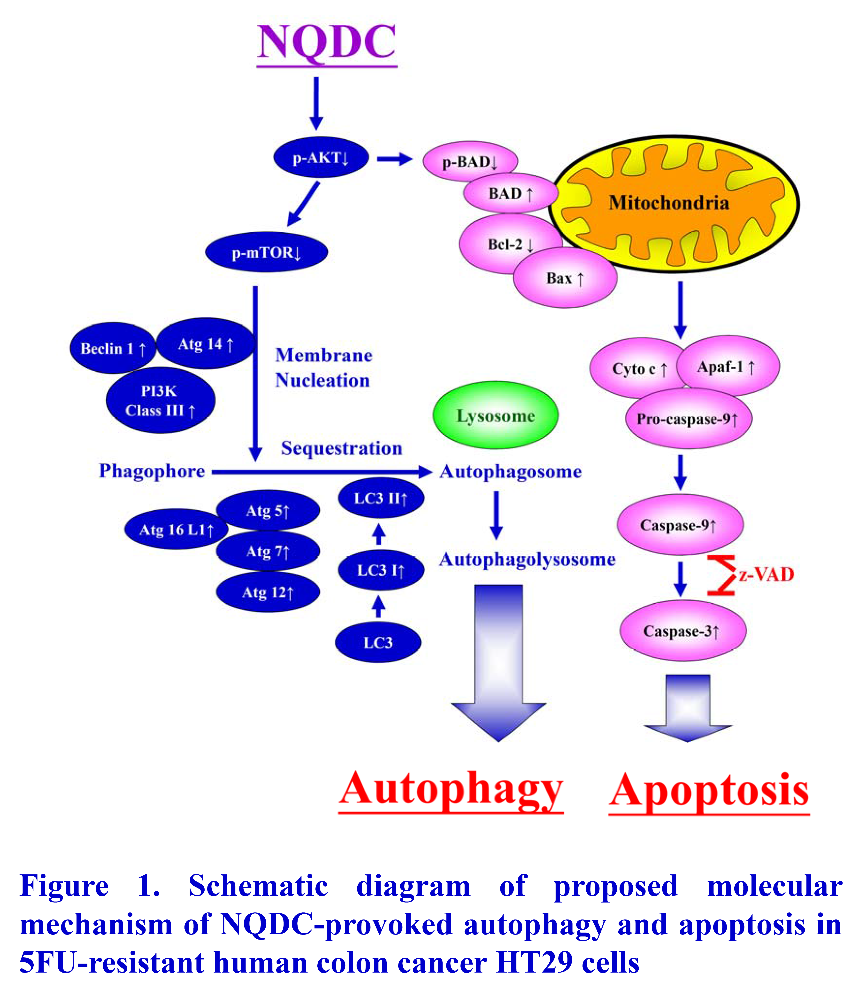
Recent Publications
- CHI-CHENG LU, YNG-TAY CHEN, SHIH-YIN CHEN, YUAN-MAN HSU,CHYI-CHYANG LIN, JE-WEI TSAO, YU-NING JUAN, JAI-SING YANG* and FUU-JEN TSAI (2016, Dec). Hematopoietically Expressed Homeobox (HHEX) gene is associated with Type 2 Diabetes in KK Cg-Ay/J (KK-Ay) Mice and Taiwan’s Han Chinese Population. Experimental and Therapeutic Medicine. (Accepted).
- JAI-SING YANG, CHAO-MIN WANG, CHIU-HSIAN SU, HAN-CHEN HO,CHIUNG-HUNG CHANG, CHANG-HUNG CHOU and YUAN-MAN HSU (2016, Dec). Eudesmin attenuates Helicobacter pylori-induced epithelialautophagy and apoptosis and leads to eradication of Helicobacter pylori infection. Experimental and Therapeutic Medicine. (Accepted).
- JAI-SING YANG, CHIA-AN LIN, CHI-CHENG LU, YEN-FANG WEN, FUUJEN TSAI and SHIH-CHANG TSAI (2016, Dec). Carboxamide analog ITR-284 evokes apoptosis and inhibits migration ability in human lung adenocarcinoma A549 cells. Oncology Reports. (Accepted).
- Shin-Hun Juang, Chang-Ying Chiang, Fong-Pin Liang, Hsiu-Hui Chan, Jai-Sing Yang, Shih-Hao Wang, Yu-Chin Lin, Ping-Chung Kuo, Meng-Ru Shen, Tran Dinh Thang, Bui Thi Minh Nguyet, Sheng-Chu Kuo & Tian-Shung Wu (2016,Dec). Mechanistic Study of Tetrahydrofuran- acetogenins In Triggering Endoplasmic Reticulum Stress Response-apotoposis in Human Nasopharyngeal Carcinoma. Scientific Reports, Scientific Reports.
- Yang JS, Wu CC, Lee HZ, Hsieh WT, Tang FY, Bau DT, Lai KC, Lien JC, Chung JG. (2016, Oct). Suppression of the TNF-alpha level is mediated by Gan-Lu-Yin (traditional Chinese medicine) in human oral cancer cells through the NF-kappa B, AKT, and ERK-dependent pathways.. Environmental Toxicology ,31(10):1196-205.

 Biography
Jai-Sing Yang is a Researcher Fellow of Department of Medical Research, China Medical University Hospital, China Medical University, Taichung 404, Taiwan. Main research interests of Dr. Yang are exploring molecular mechanisms of herbal medicine and new drugs against cancer development. Dr Yang set up the research platform mainly combining molecular pharmacology, immuno-pharmacology, cell biology, drug delivery, nano-technology, animal models and bio-informatics for screening anti-cancer activities of herbal products or newly synthetic drugs. Dr Yang focuses his work on the development of natural products, traditional Chinese medicine (TCM), drug-loaded nanoparticles and the synthesis of new compounds against different types of cancers.

Email: jaisingyang@gmail.com

Presenting author details
Full name: Jai-Sing Yang
Contact number: +886-422052121-2758
Linked In account:
Session name/ number: Pharmacology/
Category: (Poster presentation)
Notes/Comments:

