Enhanced anti-cancer efficacy of Bromelain nanoparticles against Ehrlich ascites carcinoma upon oral administration
Priyanka Bhatnagar, Kailash Chand Gupta

Abstract
Oral administration of anti-cancer drugs is an effective alternative to improve their efficacy and reduce undesired toxicity. Bromelain (BL) is known as an effective anti-cancer phyto-therapeutic agent; however, its activity is reduced upon oral administration. As a result, BL was encapsulated in Poly (lactic-co-glycolic acid) to formulate nanoparticles (NPs), which were further coated with Eudragit L30D polymer in order to provide stability against the gastric acidic conditions upon oral delivery of NPs. NPs were characterized for BL entrapment, proteolytic activity and mean particle size. The stability and release pattern of NPs was also evaluated under simulated gastrointestinal tract pH conditions. Cytotoxicity studies, carried out in human cell lines of diverse origin showed a significant dose advantage (~7-10 folds) with NPs in reducing the IC₅₀ values as compared to free BL. The cellular uptake of NPs in MCF-7, HeLa cells and Caco-2 cell monolayer was significantly enhanced several folds as compared to free BL. Altered expression of marker proteins associated with apoptosis and cell death (P53, P21, Bcl2, Bax) also confirmed the enhanced anti-carcinogenic potential of formulated NPs. Oral administration of NPs reduced the tumor burden on mice and also increased their life-span when compared with the free BL. The generation of reactive oxygen species, induction of apoptosis and impaired mitochondrial membrane potential in tumor cells treated with NPs confirmed the suitability of NPs as a promising candidate for oral chemotherapy.

Image
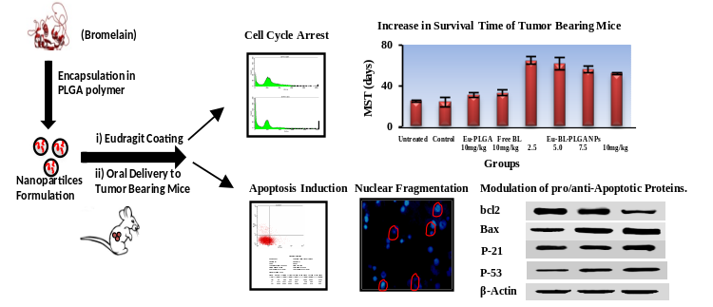

Recent Publications
- Priyanka Bhatnagar, Aditya B Pant, Yogeshwer Shukla, et al. Hyaluronic acid grafted PLGA copolymer nanoparticles enhance the targeted delivery of Bromelain in Ehrlich’s Ascites Carcinoma. Eur. J. Pharmaceu. Biopharm. 2016, 105, 176–192.
- Priyanka Bhatnagar, Aditya B Pant, Yogeshwer Shukla, et al. Bromelain nanoparticles protect against 7, 12-dimethylbenz[a]anthracene induced skin carcinogenesis in mouse model. Eur. J. Pharmaceu. Biopharma. 2015, 91, 35-46.
- Priyanka Bhatnagar, Soma Patnaik, Amit K. Srivastava, et al. Anti-Cancer activity of Bromelain Nanoparticles by oral administration. J. Biomed. Nanotechnol. 2014, 10, 1-17.
- Soma Patnaik, Priyanka Bhatnagar, Ruby Bansal, et al. Polysaccharides as Carriers for Biomolecules. Pharmaceut. Nanotechnol. 2015, 3, 261-87.
- Madhulika Singh, Priyanka Bhatnagar, Sanjay Mishra, et al. PLGA-encapsulated tea polyphenols enhance the chemotherapeutic efficacy of cisplatin against human cancer cells and mice bearing Ehrlich ascites carcinoma. Int. J. Nanomed. 2015, 2015, 10, 6789-09.

 Biography
Priyanka Bhatnagar has her expertise in nanoparticle based delivery of drug molecules so as to improve their therapeutic efficacy. She has completed her PhD in Biotechnology from CSIR-Institute of Genomics & Integrative Biology, Delhi. She is currently working as DST INSPIRE Faculty in All India Institute of Medical Sciences, Delhi. She has published several papers in the journals of high international repute. Currently, she is trying to develop novel nano formulations for the co delivery of anti-cancer effect and P53 activators to achieve synergistic effects for the treatment of triple negative breast cancer.

Email: priyankab.chem@gmail.com

