Hazard identification in newly developed antimicrobials
Kejlová Kristina, Ph.D, Bendová Hana, Ph.D., Sosnovcová Jitka, M.Sc., , Chrz Jan, MSc., Dvořáková Markéta, M.Sc., National Institute of Public Health, Czech Republic

Abstract
Protection of consumer products such as food contact plastics, coatings, cosmetics and textiles against undesirable microbial attack requires innovative agents with a wide spectrum of efficiency, long term stability and safety of use. These requirements are often difficult to meet when using current biocides and antimicrobials. The aim of the currently performed reseach project ALTERBIO is to identify and select innovative and efficient antimicrobial agents, based on silver nanoparticles (1) and photoactive phthalocyanine derivatives (2), able of covalent or ionic bond within a polymeric system and without undesirable effects on human health and the environment. Within the project, the promissing agents with proved efficient and stable antimicrobial effects need to be subjected to a battery of toxicological tests to avoid local and systemic toxicity hazard. The battery of toxicological test to identify local toxicity includes namely skin and eye irritation/corrosion, phototoxicity and skin penetration. The basic systemic toxicity tests comprise acute toxicity, genotoxicity, skin sensitization and endocrine disruption. In compliance with the current European legislation restricting the use of experimental animals (3, 4, 5) the toxicological methods employed in the project comprise exclusively in vitro procedures based on cellular and tissue models either of human origin or mimicking human tissues. The presented poster summarizes the available methods and obtained results.
The study was supported by TE02000006 Centre for alternative environment friendly high effective polymer antimicrobial agents for industrial applications (ALTERBIO).

Image
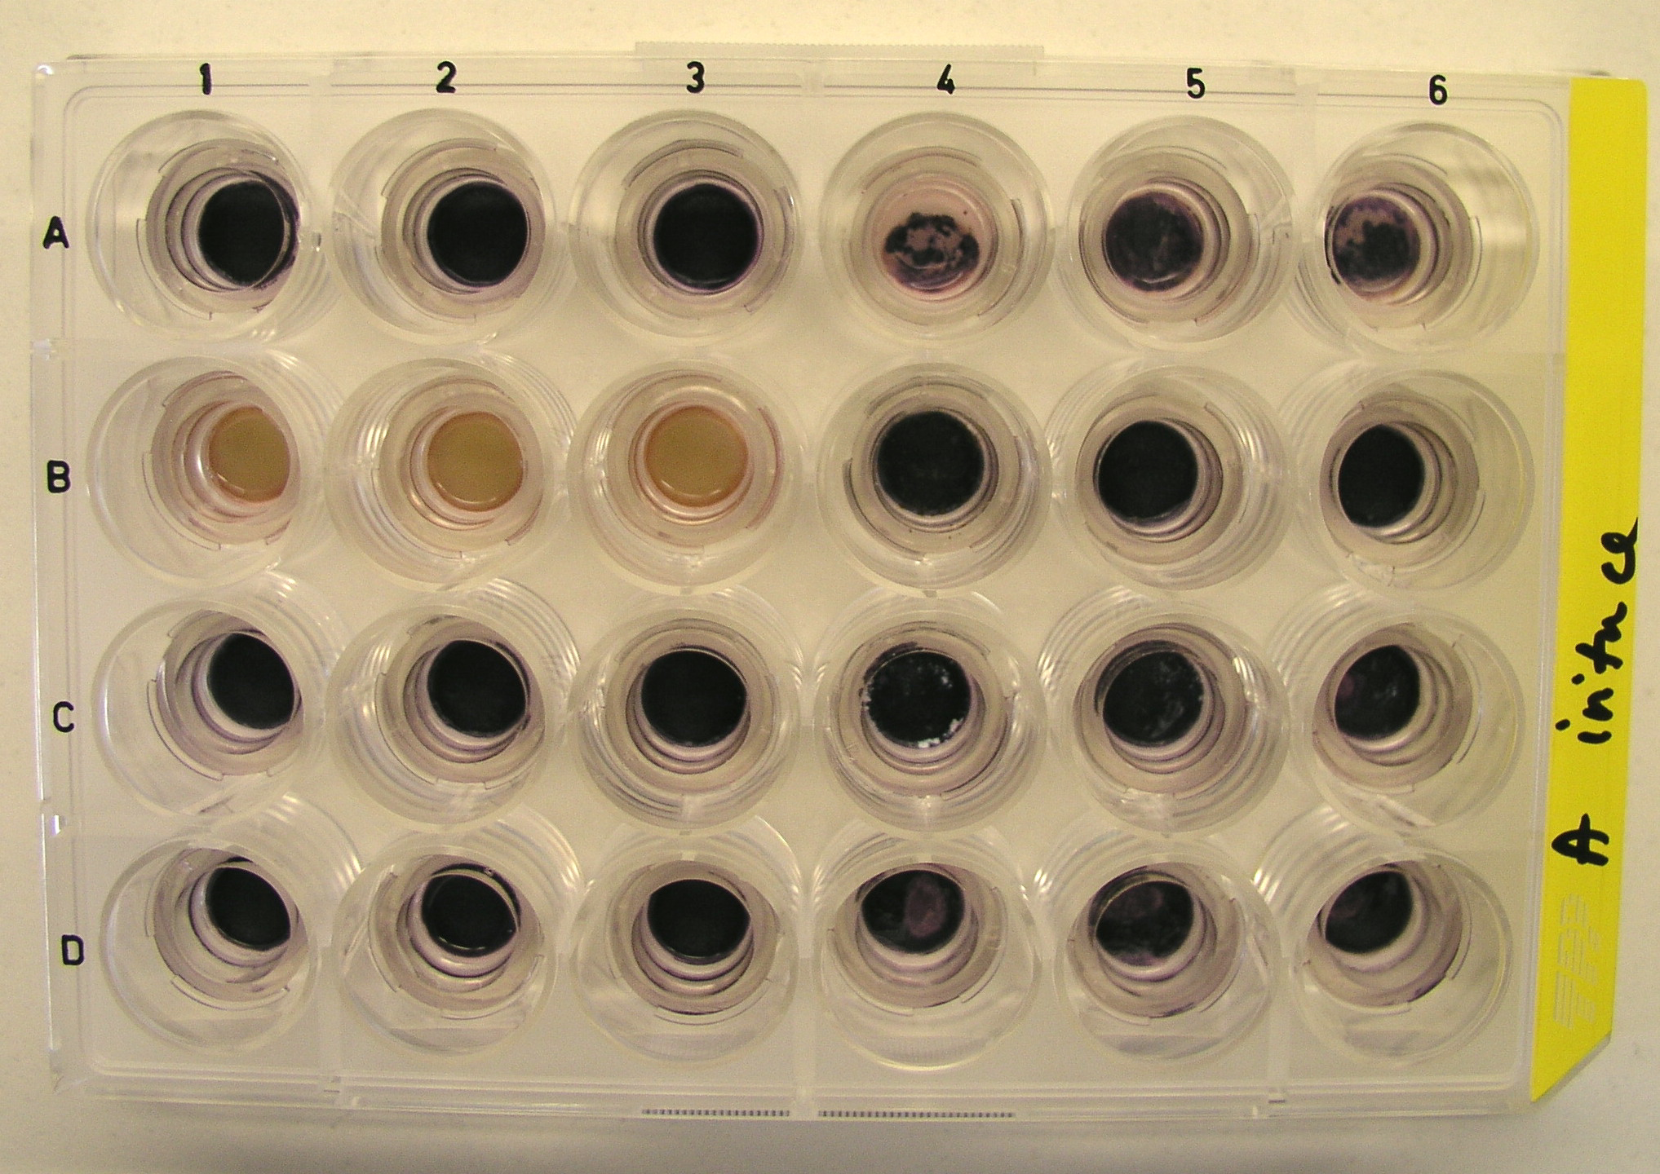
Figure 1: Skin irritation test using reconstructed human tissue model EpiDermTM (MatTek Corp., USA), endpoint - MTT staining for quantification of tissue viability.
Recent Publications
- Castro-Mayorga J.L. et al (2016). Chapter 32 – Silver-Based Antibacterial and Virucide Biopolymers: Usage and Potential in Antimicrobial Packaging. Antimicrobial Food Packaging 2016: 407–416.
- Ke M.R. et al. (2014) Photodynamic inactivation of bacteria and viruses using two monosubstituted zinc(II) phthalocyanines. European Journal of Medicinal Chemistry 84: 278-283.
- Regulation (EC) No 1907/2006 - REACH of 18 December 2006 concerning the Registration, Evaluation, Authorisation and Restriction of Chemicals (REACH) and establishing a European Chemicals Agency, OJ L 396, 30.12.2006: 1-520.
- Council Regulation (EC) No 440/2008 of 30 May 2008 laying down test methods pursuant to Regulation (EC) No 1907/2006 of the European Parliament and of the Council on the Registration, Evaluation, Authorisation and Restriction of Chemicals (REACH). OJ L 142, 31.5.2008: 1–739.
- Regulation (EC) No 1223/2009 of the European Parliament and of the Council of 30 November 2009 on cosmetic products. OJ L 342, 22.12.2009: 59–209.

Biography
Dr. Kristina Kejlová graduated from the Charles University in Prague and received her Ph.D. at the Palacký University in Olomouc. She works as the Head of Unit for Alternative Toxicological Methods at the National Institute of Public Health in Prague, Czech Republic. She is an OECD and EURL-ECVAM expert for in vitro methods. She has published as author or co-author more than 50 papers in reputed journals. Email: kristina.kejlova@szu.cz

Notes/Comments:

