Title: Targeting PHD2/HIF-2a Signaling as A Novel Therapy of pulmonary Arterial Hypertension
You-Yang Zhao, Ph.D. Department of Pharmacology and Center for Lung and Vascular Biology, The University of Illinois College of Medicine, Chicago, IL, USA
Statement of the Problem: Vascular occlusion and complex plexiform lesions are hallmarks of the pathology of severe pulmonary arterial hypertension (PAH) in patients. However, mechanisms of obliterative vascular remodeling remain elusive and hence current therapies have not targeted the fundamental disease modifying mechanisms and result in only modest improvement in morbidity and mortality. Methodology & Theoretical Orientation: Genetic modified mouse models were used to understand the pathogenesis of obliterative pulmonary vascular remodeling and severe PAH. hypoxia-inducible factor-2α (HIF-2α) selective inhibitors were administered to various animal models of PAH. Findings: Mice with Tie2Cre-mediated disruption of Egln1 (encoding prolyl-4 hydroxylase 2, PHD2) (Egln1^{Tie2}) in endothelial cells (ECs) and hematopoietic cells exhibited spontaneous severe PAH with extensive pulmonary vascular remodeling including vascular occlusion and plexiform-like lesions as well as vascular fibrosis and marked increase of oxidative/nitrative stress resembling the hallmarks of the pathology of clinical PAH. As seen in idiopathic PAH patients, Egln1^{Tie2} mice exhibited unprecedented right ventricular hypertrophy and failure and progressive mortality. Consistently, PHD2 expression was diminished in lung ECs of obliterated pulmonary vessels in idiopathic PAH patients. Genetic deletions of both Egln1 and Hif1a or Egln1 and Hif2a identified HIF-2α as the critical mediator of severe PAH seen in Egln1^{Tie2} mice. Pharmacological inhibition of HIF-2α with novel HIF-2α-selective compounds reversed PAH in Egln1^{Tie2} mice, monocrotaline-treated rats, and Sugen5416/Hypoxia-challenged rats. Conclusion & Significance: These studies defined an unexpected role of PHD2 deficiency in the mechanisms of severe PAH and identified the first genetically modified mouse model with obliterative vascular remodeling and pathophysiology recapitulating clinical PAH. Targeting HIF-2a with selective inhibitors is a promising strategy to reverse vascular remodeling for treatment of severe PAH.

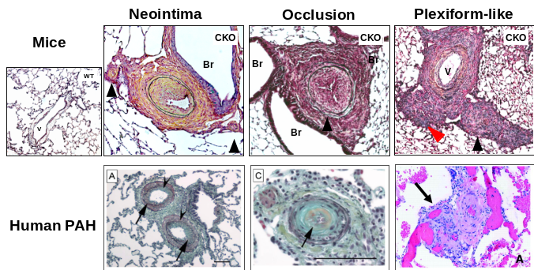

Egln1^{Tie2} (CKO) mice develop severe PAH with obliterative pulmonary vascular remodeling seen in PAH patients. V, vessel; Br, bronchioles.
Recent Publications
- Dai Z, and Zhao YY. (2016) Discovery of a murine model of clinical pulmonary arterial hypertension: Mission impossible? Trends Cardiovasc Med. 27:229-236.
- Dai Z, Li M, Wharton J, Zhu MM, and Zhao YY. (2016). PHD2 deficiency in endothelial cells and hematopoietic cells induces obliterative vascular remodeling and severe pulmonary arterial hypertension in mice and humans through HIF-2α. Circulation 133:2447-2458.
- Stacher E, et al. (2012). Modern age pathology of pulmonary arterial hypertension. Am J Respir Crit Care Med 186:261-272.
- Abe K, et al. (2010). Formation of plexiform lesions in experimental severe pulmonary arterial hypertension. Circulation 121:2747-2754.
- Zhao YY, et al. (2009) Persistent eNOS activation secondary to caveolin-1 deficiency induces pulmonary hypertension in mice and humans through protein kinase G nitration. J Clin Invest. 119:2009-2018.


Dr. YOUYANG ZHAO is Professor of Pharmacology at the University of Illinois at Chicago (UIC). He received his training in cardiopulmonary vascular biology at Harvard University and UCSD. Prior to his tenure at UIC, Dr. Zhao was a Senior Research Scientist in cardiovascular drug discovery in Pharmacia/Pfizer Inc. Dr. Zhao's research is focused on lung and vascular biology to delineate the molecular mechanisms of endothelial regeneration and resolution of inflammatory injury, as well as pulmonary vascular remodeling in the pathogenesis of pulmonary arterial hypertension (PAH), and thereby to provide novel druggable targets and therapeutic strategies for treatment of acute respiratory distress syndrome and PAH. Dr. Zhao has published many papers in top-tier journals such as Nat Med, PNAS, J Clin Invest, J Exp Med and Circulation. His lab is well-funded with multiple R01 grants and PPG grant from NIH.

Email: yyzhao@uic.edu

Notes/Comments:

