ACUTE AND SUBACUTE TOXICITY OF DETARIUM SENEGALENSIS SEED OIL EXTRACT ON WISTAR ALBINO RAT
¹OYEBANJI, E.O, ¹ADEKUNLE, A.A, ²COKER, H.AB and ³OGBONNIA, S.O
¹Department of Botany, University of Lagos
² Department of Pharmaceutical chemistry, Faculty of Pharmacy, College of Medicine
Campus, Idiaraba, University of Lagos.
³ Department of Pharmacognosy, Faculty of Pharmacy, College of Medicine Campus, Idiaraba, University of Lagos.

ABSTRACT
The study examined the acute toxicity and subacute toxicity effect of D. senegalensis seed oil on hematological parameters, antioxidant parameter and histology of the organs of swiss albino mice and wistar albino rat respectively. The LD₅₀ of the drug could not be calculated as non of the mice die during the administration. Significant reduction in bodyweight was observed in group treated with 750mg/kg dose of the extract at the third week of administration (p< 0.05). There was a non significant reduction in plasma protein and creatinine level while aspartate aminotransferase (AST) and alanine aminotransferase (ALT) showed a reduction but increased significantly at the highest dose of the extract (p<0.05). The levels of high and low density cholesterol were not affected compared with the control. The haemoglobin, white blood cells and packed cell volume increased in treated animals compared to the control. Result on the effect of the extract on antioxidant parameters showed significant increase in activity of enzymatic antioxidant compared to the control group. From the LD₅₀ there was a clear indication that the extract is safe for use and the extract did not induce any toxic effects on the organs of the induced rats (liver and kidney).
Keywords: Detarium senegalensis, seed oil, acute toxicity, subacute toxicity.

INTRODUCTION
Medicinal plant is a therapeutic resource used by traditional population of the African continent specifically for healthcare and which may also serve as precursors for the synthesis of useful drugs (Sofowora, 1993). Also, the World Health Organization (W.H.O 2001), defined a medicinal plant as any herbal preparation produced by subjecting plant materials to extraction, fractionation, purification, concentration or other physical or biological process which may be produced for immediate consumption or as a a basis for herbal products. The term herbal drug determines the part/parts of a plant used for preparing medicines (for examples leaves, flowers, seeds, roots, barks stem, etc)
The genus Detarium (Fabiaceae, Sub family. Caesalpinaceae) is a native of Africa. It belongs to the tribe Detarieae. It comprises three important species. Detarium microcarpum Guill & Perr, Detarium senegalense J.F. Gmelin and Detarium microcarpum Harms. These three species are very similar morphologically but appear to differ in ecological distribution. D. microcarpum is a small tree up to 10 m tall, with horizontal root system. It is confined to drier regions of west and central Africa. It is typically a species of dry savanna (Leung et al.,1968). Different parts of the plant have been reported to possess medicinal activities (Abreu et al., 1998, Kouyate 2005, Okolo et al., 2012). Among the Ibo tribe of south eastern Nigeria, the plant known as Ofo is believed to be a religious tree which grows in God’s own compound, symbolizing truth and honestly (Ejizu, 1986). It is the most investigated species of the genus because of its popular use in African traditional medicine. D. senegalense, J.F. Gmelin is a native of tropical Africa, found close to river bank. It occurs from Senegal and the Gambia east to Sudan, and south to northern Democratic Republic of Congo. It is planted as fruit tree and as ornamental shade tree. It may grow up to 38m high with highly buttressed bole. It is commonly known as tallow tree. It is widely used in herbal medicine in Nigeria. It has a considerable commercial in food and pharmaceutical industries (Wang et al., 1996). Detarium senegalensis occurs in the humid forest of tropical Africa. It has similar characteristic as D. microcarpum. This study therefore at evaluating the hematological parameters, antioxidant parameters and histology of the organs as compared with the control. The effect on plasma protein, glucose level, HDL (high density lipoprotein), LDL (low density lipoprotein), AST, (aspartate aminotransferase) ALT (alanine aminotransferase) and plasma creatinine were evaluated as index of toxicity.
MATERIALS AND METHODS
The seed from the tropical plant D. senegalensis was gotten at oyingbo market area of lagos state, Nigeria. D. senegalensis is a small tree up to 10 m tall, with horizontal root system. It is confined to drier regions of west and central Africa. It is typically a species of dry savanna (Leung et al.,1968). The seed from the plant is called ofo and was authenticated by Prof. A.A Adekunle of the Department of Botany, University of Lagos. The seed material were dried at ambient temperature between 30-40ºC in an oven for five days and powdered to coarsed particles. 900grams of the seed material was extracted n-hexane using hydrodistillation method. The solvent evaporated at room temperature and dried to a constant weight to yield
Animals: swiss albino mice (20-25g) and wistar rat (160±20g) of either sex were obtained from the Laboratory Animal Center, College of Medicine, University of Lagos, Idiaraba and were kept under standard environmental condition of 12/12 hr light/dark cycle. They were housed in cages (5 animals per cage), maintained on standard animal feed from Livestock feed Nigeria limited and provided with water to acclimatize to the environment before commencement of the experiment. The use of the animals and the experimental protocol was approved by the experimental Ethics Committee on Animal Use of the College of Medicine, University of Lagos, Nigeria.
Acute toxicity: The toxicity study was carried out using 30 male and female swiss albino mice. The animals were randomly distributed into 4 groups with one control. The control received 0.5% tween 80 solution while the remaining group received doses of 1.0, 2.0, 5.0. 10.0 and 15.0g/kg bodyweight respectively. They were observed in the first 4hours and then hourly to observe ant death or changes in general behavior and other physiological activities. (Shah et al., 1997; Burger et al ., 2005)
A total of 5groups containing five animals per group were used. Three groups received the extract and were treated for 30days.as follows:
Group I –750mg/kg weight of the extract
Group II –500mg/kg weight of the extract
Group III – 250mg/kg weight of the extract
Group V – Control rat received 0.5ml 5% tween 80
The animals were initially weighed and then weighed every seven days from the beginning of the treatment. On the 30th day after overnight fast, were made unconscious by cervical dislocation and blood was obtained via cardiac puncture into fluoride oxalate and heparinised containers. The blood was centrifuged within 5minutes of collection at 4000rpm for 10minutes to obtain plasma. (Wassan et al., 2001). Plasma was analysed for ALT, AST and creatinine by standard enzymatic assay method. The plasma protein content was determined using enzymatic spectroscopic methods (Hussain and Eshrat, 2002).

Statistical Analysis: All data were expressed as mean ± standard error of mean.

RESULTS
In the acute toxicity study, (Table 1) non of the animals used in this study dies and so therefore the LD₅₀ could not be calculated meaning that the extract is safe for consumption. The effect of the extract on hematological parameters are shown in (Table 4) The haemoglobin, white blood cells and packed cell volume increased in treated animals compared to the control. Table summarized the result of the extract on biochemical parameters. There was a non significant reduction in plasma protein and creatinine level while aspartate aminotransferase (AST) and alanine aminotransferase (ALT) showed a reduction but increased significantly at the highest dose of the extract (p<0.05). The levels of high and low density cholesterol were not affected compared with the control. Result on the effect of the extract on antioxidant parameters showed significant increase in activity of enzymatic antioxidant compared to the control group as shown in Table 5 The result on the effect of the extract on the organs of the animals and the normal rat is presented in Table. The macroscopic examination of the animal treated with the extract shows a loose cell in the structure which might be as a result of the extract and the normal did not show any changes.
Table 1: Probit table showing acute toxicity of Detarium senegalensis oil extract on mice
No of animals/group | Doses g/kg) | Log Dose | Death rate | Probit value
5 | 15 | 1.17 | 0 | -
5 | 10 | 1.00 | 0 | -
5 | 5 | 0.69 | 0 | -
5 | 2 | 0.30 | 0 | -
5 | control | - | 0 | -
Table 2: Bodyweight variation of rats during four weeks of administration of the seed oil from fresh Detarium senegalensis seed
Animal groupings | DAY 1 | DAY 7 | DAY 14 | DAY 21
Group 1 | 150 ±0.25 | 165 ±0.76 | 142± 0.03 | 160 ±0.11
Group2 | 162 ±0.15 | 177± 0.16 | 182± 0.21 | 178± 0.13
Group 3 | 165± 0.19 | 180 ±0 24 | 175± 0.22 | 174± 0.31
Group 4 | 167 ± 0.14 | 182± 0.15 | 174 ±0.31 | 170± 0.15
Mean ± SEM, (n = 5)
Group I –750mg/kg weight
Group II –500mg/kg weight
Group III – 250mg/kg weight
Group V – Control rat received 0.5ml 5% tween 80

Table 3: Biochemical Profile of the Wistar albino rat
Animal grouping | Creatinine  (mg/L) | Plasma protein | AST  (i.u/L) | ALT  (i.u/L) | LDL  (mg/dL) | HDL  (mg/dL)
Group 1 | 41.00±1.05 | 40.00±0.13 | 220.30± 0.01 | 305.22± 0.02 | 0.21±0.01 | 0.81±0.50
Group 2 | 43.15±0.75 | 42.11±0.21 | 130±3.18 | 80.02±0.61 | 0.21±0.03 | 0.80±0.56
Group 3 | 41.11±0.71 | 40.21±0.18 | 125.±3.00 | 60.00±1.12 | 0.22±0.00 | 0.76±0.05
Group 4 | 43.12±0.12 | 43.11±0.17 | 154±0..44 | 73.13±0.72 | 0.24±0.02 | 0.85±0.56
Mean ± SEM, (n = 5)
Group I –750mg/kg weight
Group II –500mg/kg weight
Group III – 250mg/kg weight
Group V – Control rat received 0.5ml 5% tween 80

Table 4: Effect of extract from fresh D. senegalensis seed oil on Haematological Parameters
Animal Grouping | HB (g/dl) | WBC x 10³ | MCV (FL) | PCV%
Group 1 | 31.80 ± 1.6 | 5.30 ± 0.9 | 29.70 ± 0.5 | 32.20±0.13
Group 2 | 23.60 ± 0.8 | 3.90 ± 0.5 | 28.70 ± 0.2 | 30.55±0.12
Group 3 | 14.00 ± 2.9 | 5.60 ± 0.7 | 29.30 ± 0.1 | 33.15±0.07
Group 4 | 14.50 ± 2.5 | 3.00 ± 0.5 | 21.50 ± 0.5 | 22.34±0.60
Mean ± SEM, (n = 5)
Group I –750mg/kg weight
Group II –500mg/kg weight
Group III – 250mg/kg weight
Group V – Control rat received 0.5ml 5% tween 80

Table 5: Effect of extract from D. senegalensis seed oil on Antioxidant Parameters
Animal Grouping | GSH (µ/mg) | SOD (µ/mg) | CAT (µ/mg) | MDA (µ/mg)
Group 1 | 2.97 ± 0.01 | 5.54 ± 0.02 | 37.01 ± 0.20 | 0.36 ± 0.30
Group 2 | 1.36 ± 0.25 | 4.58 ± 0.31 | 30.60 ± 0.15 | 0.27 ± 0.01
Group 3 | 0.12 ± 0.15 | 1.49 ± 0.12 | 18.26 ± 0.01 | 0.10 ± 0.14
Group 4 | 1.03 ± 0.15 | 1.39 ± 0.16 | 16.38 ± 0.14 | 0.09 ± 0.31
Mean + SEM, (n = 5)
Group I – 750mg/kg weight
Group II –500mg/kg weight
Group III – 250mg/kg weight
Group V – Control rat received 0.5ml 5% tween

Histopathological studies of the organs of the wistar albino rats
a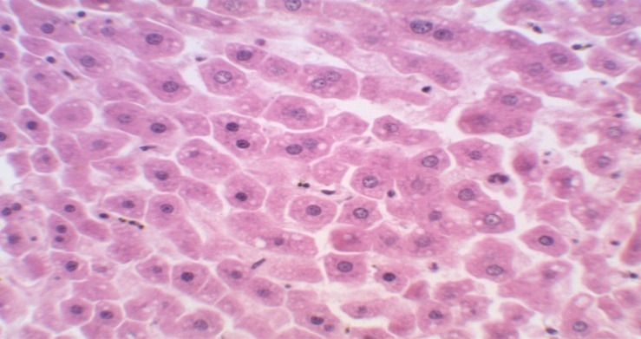 b c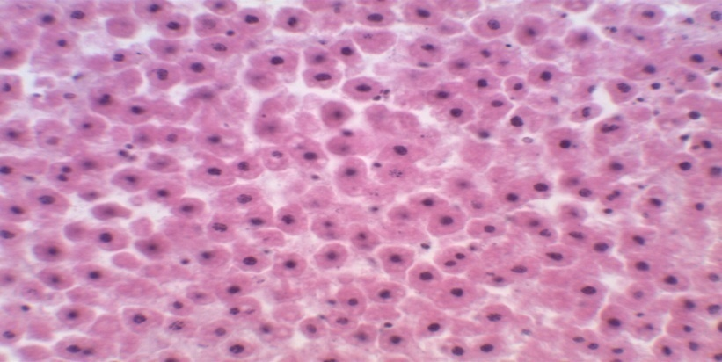d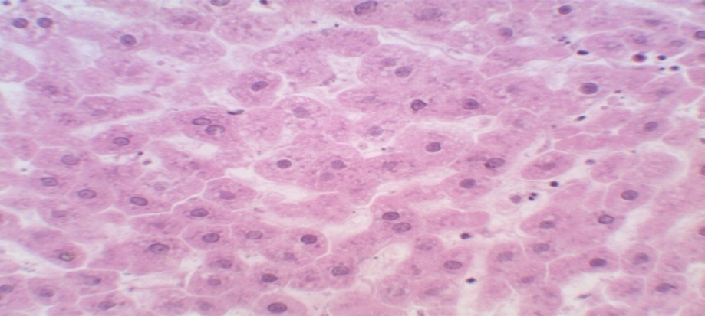 e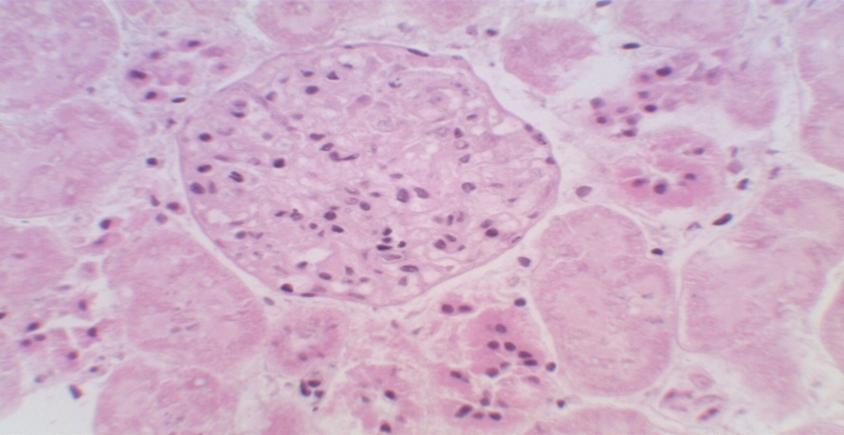 f g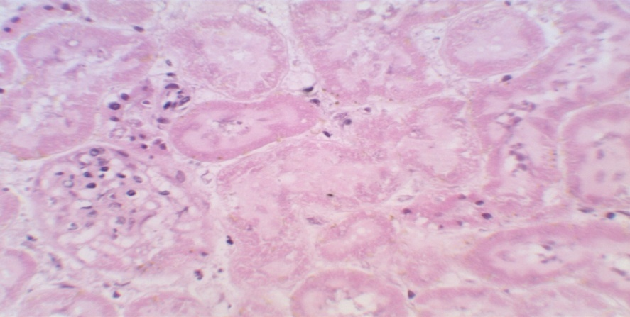 h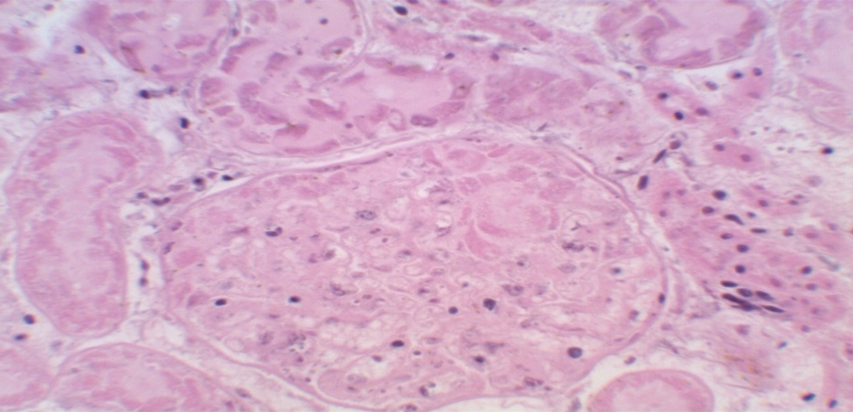
Plate 5a: Photomicrograph of the section of liver of the control Group 4 administerd with 0.5ml of 5% tween 80 solution.
b: Photomicrograph of Wistar rats’ liver in group 1 administered with 750mg/kg body weight of the extract
c: Photomicrograph of Wistar rats liver in group 2 administered with 500mg/kg of the extract
d: Photomicrograph of Wistar rats’ liver in group 3 administered with 250mg/kg body weight of the extract
e: Photomicrograph of the section of Wistar rats’ kidney of the control Group 4 administerd with 0.5ml of 5% tween 80
f: Photomicrograph of the kidney tissues of Wistar rats in group1administered with 750mg/kg body weight of the extract
g: Photomicrograph of kidney tissues of Wistar rats in group 2 administered with 500 mg/kg body weight of the extract
h: Photo micrograph of the kidney tissues of Wistar rats in group 3 administered with 250mg/kg

DISCUSSION
Medicinal plant is a therapeutic resource used by traditional population of the African continent specifically for healthcare and which may also serve as precursors for the synthesis of useful drugs (Sofowora, 1993). Also, the World Health Organization (W.H.O 2001), defined a medicinal plant as any herbal preparation produced by subjecting plant materials to extraction, fractionation, purification, concentration or other physical or biological process which may be produced for immediate consumption or as a a basis for herbal products. The term herbal drug determines the part/parts of a plant used for preparing medicines (for examples leaves, flowers, seeds, roots, barks stem, etc). Studies on the use of plant extracts for control of diseases have shown the importance of natural chemicals (phytochemicals) as possible sources of non-phytotoxic and easily biodegradable alternatives fungicides and antibiotics (Akueshi et al., 2002; Okigbo and Mmeka, 2008). The median lethal dose LD₅₀ which could not be calculated since none of the mice died can be classified as being non-toxic. Although there was an increase in appetite and water consumption in group administered with the extract compared to normal. Significant reduction in bodyweight was observed in group treated with 750mg/kg dose of the extract at the third week of administration (p< 0.05). There were also no changes observed in the macroscopic examination of the organ of the group administered with the extract compared with the control.
There was a non significant reduction in plasma protein and creatinine level while aspartate aminotransferase (AST) and alanine aminotransferase (ALT) showed a reduction but increased significantly at the highest dose of the extract (p<0.05). The decrease in ALT and AST compared to the control implies that the extract at different doses used did not produce any toxic effect on either the cardiac or the hepatic tissue. The levels of high and low density cholesterol were not affected compared with the control. The haemoglobin, white blood cells and packed cell volume increased in treated animals compared to the control. According to report, WBC usually show increase in activity in response totoxic environment (Robin, 1974). Result on the effect of the extract on antioxidant parameters showed significant increase in activity of enzymatic antioxidant compared to the control group.
CONCLUSION
The acute toxicity test was a clear indication that the extract could be safe for use. The study also revealed that the extract at doses investigated did not provoke any toxic effect to the animal kidney and liver. The study showed that the extract has some antioxidant properties compared with the control.
REFERENCES
Abreu, P.M., Rosa, V.S., Araujo, E.M., Canda, A.B., Kayser, O., Bindseil, K.U., Siems, K. and Seeman, A. (1998). Phytochemical analysis and antimicrobial evaluation of Detarium microcarpum bark extracts. Pharmaceutical and Pharmacological letters 8(3) 107-109.
Ejizu, C.I. (1986). Ofo: Igbo rituals symbols. Fourth Dimension publishers, Enugu, Nigeria 190pp.
Hussain, A. and Eshrat, H.M. (2002). Antioxidant properties of Combination of Curcuma longa Linn and partially purified product from Abroma augusta Linn. In Streptozotocin. Indian Journal of Clinical Biochemistry. 17(2):33-43.
Kouyate, A.M. (2005). Aspects of ethnobotaniqueset etudea de la variability morphologique biochemique et phenologuque de Detarium microcarpum, Guill and PCN.AU.M ali. Ph.D Thesis, Faculty of Agriculture and Applied Biological Sciences, University of Kent Belgium.
Leung, W.T., Busson, F. and Jardin, C. (1968). Food consumption table for use in Africa, FAO, Rome Italy 306pp.
Okolo , C.E., Akah, P.A. and Uzodinma, S.U. (2012). Antidiabetic activity of root extract of Detarium microcorpum (Fabiacease) Quill & Perr. Phytopharmacology 3 (1): 12-18.
Okolo, C.E., Akah, P.A. and Uzodinma, S.U. (2012). Antidiabetic activity of root extract of Detarium microcarpum(Fabiaceace) Quill and Perr. Phytopharmacology 3(1):12-18.
Shah, A.M.A., Garg, S.K. and Garg, K.M. (1997). Subacute toxicity studies on Pendimethalin in rats. Indian Journal of P
Sofowora, A. (1993). Medicinal Plant and Traditional Medicine in Africa. Spectrum Books Ltd, Ibadan. 289pp.
Sowemimo, A.A., Pendota, C., Okoh, B., Omotosho, T., Idika, N., Adekunle, A.A. and Afolayan, A.J. (2011). Chemical composition, antimicrobial activity, proximate analysis and mineral contents of the seed of Detarium senegalensis JF Gmelin. African Journal of Biotechnology 10(48):9875-9879.
Wang, Q., Ellis, P.R., Ross-Murphy, S.B., Feid, P.R., Ross Murphy, S.B. and Rcid, J.S. (1986). A new polysaccharides from a traditional Nigerian plant food, Detarium senegalense Gmelin. Carbohydrate Research 284 (2):229-239.
Wassan, K.M., Najafi, S., Wong, J. and Kwong, M. (2001). Assessing plasma lipid levels, bodyweight, hepatic and renal toxicity following chronic oral administration of a water soluble phytostanol compounds FM-VP4, to gerbils. Journal of Pharmaceutical Sciences 4(3): 228-234.

