Cryopreservation of cock semen with different freezing methods
Mphaphathi M.L ^{A}, ^{B}, Seshoka M.M ^{E}, Thandavhathu M.R ^{A}, Maqhashu A ^{A}, Ramukhithi F.V ^{A, C}, Netshirovha T.R ^{A}, Kanuya N.L ^{D}, Raito M.B ^{B} and Nedambale T.L ^{C}

^{A} Agricultural Research Council, RSA.
^{B} University of the Free State, RSA.
^{C} Tshwane University of Technology, RSA.
^{D} Sokoine University of Agriculture, Tanzania.
^{E} Vaalharts Research Station, RSA.

Abstract (300 word limit)
Statement of the Problem: Cryopreserved cock semen has a limited on-farm use, due to its presumably low sperm motility rate recovery post-thaw, with the primary role of the sperm being to fertilize the ovum. The purposes of this study was to compare two cryopreservation methods (slow freezing and vitrification) and the effect of different thawing/warming temperatures (5°C, 25°C and 41°C) on cock sperm motility traits. Methodology & Theoretical Orientation: The abdominal massage technique was used for semen collection. The sperm motility and the velocity traits were evaluated using a Sperm Class Analyzer® system. Semen sample for slow freezing group was diluted with modified Kobidil⁺ extender supplemented with 8% DMSO and equilibrated at 5°C. It was then loaded into 0.25 ml straws and placed in a programmable freezer. Semen straws were transferred into a liquid nitrogen container (–196°C) for storage. After three months, the straws were thawed at 5°C for 5 minutes, at 25°C for 1 minute and at 41°C for 1 minute. The precooling procedures were also used for the solid surface vitrification (SSV) method. Following an equilibration period, 5 μl of diluted semen were dropped into a pre-cooled SSV device. The drops were loaded into a cooled cryovial and stored in a liquid nitrogen container. Vitrified semen drops were warmed at 5°C for 5 minutes, 25°C for 1 minute and at 41°C for 1 minute. Findings: Cock sperm cryo-preserved by slow freezing (43%) and thawed at 5°C had a significantly higher survival and motility rate compared to vitrification (2.5%) method. Conclusion & Significance: Cryopreservation process reduces sperm motility and velocity traits regardless of cryopreservation method and thawing or warming temperatures. However, slow freezing was a better method to maintain sperm motility. Recommendations are made for further studies to conduct artificial insemination for quantification of the better sperm fertility obtained following freezing.

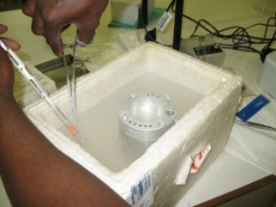
B
A

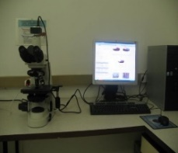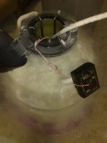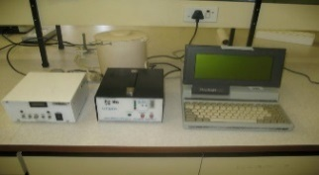
D
C
E

Figure 1: (A) Semen collection from cock, (B) solid surface vitrification of diluted semen, (C) conventional slow freezing of diluted semen, (D) storage of semen straws and cryovial into liquid nitrogen tank and (E) evaluation sperm motility traits by CASA system.
Recent Publications (minimum 5)
- Mphaphathi ML, Seshoka MM, Luseba D, Sutherland B, Nedambale TL (2016) The characterisation and cryopreservation of Venda chicken semen. Asian Pacific Journal of Reproduction 5(2):132-139.
- Seshoka MM, Mphaphathi ML, Nedambale TL (2016) Comparison of four different permitting and combination of two best cryoprotectants on freezing Nguni sperm evaluated with the aid of computer aided sperm analysis. Cryobiology 72:232-238.
- Maqhashu A, Mphaphathi ML, Seshoka MM, Ramukhithi FV, Seolwana LF, Masenya MB, Netshirovha TR, Mapeka MH, Nengovhela NB, Kanuya NL, Muchenje V, Nedambale TL (2016) Comparison of Oestrous Synchronization Response and Pregnancy Rate of Village Cows Following Timed Artificial Insemination in KwaZulu-Natal and Limpopo Provinces. Open Journal of Animal Sciences 6:9-15.
- Lekola KPM, Ng’ambi JW, Nkadimeng M, Mphaphathi ML, Nedambale TL (2016) Effects of various concentrations of gonadotropins and 17β estradiol on the in vitro maturation of cattle oocytes selected using brilliant cresyl blue staining. South African Journal of Animal Science 46(3):321-326.
5. Mphaphathi ML, Luseba D, Sutherland B, Nedambale TL (2012) Comparison of slow freezing and vitrification methods for Venda cockerel’s spermatozoa. Open Journal of Animal Sciences 2(3): 204-210.

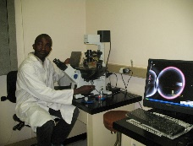 Biography (150 word limit)
Mphaphathi Masindi has his expertise in semen cryopreservation and passion in improving post-thaw sperm viability/survival. In addition, he also provide and support on in-situ and ex-situ conservation programmes.
Email: masindim@arc.agric.za

Notes/Comments:

