Advanced 3D vascularized in vitro models of human bone and muscle to study tumor cell extravasation
Bersini S, PhD, IRCCS Istituto Ortopedico Galeazzi, Italy
Arrigoni C, PhD, IRCCS Istituto Ortopedico Galeazzi,Italy
Gilardi M, PhD, IRCCS Istituto Ortopedico Galeazzi, Italy
Talò G, IRCCS Istituto Ortopedico Galeazzi, Italy
Lopa S, PhD, IRCCS Istituto Ortopedico Galeazzi, Italy
Bongio M, PhD, IRCCS Istituto Ortopedico Galeazzi, Italy
Vanoni M, Prof., Università Milano Bicocca, Italy
Dubini G, Prof., Politecnico di Milano, Italy
Kamm RD, Prof., Massachusetts Institute of Technology, USA
Moretti M, PhD, IRCCS Istituto Ortopedico Galeazzi, Italy; Ente Ospedaliero Cantonale, Switzerland

Abstract (300 word limit)

Cancer metastases cause 90% of cancer deaths and affect different organs, depending on the tumor, e.g. breast cancer metastasizes to bone but not to skeletal muscle [1]. Extravasation is the last critical step of metastatic cascade before organ colonization and, for its investigation, standard in vitro models are oversimplified, while in vivo models are analytically limited and present species-specific differences in pathological mechanisms [2].

Thus, we generated innovative in vitro models for the study of breast cancer cell (BCC) extravasation. Our models are based on 3D gels embedding co-cultures of human bone, muscle and vascular cells. They can be either microscale, based on microfluidics, or mesoscale, exploiting ad-hoc designed supports [3].

BCCs injected into microvascular networks of our models extravasated more towards bone model, compared to control and to skeletal muscle model (56.5 ± 4.8% vs. 14.7 ± 3.6% vs. 8.2 ± 2.3%), although permeability of the bone endothelium was lower [4]. Furthermore, adenosine addition to the bone model decreased extravasation (12.7 ± 2.8% vs. 56.5 ± 4.8%), and the supplementation of a specific adenosine inhibitor in the muscle model increased BCC extravasation (32.4 ± 7.7% vs. 8.2 ± 2.3%)[4]. Furthermore, with these models we demonstrated the key role of Talin-1 protein in the extravasation process [5]. We also generated the first 3D in vitro mesoscale models of metabolically active human bone [6] and we have biofabricated a 3D human vascularized skeletal muscle environment, which not only incorporates a physiological muscle-specific vascular network, but also includes muscle-supporting fibroblasts recapitulating the structure of the endomysium.

In conclusion, our 3D in vitro human models, vascularized and organ-specific, allowed us to replicate the process of extravasation of breast cancer cells and to investigate its basic biological mechanisms, thanks to the control on the microenvironment and to the high resolution of analytical methods.
Image

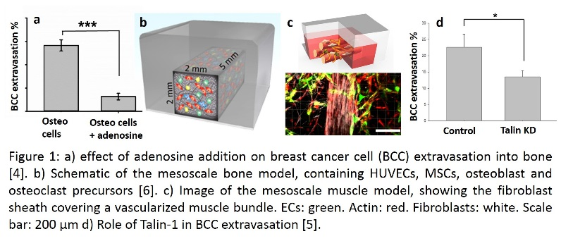

Recent Publications (minimum 5)
- Chaffer CL, Weinberg RA. A perspective on cancer cell metastasis. Science. 2011 Mar 25;331(6024):1559-64.
- Bersini S, Moretti M. 3D functional and perfusable microvascular networks for organotypic microfluidic models. J Mater Sci Mater Med. 2015 May;26(5):180.
- Bersini S, …, Moretti M. Human in vitro 3D co-culture model to engineer vascularized bone-mimicking tissues combining computational tools and statistical experimental approach. Biomaterials. 2016 Jan;76:157-72.
- Jeon JS, Bersini S, …, Moretti M, Kamm RD. Human 3D vascularized organotypic microfluidic assays to study breast cancer cell extravasation. Proc Natl Acad Sci U S A. 2015 Jan 6;112(1):214-9.
- Gilardi M, Bersini S, …, Moretti M. The key role of talin-1 in cancer cell extravasation dissected through human vascularized 3D microfluidic model. Thromb Res. 2016 Apr;140 Suppl 1:S180-1.
- Bongio M, …, Moretti M. A 3D vascularized bone remodeling model combining osteoblasts and osteoclasts in a CaP nanoparticle-enriched matrix. Nanomedicine (Lond). 2016 May;11(9):1073-91.

 Biography
Matteo Moretti is Director of the Cell and Tissue Engineering Lab at Galeazzi Hospital in Milan, Italy, and of the Regenerative Medicine Technologies Lab at EOC in Lugano, Switzerland. His research lies in the interdisciplinary fields of tissue engineering and 3D models. In particular, his main research interests lie within micro and meso-scale advanced cell culture technologies. He developed multiscale bioreactor systems from design to fully working prototypes, aimed at up-scalable, automated platforms as a key to more viable advanced therapies. Furthermore, he worked on the application of different physico-chemical cues to engineered vascularized physiological and pathological tissues, with concern to human primary in vitro 3D model systems aimed at translational applications and as novel tools for biology research. He is Treasurer of the Tissue Engineering and Regenerative Medicine Society European chapter (TERMIS-EU). He authored more than 60 papers on international peer-reviewed journals and has co-founded two biotech start-ups.
Emails: Matteo.Moretti@grupposandonato.it; Moretti@mit.edu; Matteo.Moretti@eoc.ch

Notes/Comments:

