CRISPR/Cas9-mediated nock-in of large DNA in human embryonic stem cells and somatic cells

Xiangjun HE, Bo FENG
Key Laboratory for Regenerative Medicine, Ministry of Education, School of Biomedical Sciences, Faculty of Medicine, The Chinese University of Hong Kong, Hong Kong SAR, China, Email: fengbo@cuhk.edu.hk

Abstract
CRISPR/Cas9-induced site-specific DNA double-strand breaks (DSBs) can be repaired by homology-directed repair (HDR) or non-homologous end joining (NHEJ) pathways. Extensive efforts have been made to knock-in exogenous DNA to a selected genomic locus in human cells; which, however, has focused on HDR-based strategies and was proven inefficient. Here, we report that NHEJ pathway mediates efficient rejoining of genome and plasmids following CRISPR/Cas9-induced DNA DSBs, and
promotes high-efficiency DNA integration in various human cell types. With this homology-independent knock-in strategy, integration of a 4.6 kb promoterless ires-eGFP fragment into the GAPDH locus yielded up to 20% GFP+ cells in somatic LO2 cells, and 1.70% GFP+ cells in human embryonic stem cells (ESCs). Quantitative comparison further demonstrated that the NHEJ-based knock-in is more efficient than HDR-mediated gene targeting in all human cell types examined. These data support that CRISPR/Cas9-induced NHEJ provides a valuable new path for efficient genome editing in human ESCs and somatic cells.

Recent Publications
- He X, Tan C, Wang F, Wang Y, Zhou R, Cui D, You W, Zhao H, Ren J, Feng B#. Knock-in of large reporter genes in human cells via CRISPR/Cas9-induced homology-dependent and independent DNA repair, Nucleic Acids Res 44(9):e85 (2016).
- Hu J, Lei Y, Wong WK, Liu S, Lee KC, He X, You W, Zhou R, Guo JT, Chen X, Peng X, Sun H, Huang H, Zhao H, Feng B#, Direct activation of human and mouse Oct4 genes using engineered TALE and Cas9 transcription factors, Nucleic Acids Res 42(7):4375-90 (2014).
- Chia NY, Chan YS, Feng B*, Lu X, Orlov YL, Moreau D, Kumer P, Yang L, Jiang J, Lau MS, Huss M, Soh BS, Kraus P, Li P, Lufkin T, Lim B, Clarke ND, Bard F & Ng HH, A genome-wide RNAi screen reveals determinants of human ES cell identity. Nature 468: 316–20 (2010). (*Co-first authors)

Image

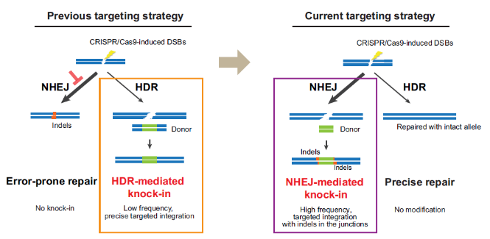
Figure 1. CRISPR/Cas9-coupled NHEJ mediates more efficient reporter knock-in than HDR in human ESCs and somatic cell lines. Shown is the schematic diagram illustrating the balance between NHEJ- and HDR-mediated DSB repair in human cells, as well as the strategies (boxes) used for gene targeting.

- Heng JC, Feng B*, Han J, Jiang J, Kraus P, Ng JH, Orlov YL, Huss M, Yang L, Lufkin T, Lim B & Ng HH, The nuclear receptor Nr5a2 can replace Oct4 in the reprogramming of murine somatic cells to pluripotent cells. Cell Stem Cell 6:167-74 (2010). (*Co-first authors)
- Feng B, Ng JH, Heng JC, Ng HH., Molecules that promote or enhance reprogramming of somatic cells to induced pluripotent stem cells, Cell Stem Cell 4, 301-12 (2009). Review.
- Feng B, Jian, J, Kraus P, Ng JH, Heng JC, Chan YS, Yaw LP, Zhang W, Loh YH, Han J, Vega VB, Cacheux-Rataboul V, Lim B, Lufkin T & Ng HH, Reprogramming of fibroblasts into induced pluripotent stem cells with orphan nuclear receptor Esrrb. Nat Cell Biol 11:197-203 (2009).

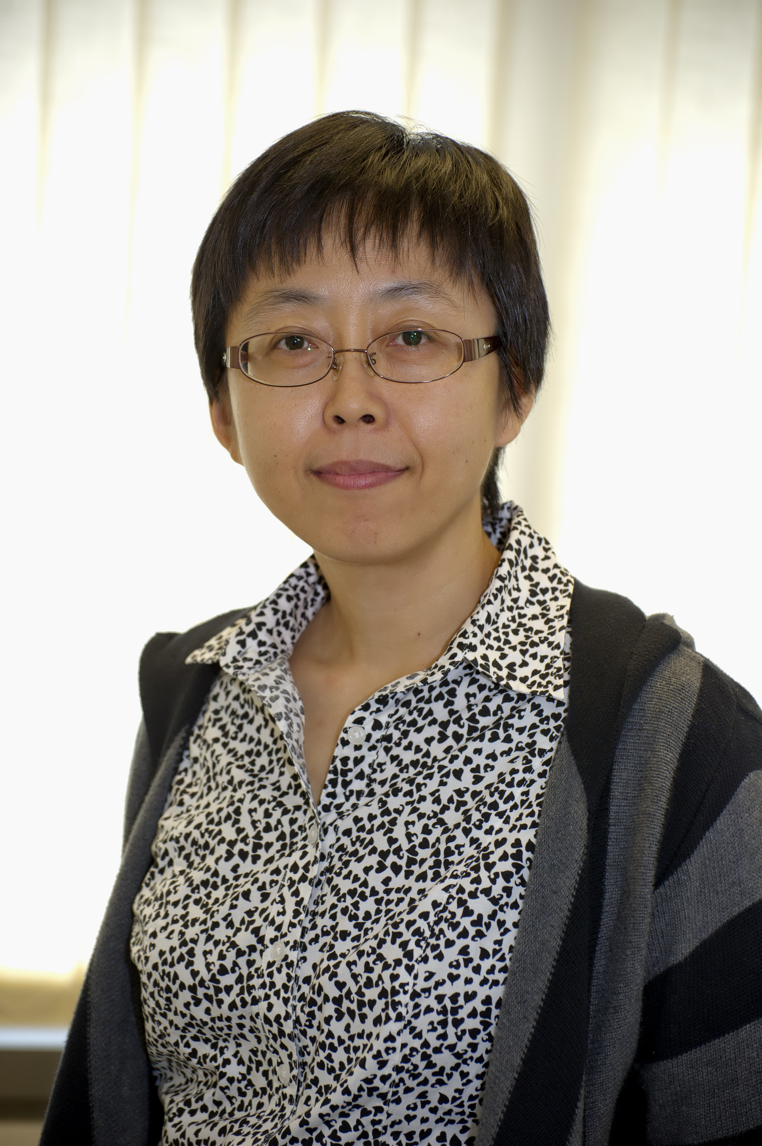
Biography
Dr. Bo Feng is an Assistant Professor in the School Biomedical Sciences, Faculty of Medicine, The Chinese University of Hong Kong. She is an active staff member in the Stem Cell and Regeneration program, MOE key laboratory for Regenerative Medicine and CUHK-GIBH joint laboratory on Stem Cell and Regenerative Medicine. Dr Feng graduated from Nankai University with B.Sc. (1993) and M.Sc (1996), and received her Ph.D. (2006) from National University of Singapore. After graduation, Dr. Feng joined Prof Ng Huck Hui’s lab in Genome Institute of Singapore as a postdoc. She worked on stem cells and reprogramming and published her works in Nature Cell Biology, Cell Stem Cell and Nature. In Nov 2010, Dr Feng joined CUHK and her current research interest lies within the molecular mechanism that controls pluripotency and differentiation of ESCs/iPSCs, as well as development of new tools for stem cell research and applications.

Email: fengbo@cuhk.edu.hk

