Using organ-specific progenitor cells extracts in regenerative medicine
Anand Baskaran Padma Priya MS, Oleksandr Kukharchuk Prof., Andrii Kukharchuk MD, Abhijit Bopardikar MD, Rohit Kulkarni MD, Sunil Pophale, ReeLabs, India

Statement of the Problem: Proliferation and differentiation of stem cells (SCs) requires a specific microenvironment – “stem cells niche”. Making this niche in vivo is a big problem. For in vivo modulation of organ-specific niches during SCs transplantation could be useful fetal tissue extracts (FTEs). In the stage of incomplete organogenesis microenvironment in each of the organs must be specific and stable enough to generate constant signal for the final differentiation of organ-specific progenitor cells. The purpose of this study is to test and validate this hypothesis. Methodology & Theoretical Orientation: to investigate the content and concentrations of growth factors in FTEs of various organs; and to study the efficacy of FTEs in patients who did not respond to SCs treatment. Findings: We show, that ratio of the growth factors (EGF, FGF-7, HGF, IGF-1, VEGF) in tissues of the fetal organs differs considerably. This may be due to differences in regulatory niches that are specific to each organ. In next step we use FTEs for modeling the stem cell niche in treatment of patients with liver cirrhosis and patients with non-healing wound/ulcer who do not have positive response to previous SCs treatment. Transplantation of prenatal hepatoblasts, hematopoietic SCs, and 3 weeks of daily fetal liver extracts injections showed effectiveness in 75% of this liver cirrhosis cases that is characterized by significant decrease of liver fibroscan density, decrease of portal hypertension and ascites, decrease or normalization of biochemical markers of liver damage. Connective tissue metabolism showed increase of fibrinolytic and collagenolytic activity. In patients with chronic non-healing wounds who do not have any improvement after previous SCs treatment, administration of FTEs (skin, muscle) activated the wound epithelialization with completely healing of the. Conclusion & Significance: FTEs obtained from the stage of incomplete organogenesis can be useful for in vivo modulation of organ-specific niches for transplanted SCs.

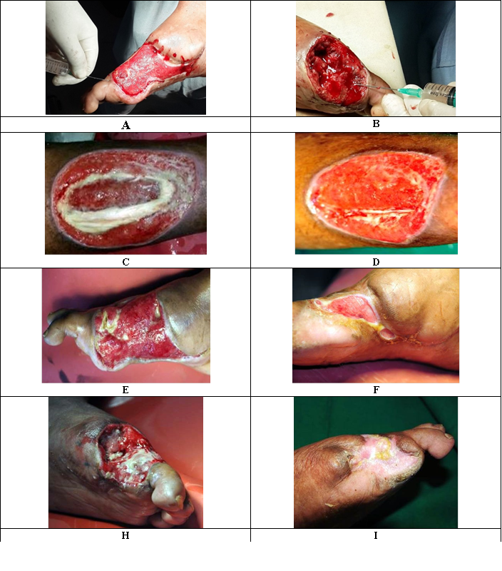
Dynamics of wound healing in patients with chronic critical limb ischemia after the stem cell niche modeling
A: The patient B., diabetes mellitus, diabetic foot; after 3 months post administration of stem cells, fetal skin tissue extract was administered in the periphery of wounds for modeling niche; B: The patient C., thromboangiitis obliterans; after 3 months post administration of cells, extract of fetal liver was administered into the bed of wounds for modeling niche; E: Patient B., diabetes mellitus, diabetic foot; after stem cells treatment; necrotized tissues observed; canal filled with pus; F: Patient B., 7th day after second fetal liver and fetal skin tissue extracts administrations; intensification and accelerating epithelialization of wound; H: Patient C., thromboangiitis obliterans (Berger's disease); after stem cells treatment; I: Patient C., 15th day after last fetal liver and fetal skin tissue extracts administrations; complete healing of the wound.
Recent Publications)
- Bhattacharya B, Stubblefield Ph. Human Fetal Tissue Transplantation, Springer-Verlag London, 2013.
- Dame C, Fahnenstich H, Freitag P, Hofmann D, Abdul-Nour T, Bartmann P, Fandrey J (1998) Erythropoietin mRNA Expression in Human Fetal and Neonatal Tissue Blood, Vol 92, No 9 (November 1), 1998: pp 3218-3225
- Kukharchuk O, Padma Priya AB, Kukharchuk A, Kulkarni R, Bopardikar A, Pophale S (2017) Modelling of organ-specific niches in regenerative medicine. BIT’s 11th Annual World Congress of Regenerative Medicine & Stem Cells-2017. Conference Abstract Book, Singapore, 2017: 077.
- Rebecca L (2017) Fetal Membranes in Regenerative Medicine: New Tricks from an Old Dog? Stem Cells Translational Medicine 6: 1767–1776.
- Shea M, Addison A, Taylor N, Sebire S (2012) High quality genomic DNA extraction from postmortem fetal tissue. July 2012 doi: 10.3109/14767058.2012.704442


Experienced Researcher with a demonstrated history of working in the hospital & health care industry. Skilled stem cells therapy protocol from preparation to treatment with 15 scientific publications. Established efficacy of stem cells in clinical research. Strong research professional with a Masters focused in Biotechnology from Saint-Petersburg State Chemical Pharmaceutical Academy (Russia). Field of interest: prenatal stem cells, exosomes, 3D progenitor cell cultures, stem cell niche modeling.

Email: padma.p@reelabs.com

