Pilonedal Fistula
Pilonidal sinus is well-recognized chronic inflammatory condition, mostly in sacrococcygeal area. Pilonedal fistula is a rare variety of pilonidal sinus with extension of the disease to the anal canal. We report four cases of pilonidal fistula. Three were males& one female aged 23, 25, 42 &14years respectively, Average duration of complain was approximately eight months.
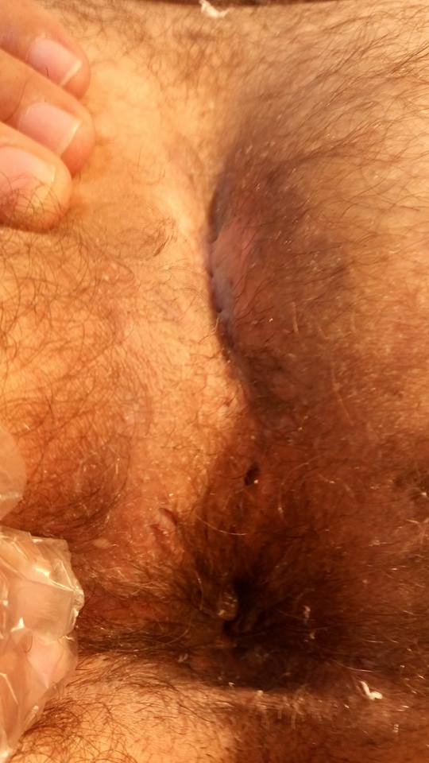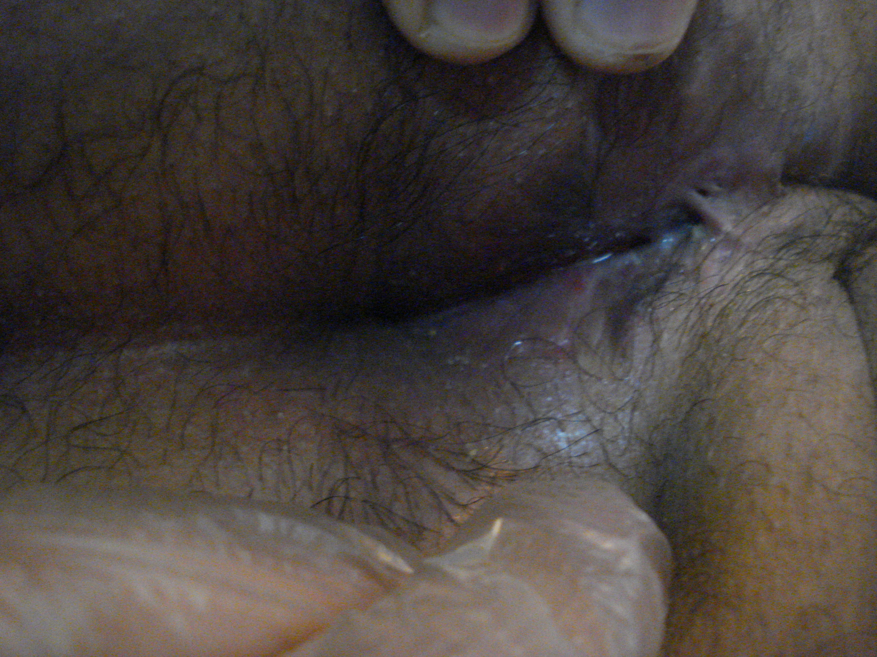
Endo-anal ultra sound demonstrated that the disease opened in anal canal at dentate line at 6th. O`clock in three patient and 5th. O`clock in the fourth one.
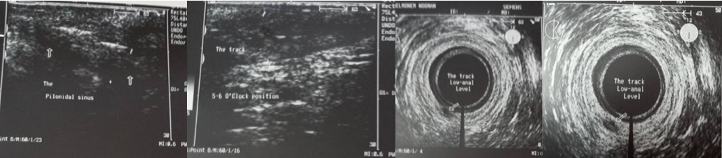
Surgical treatment was done in all cases. This was challenging, being extensive, open into the anal canal (a continuous source for infection) and relation to anal sphincter. The resulted large wound made the open method very annoying to patients. Also anal reservoir at the end of the wound made different closed methods for closure risky and very susceptible to infection. So, here we did a special technique hoping for better result; rapid healing, less recurrence and infection . We did fistulotomy firstly through lithotomy position after examination, and then the patient is turned prone with excision of the proximal part with meticulous follow up of all side branches. Then, the resulting large wound was divided into three parts. The proximal part (more than half of the wound) closed directly ,the middle perineal part was a seat for marsuplization and the distal anal part was a seat of mere fistulotomy. In the proximal part we refashioning the excised part to produce asymmetrical (D shaped ) ellipse similar to Karydakis to abolish the midline cleft.
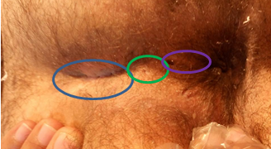
The average period of healing was nearly 1.5 month, with no recurrence reported after a period of follow up at least one year. This method of closure seems to be good & promising method in dealing with special entity.

