RUPTURED HUGE ECTOPIC SPLEEN: A CASE REPORT
Bayanduuren B*, Altankhuyag B, Enkhbayar D, Bulgan Ch, Mishigdorj L, Gonchigsuren D
Grand med Hospital, Ulaanbaatar, Mongolia
*Email: mgl_bayanaa@yahoo.com
Tel: +976-99454525
Abstract

RUPTURED HUGE ECTOPIC SPLEEN: A CASE REPORT
Bayanduuren B*, Altankhuyag B, Enkhbayar D, Bulgan Ch, Mishigdorj L, Gonchigsuren D
Grand med Hospital, Ulaanbaatar, Mongolia
*Email: mgl_bayanaa@yahoo.com
Tel: +976-99454525

Introduction: The occurrence of an ectopic spleen is relatively common and observed in 10-30% of autopsy patient. Ectopic spleen is found in 10-15% of the population, and even more prevalent in patient with hematological disorders. Usually, ectopic spleen is asymptomatic; torsion and infarction, rupture with bleeding, and infection with abscess are a very rare complication. Rupture of an ectopic spleen is extremely rare, and require prompt medical attention.
Case presentation: We report the case of 49 years, old female. Presenting with an upper recurrent abdominal pain and nausea, vomiting, dizziness. Pain is sudden onset presenting 5 days ago. Previous no pain and no history of family.
Blood examination: HGB=9 g/dl, RBC=3.10*10^³ U/l
Abdominal computed tomography: 8cm*5cm*4cm well defined homogenous lesion in middle abdomen adjacent in the stomach wall. Free blood in peritoneal cavity.
Exploratory laparotomy, ectopic splenectomy. Large ectopic spleen adjacent stomach wall to vascular pedicle. Ruptured ectopic spleen with hemoperitoneum.
Keywords: Ectopic spleen, rupture, hemoperitoneum, abdominal pain, posteriomedial positition

Introduction:
The ectopic spleen is a relatively common disorder and is diagnosed with 10-30% autopsy [1-2]. The population prevalence is 15% [1.5]. Ectopic spleens are often located on the left side of the human body, especially occurs in the spleen area (splenic hilum / 75%), 20% in the pancreatic tail and 5% in the pancreas, kidney and kidney gland [5.8]. Very rarely, it is diagnosed with ovaries, scrotum and mediastinum. The incidence of the outer wall of the stomach is rare [2-4]. Ectopic spleen is more likely to diagnose children and women 20 to 40 years old [1.5.9]. Moreover, splenectomy for treatment of a wandering spleen account for less than 0.25% of splenectomies in reported series [5-7]. Diagnosis of abdominal ultrasound and computed tomography (16%) [9-13].
Case presentation
Patient was a 49 years old women. On 7th of December 2018, Grand Med Hospital was sent to emergency department. Severe pain of upper middle abdomen followed vomiting and weakness, headache. Pain was sudden onset 5 days ago after loss of consciousness fallen due to syncope. She had no history of abdominal surgery or any other medical problems. Patient had to take advice from gynecology. Medication was not effective because analyzed abdominal contrast computed tomography. The patient had a not distended abdomen, discomfort on deep palpation, with peritoneal signs. Her white blood cell count was normal limits and reduced hemoglobin (Table 1). Esophagogastroduodenoscopy is normal limits (Figure 1). Abdominal computed tomography: Size 8 cm x 5 cm x 4 cm well defined homogenous lesion in middle abdomen adjacent in the stomach wall. Free blood in peritoneal cavity (Figure 2A-D).
CBC | Range | Result
WBC | /4-10*10³ U/l | 7.3*10³ U/l
HGB | /11.5-17.0 g/dl/ | 9 g/dl
RBC | /3.8-6.5*10³ U/l/ | 3.10*10³ U/l
PLT | /150-500*10³ U/l/ | 366*10³ U/l
HCT | /34-54%// | 27.6%
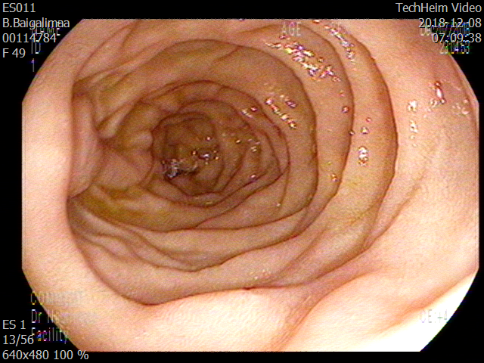
Table 1. Changes in complete blood count test Figure.1. Changes in upper gastrointestinal endoscopy

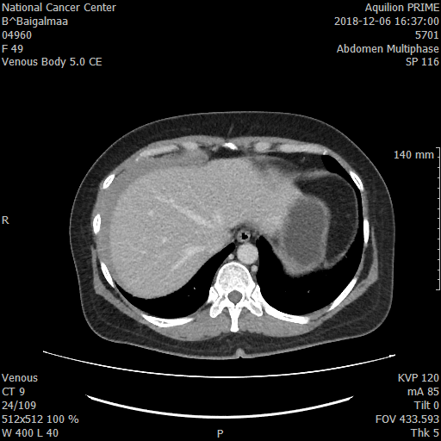
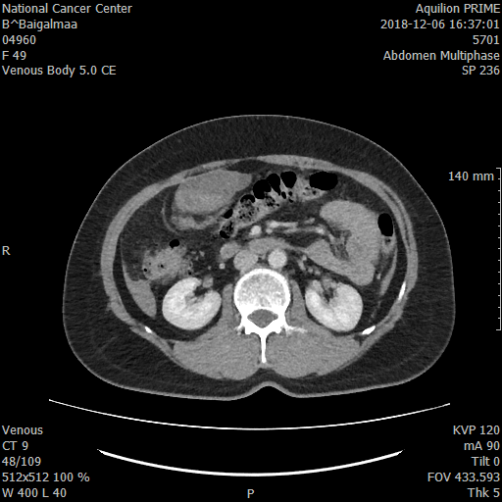
Contrast computed tomography abdomen:
Figure.2A. Free blood in peritoneal cavity /Haemoperitoneum/

Figure.2B. 8cm*5cm*4cm well defined homogenous lesion in middle abdomen adjacent in the stomach wall

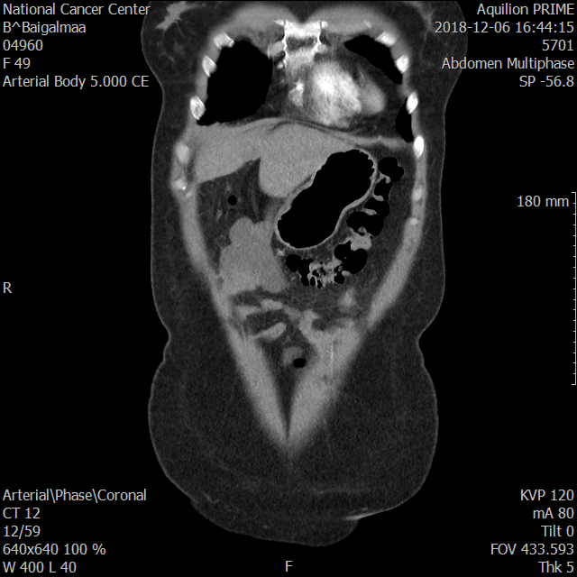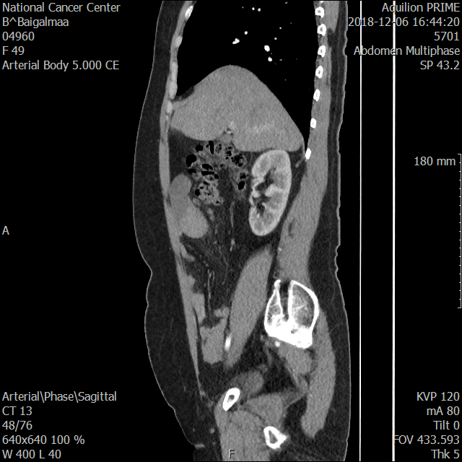
Figure.2C. Ectopic spleen /vascular pedicle/ Figure.2D. Ectopic spleen /ovoid shape/
Surgery process: We were the patient emergency exploratory laparotomy. During surgery, the ectopic spleen was size 8 cm × 6 cm × 3 cm (Figure 3E-F) located on the stomach wall connect by vascular pedicle ( Figure 3C ), ruptured ( Figure 3D) and hemorrhage (Figure 3F) with generalized hemoperitoneum (Figure 3A). We ectopic splenectomy was performed. Irrigation and drainage of abdominal cavity. During exploration normal abdominal cavity. Histology definition was ectopic spleen with circulatory disorders and hemorrhage (Figure 4). The patient was discharged on the eighth postoperative day without any complication.
Intraoperative figure:
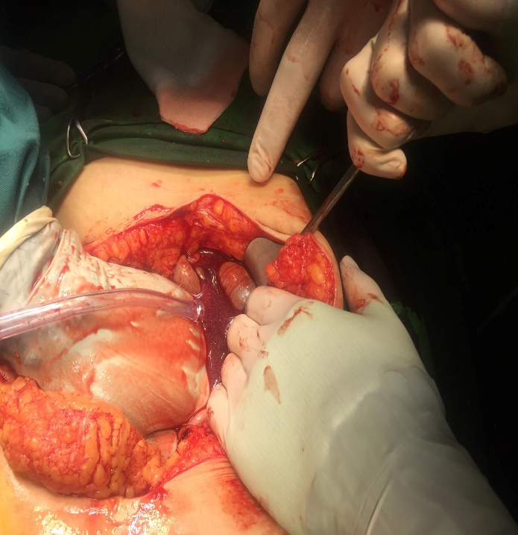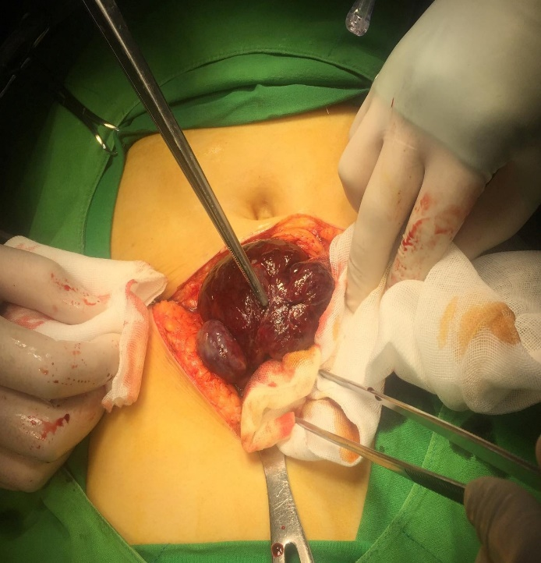
Figure 3A. Hemoperitoneum /arrow/ Figure 3B . Ectopic spleen
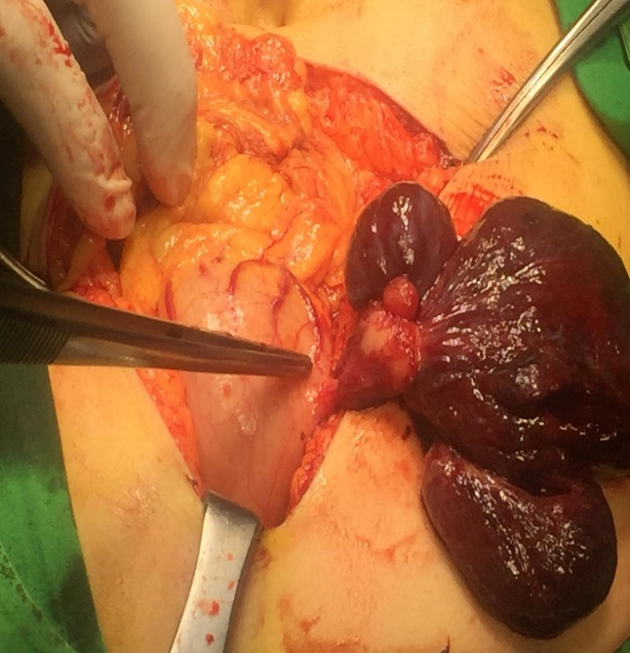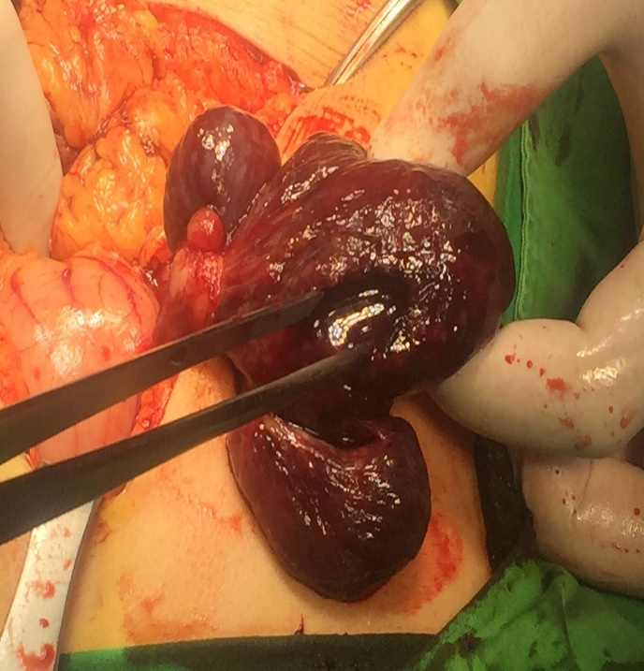
Figure 3C. Vascular pedicle of ectopic spleen Figure 3D.Ruptured ectopic spleen on the stomach wall
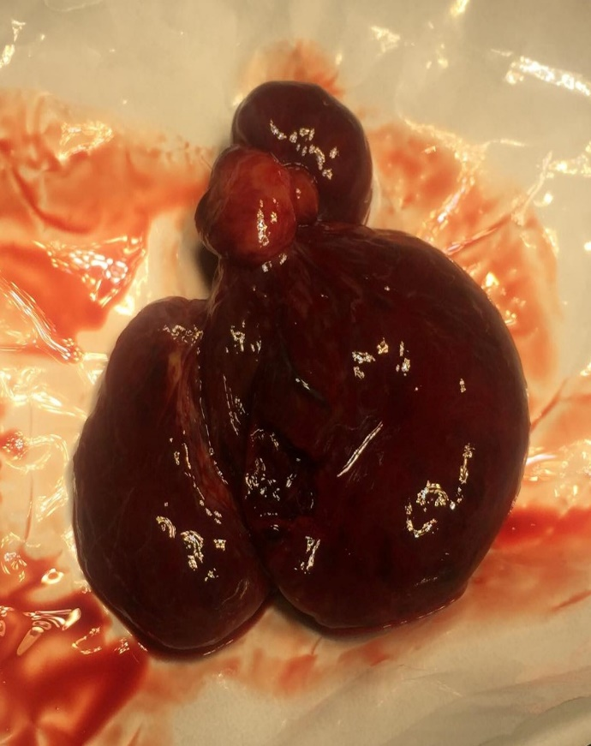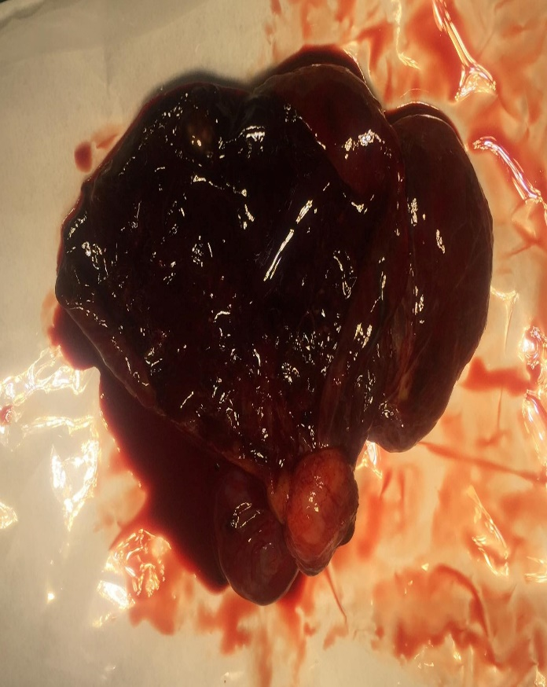
Figure 3E. Huge ectopic spleen Figure 3F. Huge ectopic spleen with hemorrage
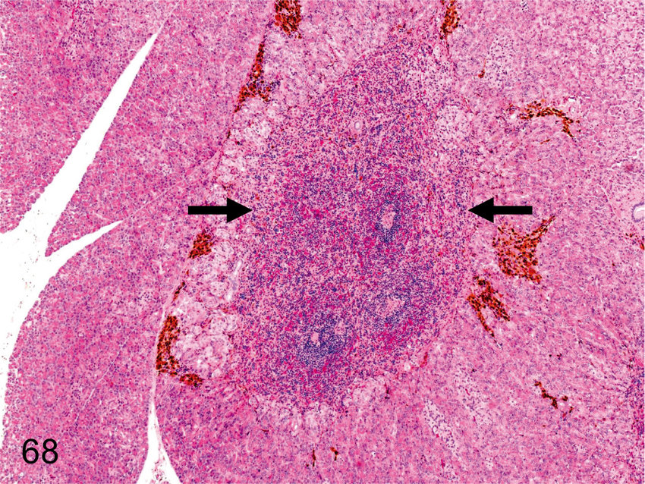
Figure 4. Ectopic spleen with circulatory disorders and hemorrhage
Discussion
We followed the methods of Konstantinos Blouhos et al. 2014.
Ectopic spleen is relatively rare disease [1-5]. This is found in 10-30% of patient at autopsy [3-8]. The population prevalence is 15% [1.5]. Ectopic spleens are often located on the left side of the human body, especially occurs in the spleen area (splenic hilum / 75%), 20% in the pancreatic tail and 5% in the pancreas, kidney and kidney gland [5.8]. Very rarely, it is diagnosed with ovaries, scrotum and mediastinum [9-14]. The incidence of the outer wall of the stomach is rare [2-4]. 500 cases of patients with recurrent abdominal pain or abdominal emergency caused by ectopic spleen have been reported in the literature [1.4]. The first case reports of ectopic spleen in a child was published in 1854 by the Polish physician Józef Dietl in the Polish journal [14]. The spleen arises during the fifth week of embryogenesis as the mesenchymal tissue in the dorsal mesogastrium [4-9]. Splenectomy for treatment of ectopic spleen account for less than 0.25% of splenectomies in reported series [5.7.10]. Ectopic spleen is 7 times more common in females than males after age 10 and 2.5 times more common in males than females under the age of 1 year [5-8.10]. The most common age of presentation is childhood especially under 1 year of age followed by the third decade of life, and is more frequently seen in females of reproductive age [3-7.12]. Koenraad J, Mortele in the study three hundred and thirty-four patients (198 female and 136 male) with a mean age of 47.18 years (SD 15.75), ranging from 13–82 years, were included in this study [9-13]. Out of 334 cases, 82 accessory spleens were detected in 63 patients (18.8%) fifty-six accessory spleens (68.3%) were of round shape, 20 accessory spleens (24.4%) were oval in shape, 5 (6.1%) were triangular, and only one single accessory spleen (1.2%) was heart shaped [5.9.11]. The maximum diameter range was 3–79 mm, with a mean diameter of 14.7 mm [6.8.13]. Our case was large size 8 x 6 x 3 cm and round shape [8-13]. We found out the worldwide open and laparoscopic ectopic splenectomy cases (Table 2-3).
Author | Age/sex | Clinical sign | Size Position
Mendi 2006 | 12/f | Left upper abdomenal pain | < 3 cm Splenic hilum
Yousef 2010 | 12/m | Left upper abdomenal acute pain | 3.5 cm Splenic hilum
Lhuaire 2013 | 66/m | Chronic abdomenal pain | 3 cm Greater omentum
Perini 2014 | 17/f | Asymptomatic | 6 cm Pelvic
Ozeki 2015 | 31/f | Left upper abdomenal pain | 3 cm Greater omentum
Table 2. Laparoscopic ectopic splenectomy cases.

Author | Age/sex | Clinical sign | Size Position
Valls 1998 | 13/f | Acute abdominal pain | 6 cm Pancreatic tail
Grinbaum 2005 | 21/f | Left upper abdominal pain | 9 cm Greater omentum
Yagmur2008 | 34/m | Upper abdominal pain | 10 cm Left colon
Impellizzeri 2009 | 12/m | Acute abdominal pain | 8.5 cm Mesentery
Ishibashi 2012 | 3/f | Right abdominal pain | 7 cm Greater omentum
Koichi 2015 | 5/m | Left lower abdominal pain | 8 cm Greater omentum
Table 3. Ectopic splenectomy cases using open technique.

Conclusion: Our surgical team were completely diagnosed by abdominal computed tomography before surgery. As a result of the surgery patient was completely healed and discharged from hospital. In our case was very large size and rare position and complication.
References:
- Halpert B, Gyorkey F. Lesions observed in accessory spleens of 311 patients. Am J Clin Pathol.
- King CR, Mansuria S. Pelvic pain in the presence of wandering spleen. J Minim Invasive Gynecol2013; 20:549–50
- G. Gayer, R. Zissin, S. Apter, E. Atar, O. Portnoy, and Y. Itzchak, “CT findings in congenital anomalies of the spleen,” British Journal of Radiology, vol. 74, no. 884, pp. 767–772, 2001.
- Fonseca A.Z., Ribeiro M., Jr., Contrucci O. Torsion of a wandering spleen treated with partial splenectomy and splenopexy. J Emerg Med. 2013; 44:33–36.
- A. Budzynski, A. Bobrzynski, T. Sacha, A. Skotnicki Laparoscopic removal of retroperitoneal accessory spleen in patient with relapsing idiopathic thrombocytopenic purpura 30 years after classical splenectomySurg. Endosc., 16 (2002), p. 1636
- I. Hayward, R.E. Mindelzun, R.B. Jeffrey Intrapancreatic accessory spleen mimicking pancreatic mass on CT J. Comput. Assist. Tomogr., 16 (1992), pp. 984-985
- Mortele KJ, Mortele B, Silverman SG. CT features of the accessory spleen. Am J Roentgenol. 2004;183(6):1653–1657.
- Wadham BM, Adams PB, Johnson MA. Incidence and location of accessory spleens. N Engl J Med 1981; 304:1111.
- Halpert B, Gyorkey F. Lesions observed in accessory spleens of 311 patients. Am J Clin Pathol 1959; 32:165–8.
- Arra A, Ramdass MJ, Mohammed A, et al. Giant accessory right-sided suprarenal spleen in thalassaemia. Case Rep Pathol 2013;2013: 269543.
- Leon L, Labropoulos N, Hudlin CI, et al. Accessory spleen rupture in a patient with previous traumatic splenectomy. J Trauma 2006; 60:901–3.
- Halpert B, Alden ZA. Accessory spleens in or at the tail of the Pancreas. A survey of 2,700 additional necropsies. Arch Pathol 1964; 77:652–4.
- Wacha M, Danis J, Wayand W. Laparoscopic resection of an accessory spleen in a patient with chronic lower abdominal pain. Surg Endosc 2002; 16:1242–3
- Lane TM, South LM (1999) Management of a wandering spleen. J R Soc Med 92:84–85

Contact us
Grandmed hospital, 11 khoroo zaisan, Khan-uul district, Ulaanbaatar, Mongolia

Mgl_bayanaa@yahoo.com- Bayanduuren B /author/
Alt_iverson03@yahoo.com- Altankhuyag B
d.enkhbayr@gmail.com- Enkhbayar D
chbulgan0105@yahoo.com- Bulgan Ch
Maraa_l@yahoo.com- Mishigdorj L
mongolia.radiology@gmail.com- Gonchigsuren D

