The use of modified glove abdominal flap for the reconstruction of contracture following burns of the hand: a case report.
Puti Adla Runisa, MD. BMedSc, Almahitta Cintami Putri, MD
Division of Plastic Surgery, Faculty of Medicine University of Indonesia/Faculty of Medicine University of Padjadjaran,
Hasan Sadikin Hospital Bandung, Indonesia

Abstract
Introduction. Post burn hand contracture has always been a challenge for most Plastic surgeon for its acquired functional disabilities and deformity. Surgical reconstruction is often necessary, and pose a significant challenge for an esthetic and functional improvement.
Case Presentation. A 39 years old male patient with a contracted bilateral hand, 8 months post burn injury presented at our hospital. A multiple series of surgery was performed in this patient, consisting of released contracture, defect closure using series of skin graft, and a modified “glove like” thin abdominal flap in different surgeries. A rehabilitation program was performed 2 years following his surgery, and no post operative complication were seen in this patient. The aim of the reconstruction was to regain his independency in performing daily activities.
Conclusion. The use of modified glove abdominal flap technique can be an option in the reconstruction of contracted hand following burn giving a partial return of hand function and acceptable esthetic result, resulting in the ability to being independent in performing his daily basis activity.

Keywords: glove, thin, abdominal, flap, contracture, burn, hand.

Images

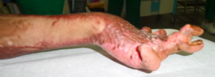
Pre operative dorsal hand contracture with minimum range of motion

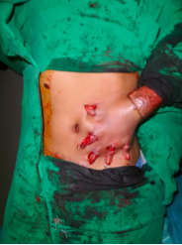
Modified “glove like” thin abdominal flap

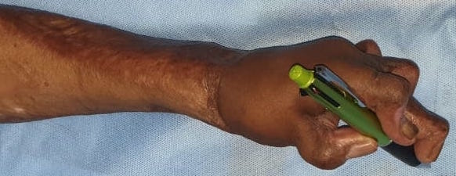
Post release contracture and defect closure with glove like flap
Recent Publications
- Urushidate S, Yotsuyanagi T, Yamauchi M, Mikami M, Ezoe K, Saito T, Yokoi K, Ikeda K, Higuma Y, Shimoyama M. Modified thin abdominal wall flap (glove flap) for the treatment of acute burns to the hands and fingers. Journal of Plastic, Reconstructive & Aesthetic Surgery. 2010 Apr 1;63(4):693-9.
- Yongwei P, Jianing W, Junhui Z, Guanglei T, Wen T, Chun L. The abdominal flap using scarred skin in the treatment of postburn hand deformities of severe burn patients. The Journal of hand surgery. 2004 Mar 1;29(2):209-15.
- Gousheh J, Arasteh E, Mafi P. Super-thin abdominal skin pedicle flap for the reconstruction of hypertrophic and contracted dorsal hand burn scars. Burns. 2008 May 1;34(3):400-5.
- Anita NH, Pandey SD. Semilunar abdominal bipedicled flap for cover of dorsal defect of the hand. Br J Plast Surg 1976;29: 129e31.
- Donelan MB. Reconstruction of the burned hand upper extremity. In: McCarthy JG, May JW, Litter J, editors. Plastic surgery. 1st ed., Philadelphia: W.B. Saunders; 1990. p. 5460–1.



Biography
Puti Adla Runisa, MD. BMedSc, is on her last year of residency in Plastic reconstructive and esthetic surgery at the University of Indonesia, Jakarta/University of Padjajaran, Bandung. She conceived her bachelor of medical science degree in Melbourne University, and has a particular interest in modalities defect closure reconstruction.

Email:putiadlarunisa@gmail.com

Notes/Comments:

