Solid pseudopapillary neoplasm of the pancreas in a fourteen-year-old: A case report

Vivien Marie P. Abitong, M.D., ITRMC, Philippines
Cesar S. Bernabe, M.D., ITRMC, Philippines
Alexander S. Quilaton, M.D., ITRMC, Philippines

Abstract

Solid pseudopapillary neoplasm of the pancreas is a rare but disparate neoplasm previously thought of as a non-functioning islet cell carcinoma comprising about 0.13 to 2.7% of all pancreatic tumors, primarily affecting women aged twenty to thirty. Presenting features are non-specific. Its natural course is not yet fully established due to the limited studies and the indolent course of these tumors. Our case is that of a fourteen-year-old female who was admitted due to chronic abdominal pain for two months. Ultrasonography and computed tomography showed a well-circumscribed mixed-density cystic mass within the pancreatic caput and neck. She underwent pancreaticoduodenectomy where reconstruction was done by doing a pancreaticojejunostomy, cholecystojejunostomy and pyloric-sparing gastrojejunostomy. Post-operative course was unremarkable with a Clavein-Dindo Classification grade of I. She followed-up four months after the procedure and was doing well. No recurrence of tumor was noted on repeat ultrasound and tomography. Histopathology report confirmed the diagnosis of solid pseudopapillary neoplasm.

Solid pseudopapillary neoplasm of the pancreas is a rare neoplasm with an excellent long-term prognosis after surgical resection. A high index of suspicion is warranted in any patient presenting with abdominal pain non-responsive to pain medications especially in females under 35 years of age. Correct preoperative diagnosis of the tumor is crucial to minimize the range of surgical ablation compared to that required for pancreatic malignancy. Surgical resection is curative with more than 95% and 100% 5-year and 10-year survival rate, respectively.
Figure 1. Computed tomography of SPN. A well-circumscribed mixed-density cystic mass containing non-dependent poorly enhancing solid components with thick irregular and enhancing rim within the pancreatic caput and neck

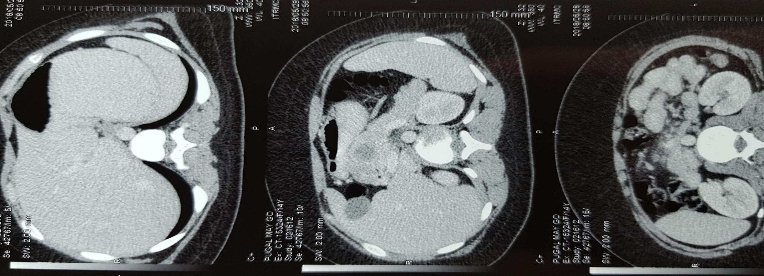
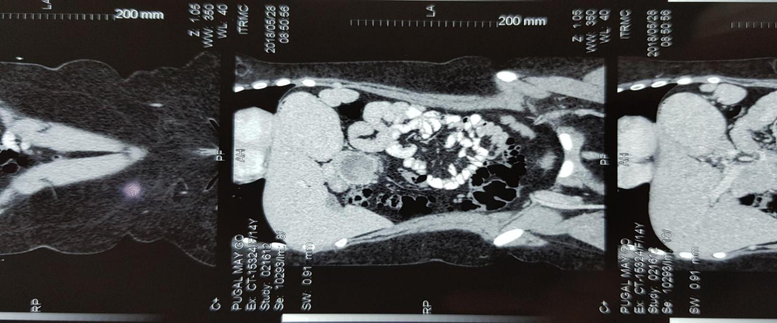

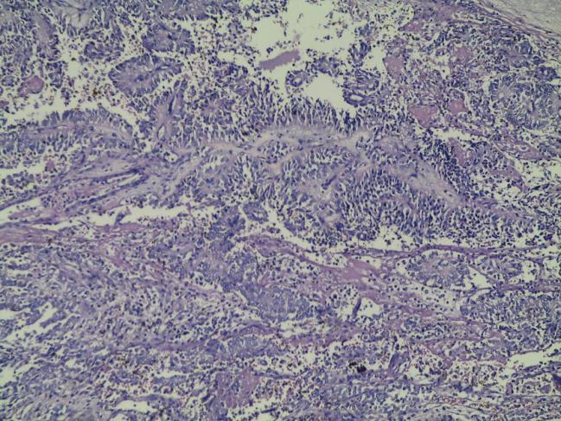
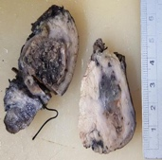
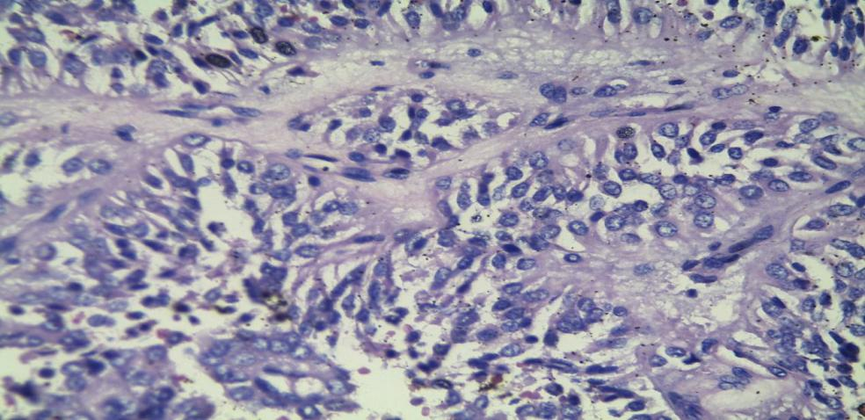
Figure 2. Pancreatic mass showing solid, variegated, yellow-tan tissue with hemorrhagic foci and and necrosis; B. Epithelial cells in papillary architecture, LP view; C. HP view.

B
A
C

Recent Publications

- Bochis O, Bota M, Mihut E, Buiga R, Hazbel D, Irimie A. Solid pseudopapillary tumor of the pancreas: clinical-pathological features and management of 13 cases. Clujul Medical Vol.90, No.2, 2017: 171-178

- Dinarvand P, Lai J. Solid Pseudopapillary Neoplasm of the Pancreas: A Rare Entity With Unique Features. Arch Pathol Lab Med—Vol 141, July 2017.Arch Pathol Lab Med. 2017;141:990–995

- Kumar N, Bhandare M, Chaudhari V, Sasi S, Shrikhande S. Analysis of 50 cases of solid pseudopapillary tumor of pancreas: Aggressive surgical resection provides excellent outcomes. European Journal of Surgical Oncology xxx (2018) 1e5.

- Li DL, Li HS, Xu YK, Wang QS, Chen RY, Zhou F. Solid pseudopapillary tumor of the pancreas: clinical features and imaging findings. Clinical Imaging 48 (2018) 113–121. http://dx.doi.org/10.1016/j.clinimag.2017.10.006

- Utturkar A, Yu Z, Lawrence C. Solid pseudopapillary tumor of the pancreas: A difficult presentation of an uncommon tumor. Radiology Case Reports 13 (2018) 1104 – 1107.

