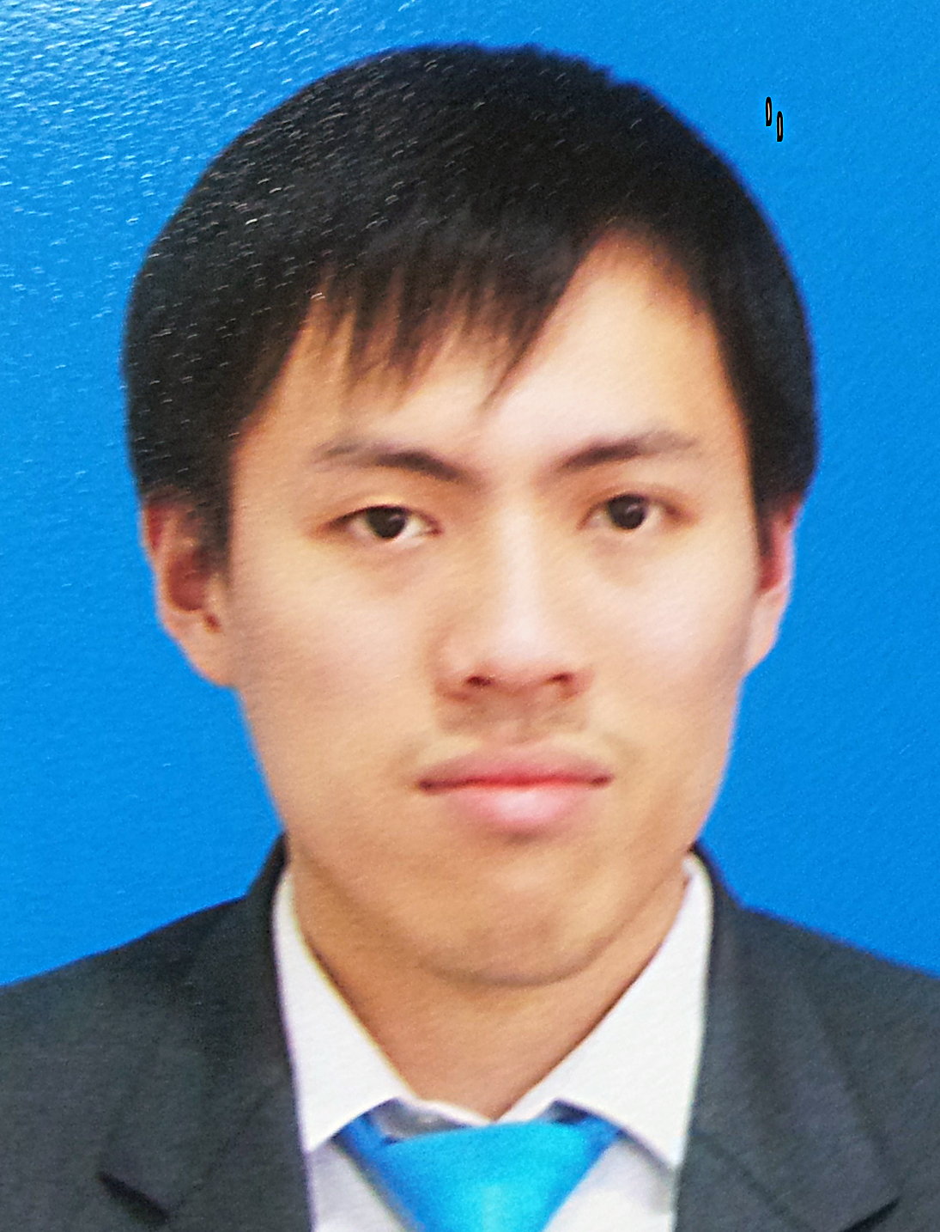

Title Delay to systemic chemotherapy; survival and recurrence in patients of rectal cancer treated with neoadjuvant chemoradiotherapy and surgery.

Name: Da Wei Thong
Gold Coast University Hospital, Gold Coast, Australia

Aims
The aim is to investigate if delay to systemic chemotherapy will it lead to growth of micrometastasis, therefore higher likelihood of distant recurrence in patients with stage II-III rectal cancer treated with neoadjuvant chemoradiationtherapy(CRT) and surgery. Overall survival(OS) and disease free survival(DFS) are outcomes of interest as well.
Methods
A single tertiary centre retrospective cohort study over a 5-year period between January 2012 to December 2016 was performed. Operative data for rectal cancer surgery were obtained and compared with patients’ electronic medical records(EMR) by investigators to recruit patients into the study. Delay to adjuvant CRT was define as more than 5 months. Time to event analysis were conducted.
Results
A total of 116 patients with rectal cancer were identified. 72 patients were ineligible due to having primary resection and metastatic disease on diagnosis, leaving 44 patients for final analysis. Mean time from diagnosis to adjuvant systemic chemotherapy was 6.5 months. 5 patients were assigned to the non-delay group and 39 patients to the delay group. Distant recurrence rates were none in the non-delay group compared to 20.5% in the delay group. Five-year OS rates were 100% and 92.0% respectively (p=0.52) Five-year DFS rates were 100% and 79.2% respectively (p=0.28).
Conclusion
Due to the small sample size, this study was unable to draw a significant result. However, a trend of delay to adjuvant systemic chemotherapy, leading to an increase in distant recurrence rates was observed.

Biography
Dr Da Wei Thong completed his medical degree (MBBS) at Monash University, Australia in 2013. Dr Thong is currently pursuing a Master (MSc) in Surgical Sciences with University of Edinburgh, UK and is in his final year of study. He is currently working as an unaccredited surgical registrar at Gold Coast Health, Australia. His main clinical interests lie in General Surgery. He is affiliated with Griffith University as a lecturer to medical students and is an active advocate of surgical research works. He had previously published and presented in conferences in Asia.
Presenting author details
Full name: Da Wei Thong
Contact number: 61432058359
Twitter account:
Linked In account: https://www.linkedin.com/in/da-wei-thong-86057570/
Session name/ number:
Category: Poster presentation

