VASCULARIZED LYMPH VESSEL TRANSFER WITH SUPERMICROSURGICAL
ULTRA-THIN SUPERFICIAL CIRCUMFLEX ILIAC ARTERY FLAP FOR TREATMENT OF ADVANCED LYMPHEDEMA NOT TREATABLE WITH SUPERMICROSURGICAL LYMPHATICOVENULAR ANASTOMOSIS

Wei F. Chen, Mindy Bowen, Maria McNurlen, Johnson Ding

Abstract
Lymphaticovenular anastomosis (LVA) and vascularized lymph node transfer (VLNT) are established supermicrosurgical and microsurgical treatments for lymphedema and are increasingly being performed around the world. They, however, each have their own limitations. Due to its requirement of healthy lymph vessel, LVA is contraindicated in advanced diseases in which sclerotic lymph vessels are expected. VLNT, while generally considered appropriate for advanced disease without elephantiasis, puts patients at risk of donor-site lymphedema, and frequently creates unsightly bulges at the recipient site that requires secondary debulking. Vascularized lymph vessel transfer (VLVT) based on the first dorsal metatarsal artery (FDMA) was proposed by Koshima et al. as an alternative to LVA and VLNT that resolves the problems associated with both. Taking advantage of the recent advancement in supermicrosurgery, we developed a novel VLVT technique and we described our initial experience in a case report.

Surgical Technique
After mapping the groin superficial lymph vessels with indocyanine green (ICG) lymphography, the lymph vessels were included in the standardly designed superficial circumflex iliac artery (SCIA) perforator flap (Fig 1). The inferior exploratory incision was made first. The flap was elevated along a non-anatomic plane superficial to the Scarpa fascia to create an ultra-thin 3 – 4 mm flap (Fig 2, 3). Both superficial and deep branches of the SCIA were dissected although the superficial branch was preferentially used. After confirming adequate SCIA perforators, the superior skin incision was committed. The vascular pedicle was dissected until adequate length was achieved. Upon completion of flap elevation, ICG lymphography was repeated to confirm harvest of lymph vessels and preservation of groin lymph nodes (Fig 4). The flap was then transferred to distal aspect of the affected limb and vascular anastomosis was performed (Fig 5). The SCIA was frequently < 0.8 mm, especially when ligated distal to its origin from femoral artery, and therefore end-to-side anastomosis was frequently necessary to overcome size discrepancy between the blood vessels.

Case Presentation
41-year-old female with post-mastectomy, Campisi stage III lymphedema with severe lymphatic injury confirmed on ICG lymphography presented to our center seeking LVA. The extent of her lymphatic injury contraindicated LVA and she strongly objected VLNT. Therefore, VLVT was offered. Surgery was completed uneventfully. Patient was discharged on postoperative day four. Almost immediately following the surgery, she experienced immediate relief of pain, tightness, and numbness. She experienced progressive improvements over the next six months demonstrable on circumference measurement, bioimpedance spectroscopy, lymphedema-Q, and ICG lymphography.

Conclusion
Our preliminary experience of SCIA-based VLVT is highly favorable. This technique resolves limitations/problems associated with LVA and VLNT. Its clinical efficacy raises the question whether harvesting lymph nodes are necessary to treat lymphedema. Further investigation is necessary and is underway.

FIGURE 1
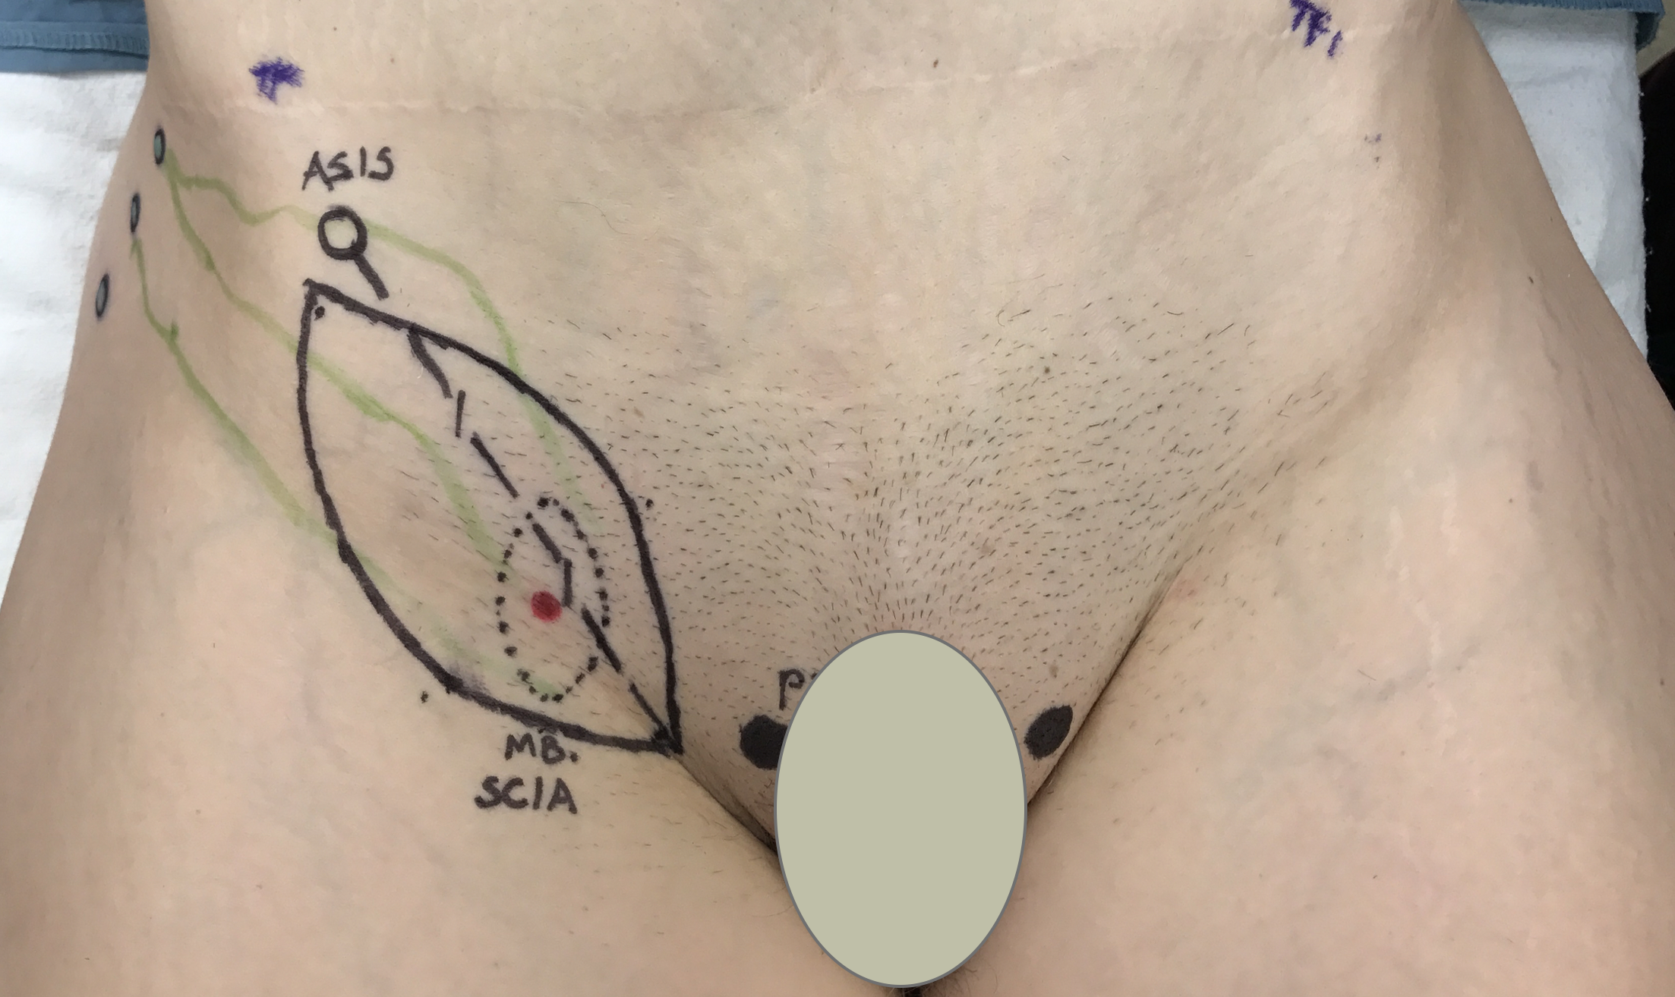

FIGURE 2
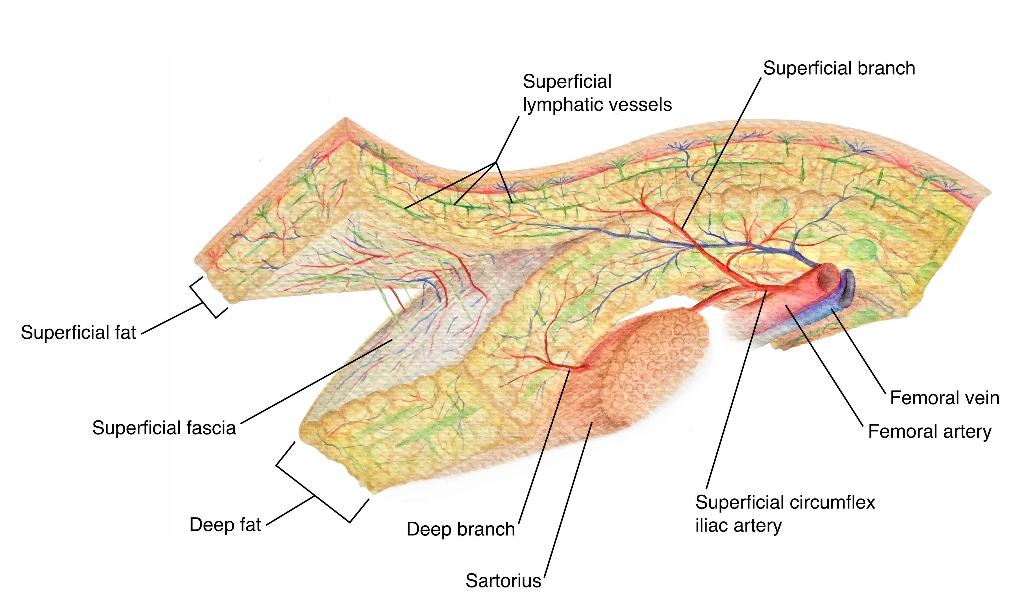

FIGURE 3
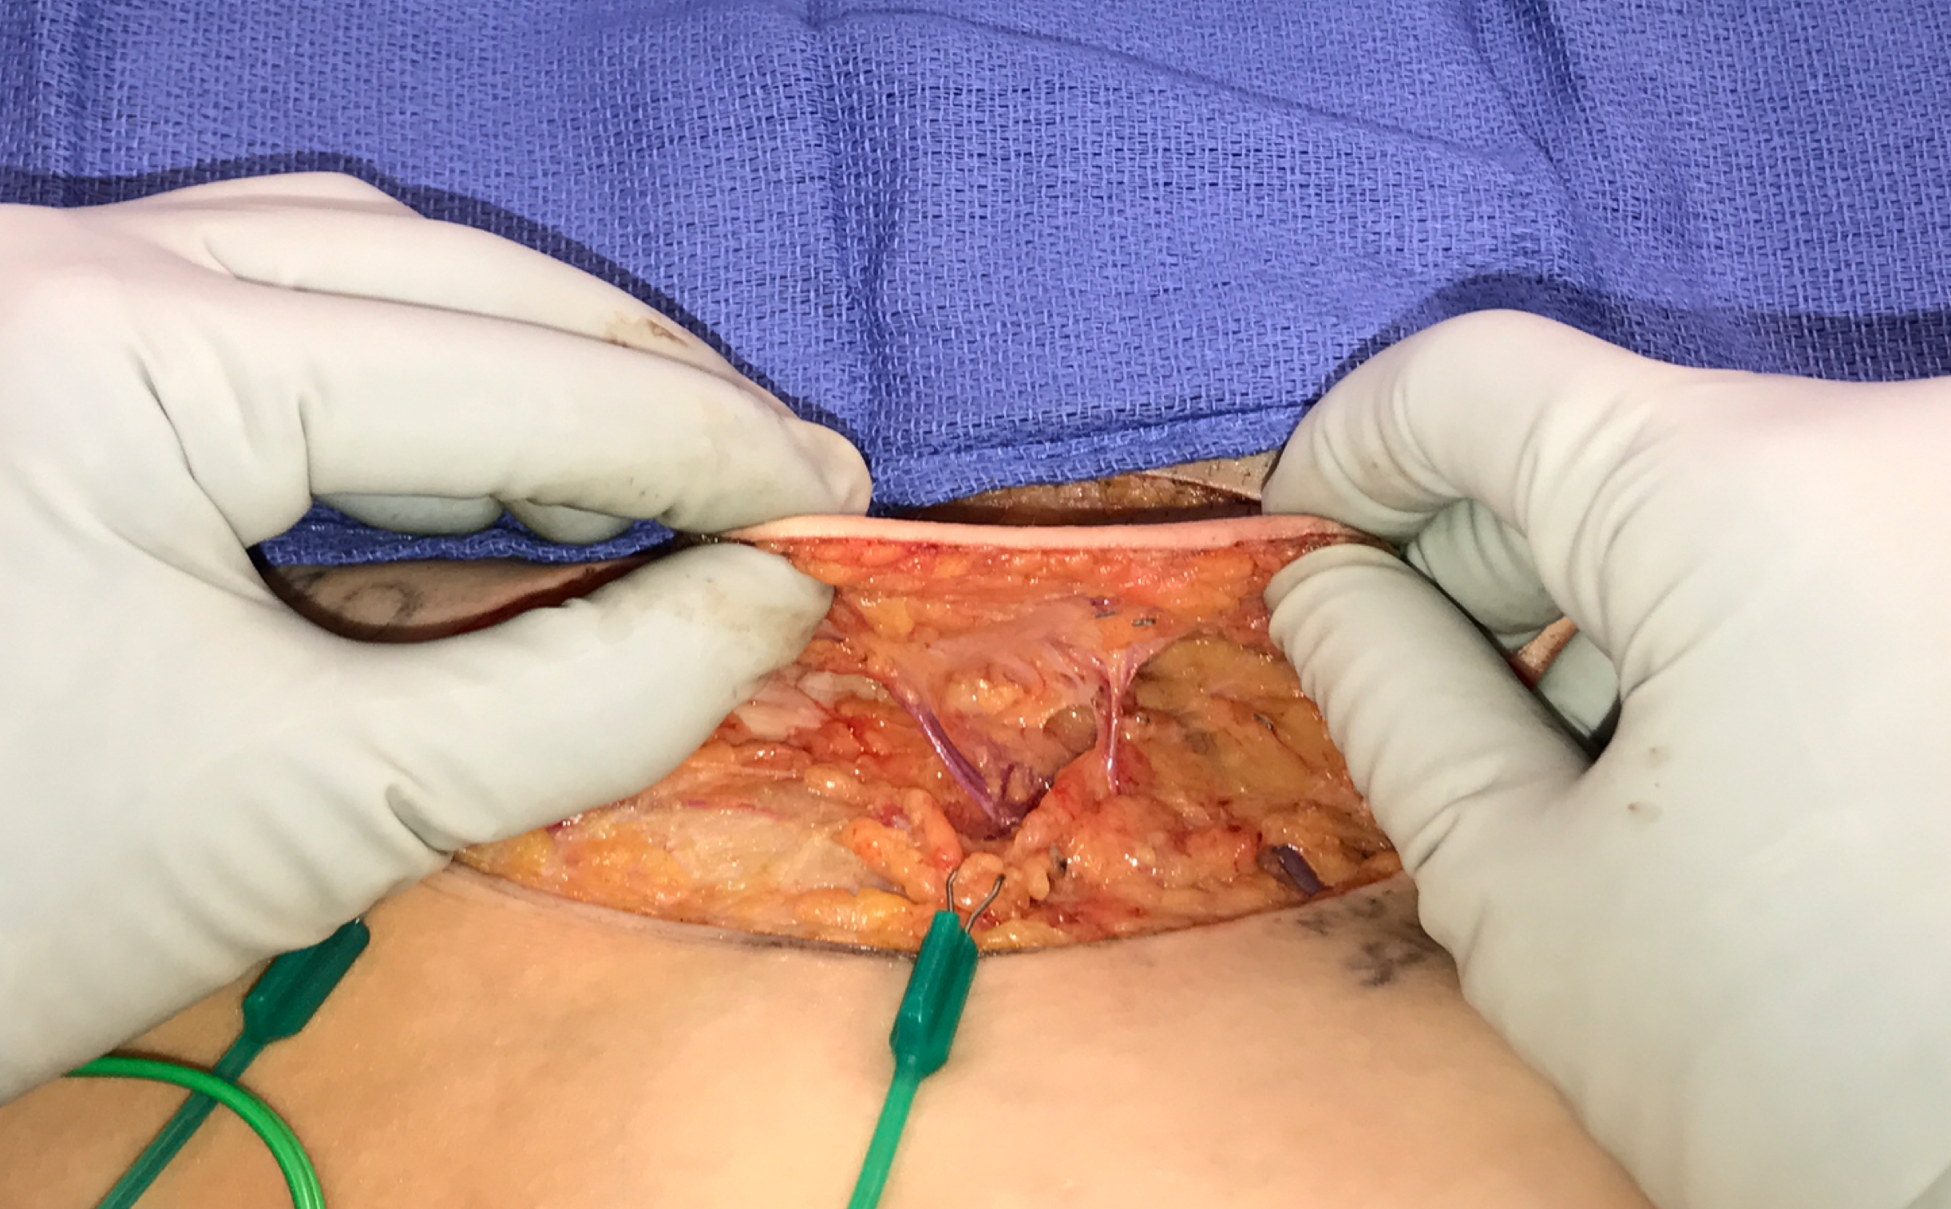

FIGURE 4
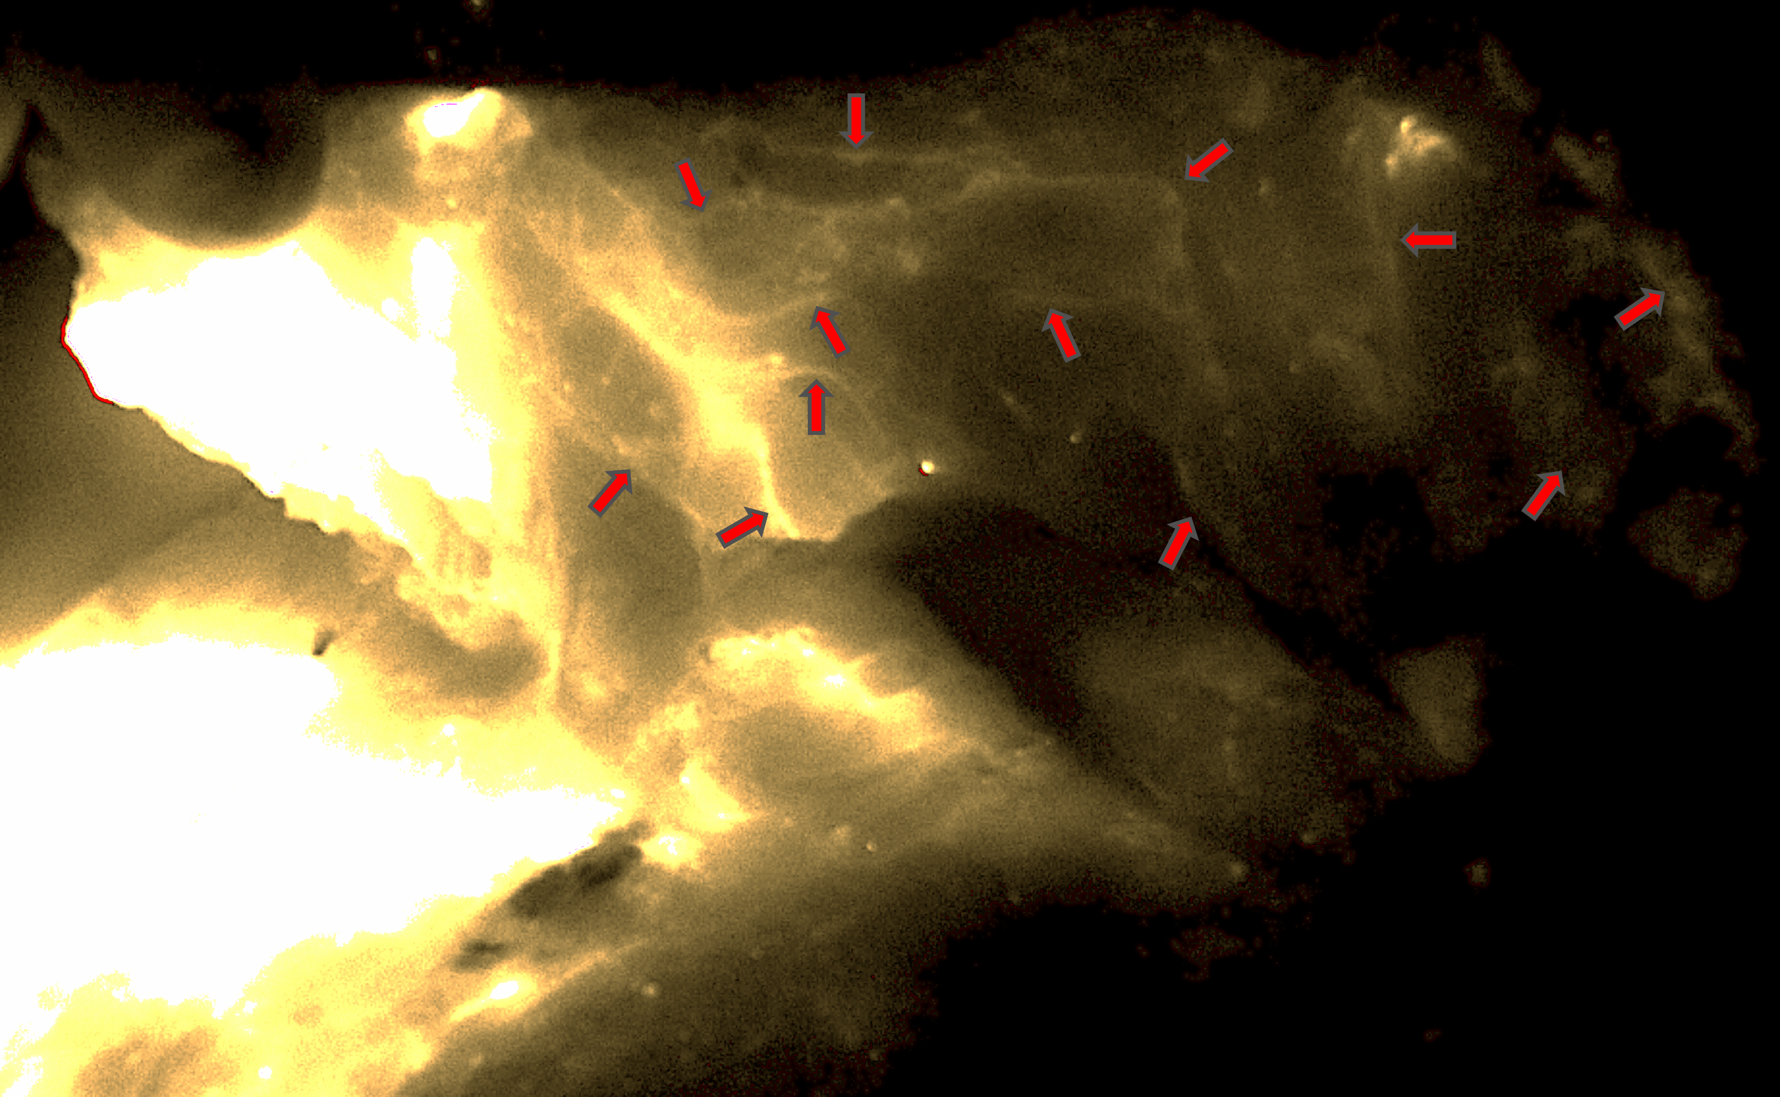

FIGURE 5
