Title: An Unusual Case Report: Right sided Bochdalek Hernia with intestinal obstruction in Adult
Safia Z Ahmed¹, Noor ul Mubeen², Humad Naeem Rana³, Dawood Morad⁴
1.Dr. Safia Z Ahmed, MBBS, FCPS, MRCS
2.Dr Noor ul Mobeen, MBBS, FCPS
3.Prof.Humad Naeem Rana. MBBS, FCPS
4.Dr Dawood Murad, MBBS, FCPS trainee
1,3-4-Department of General Surgery, Shalamar Medical and Health Sciences, Shalamar Hospital, Lahore, Pakistan
2- Department of surgery Services Hospital, Lahore Pakistan

Abstract:
Introduction: Bochdalek hernia is one of the commonest types of congenital diaphragmatic hernia in neonates with clinical presentation of respiratory features. Conversely, it is rare in adults with a prevalence of less than 6% of all diaphragmatic hernias and less than 20 cases been reported of right sided bochdalek hernia in the literature and even extremely rare that containing colon.
Case Presentation: We represent a case of 57-year-old woman with symptomatic bockdalek hernia and had a medical history of interstitial lung disease for 5 years due to respiratory features. She presented in emergency with intestinal obstruction which was diagnosed on computed tomography and found herniation of right lobe of liver with hepatic flexure of colon into thoracic cavity with obstruction of colon as well as gastric pylorus and first part of duodenum along with gall bladder. An exploratory laparotomy was performed, incarcerated colon was reduced through the defect of right diaphragm and right hemi colectomy was performed due to gangrenous patches on ascending colon. Whole of right lobe of liver along with gallbladder was also herniated into right thoracic cavity, which was returned into abdominal cavity and rent in the diaphragm was repaired by primary sutures. Patient required intensive care, initial she recovered but later deteriorated due to weak respiratory functions.
Conclusion: Although right sided bochdaleck hernia is extremely rare in adults and can be misdiagnosed due to non-specific sign and symptoms but should be suspected and investigated, as to prevent a delay in diagnosis which can increase the risk of mortality and treated appropriately to avoid complications.

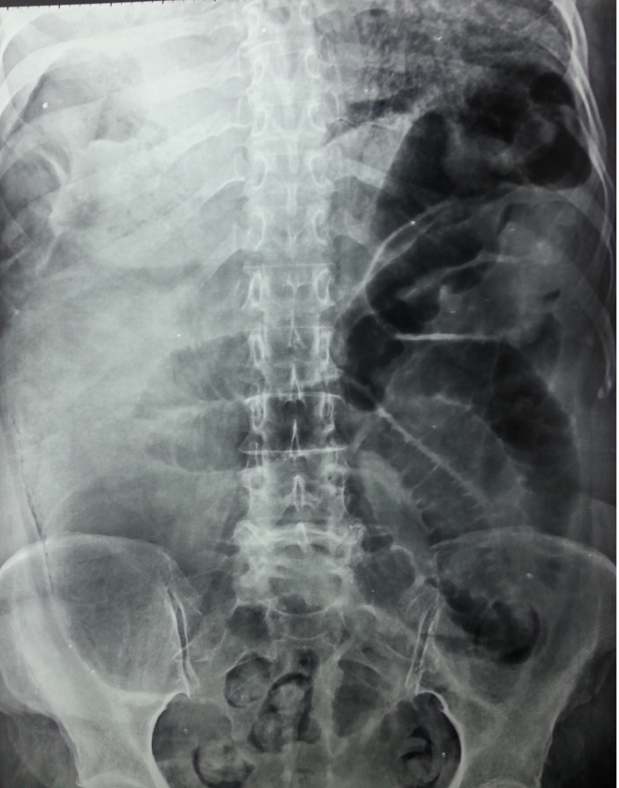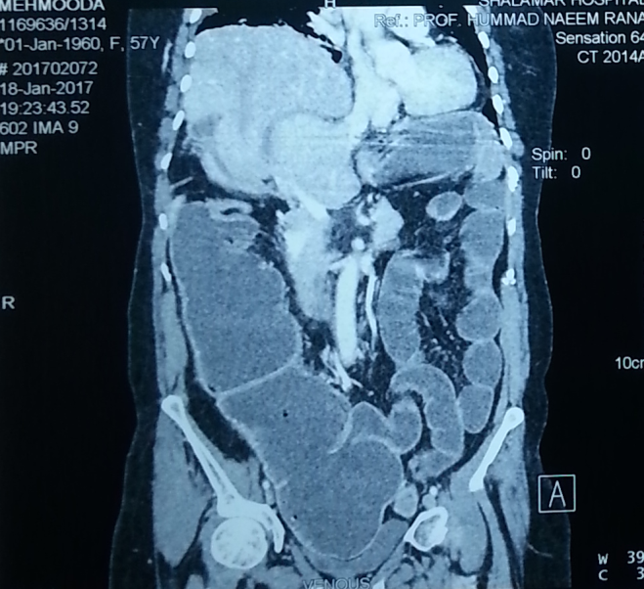
Fig 1. X ray showing left sided dilated bowel with right sided bowel in thoracic cavity(L) and CT scan shows obvious liver herniation in right thoracic cavity(R).
Recent Publication:1. Inflammatory Fibroid Polyp: A rare cause of Small intestinal obstruction due to intussusception. Professional Med J 2019;26(4).
2.Hemorrhoidectomy in patients with Grade III and IV disease: Harmonic scalpel vesus conventional technique (Accepted for submission)
3. Comparison study: Ligasure versus Conventional Hemorrhoidectomy in III and IV-degree Hemorrhoids (under external peer review awaited)
4. Comparison of outcomes after laparoscopic versus open Appendectomy in Acute Appendicitis (Paper submitted)

Recent Photograph:
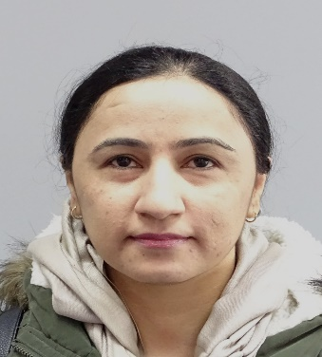
Biography:
Safia Zahir Ahmed, has qualified her primary medical school in 2010 from Bolan Medical College Pakistan. With interest of surgery, soon after finishing internship in medicine and allied and surgical and allied for a year she started her career in surgery working as post graduate surgical trainee in General surgery from 2012 to 2016.She did her postgraduation from College of Surgeons and Physician, Pakistan. Meanwhile, she completed her MRCS and became a member of Royal college of Surgeons Edinburgh in 2016. After working for one and half year as senior registrar in Pakistan, she moved to United Kingdom for further exposure and polish her career in Surgery. With this mindset in surgery and passion for surgical sciences, she has actively involved in prospective study projects which are waiting for publication and presentation in local institute levels. She is looking forward for opportunities for oral and poster presentation at international level.
Email:zahir.safia@hotmail.com

