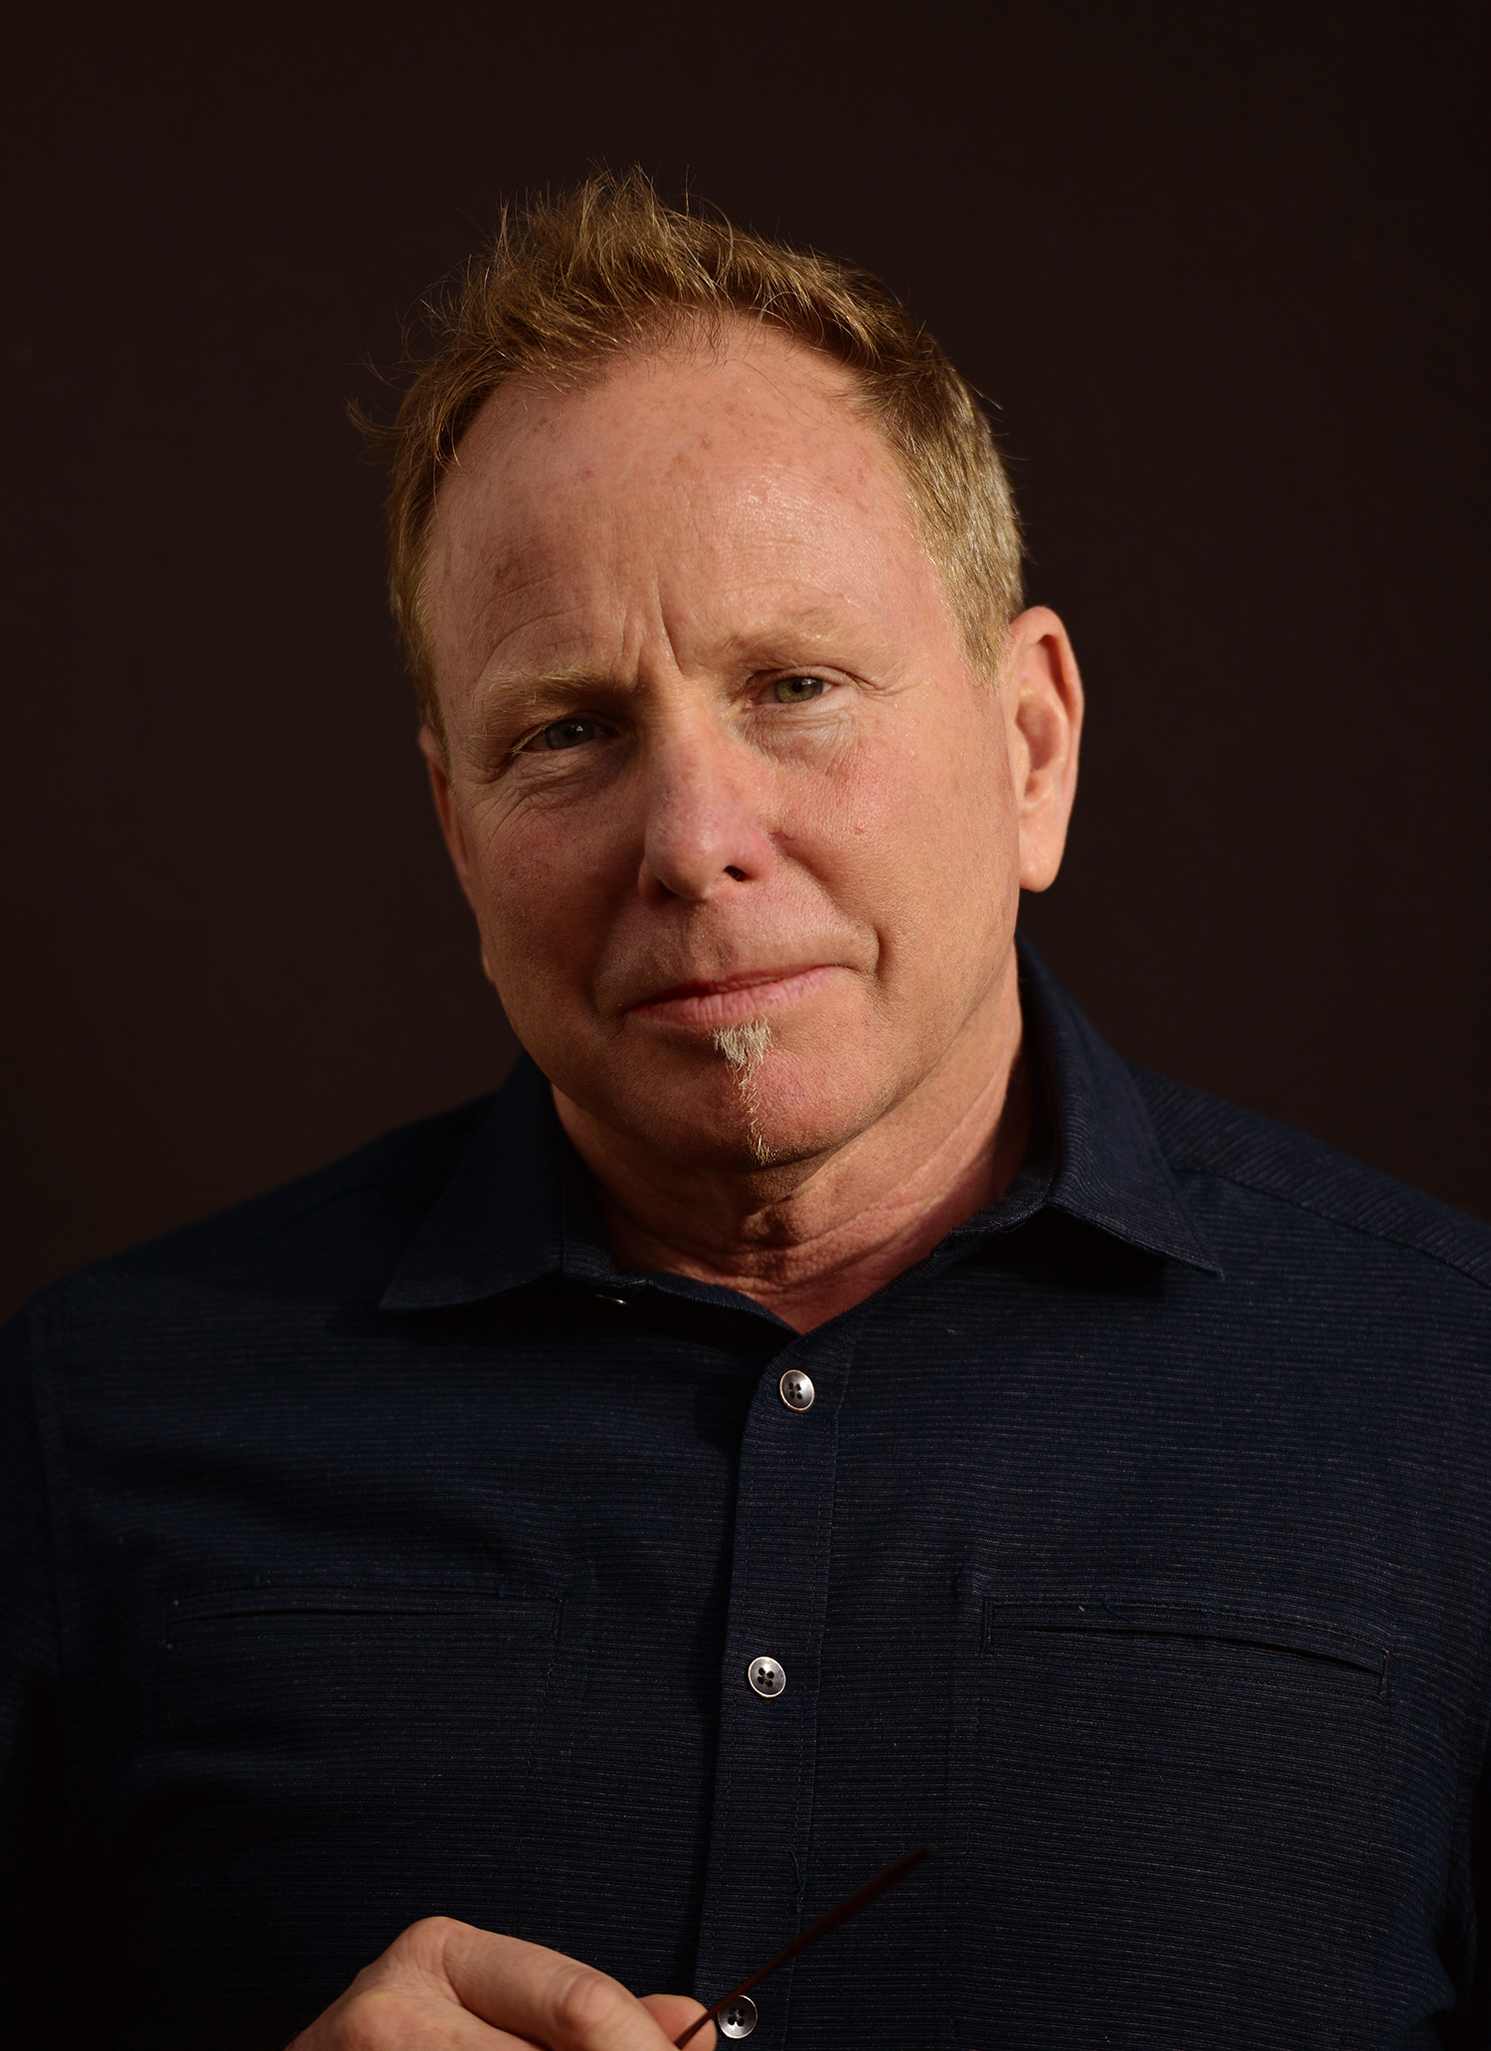
Title: Surgeon-Centered Design: The Future of Surgical Robotics

Name: David P. Moore
Principal, Zero Nine Design, LLC, San Francisco CA 94965

Section 1: Current Surgical Robotic Systems
Current Surgical Robotics Systems are obsolete. There is no longer any reason a highly trained, experienced Surgeon should be conforming to a physical device. Even the latest in robotic assisted devices require the surgeon to adapt to the technology, removed from the surgical site and the team, sitting on a forty-dollar stool in the corner.

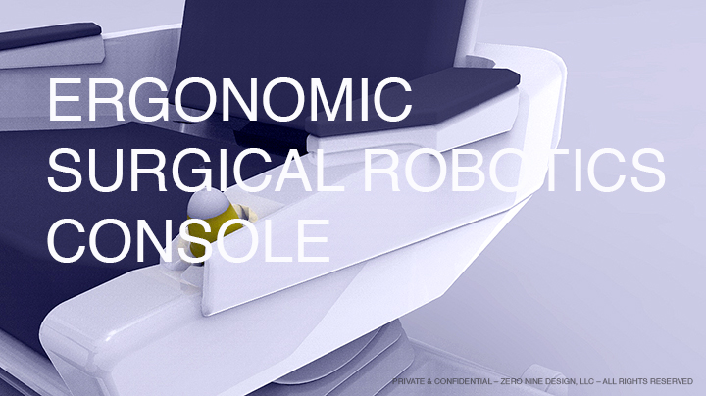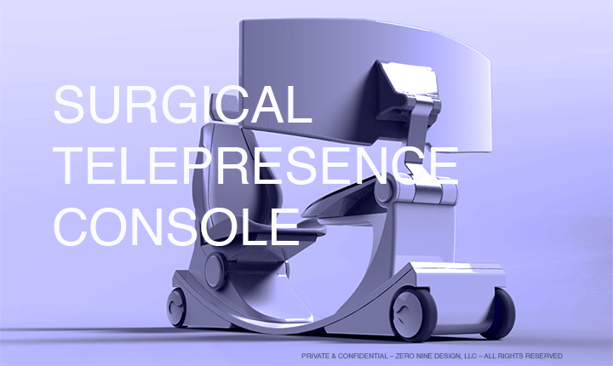

Section 2: Cultural Shifts, The Paradox of Innovation
Cultures run deep, especially the highly technological cultures found in our brilliant, cutting-edge Surgical Robotic engineering teams. Paradigms dissolve and obsolete structures fade, this is and will happen in Surgical Robotics. New ideas require cultural shifts to be accepted, otherwise you’re in a battle, a power struggle of the known – how we’ve always done it – and the unknown, – how it could be. Cultural shifts require a new view, new perspective that begins human-centered design principals.

Things Getting Better: Historians use the term, “The Theory of Rising Expectations” to explain when and why cultures and societies shift. It states, cultures don’t make changes when conditions are bad, they make changes when they realized things can be better.

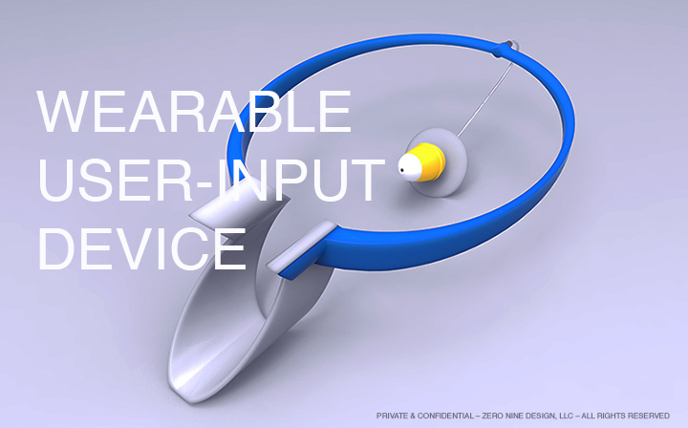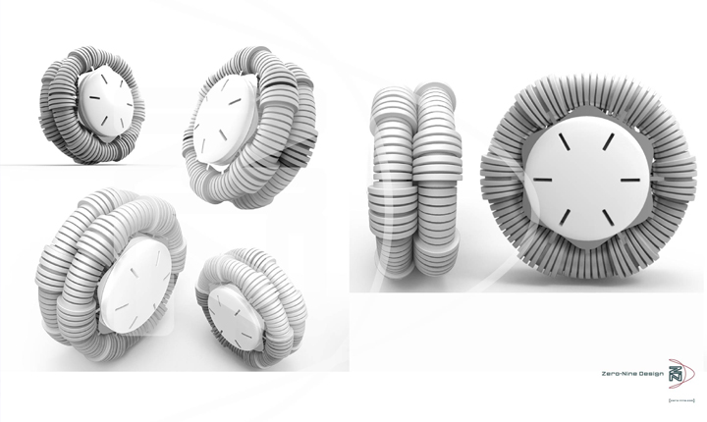

Section 3: Surgeon-Centered Design, began as a term I created to shift the perspective. After months designing concepts, building prototypes and meeting with surgeons from around the world I realized the surgeon was the key, the basis on which to build the next Surgical Robotic Platform. In a series of ‘discussion guide presentations’ for the engineering teams I directed my design team to begin all questions, concepts and proposals with the Surgeon, and the process of Surgeon-Centered Design to reinvent surgical robotics began.

Mastery: Creativity requires mastery, a level of understanding that only comes from familiarity one achieves through discipline, dedication and the ability to apprentice ourselves to the craft or goal we so much desire.

Biography
Over 10 years as a versatile and visionary design leader, SRI International Robotics. Expertise in transforming technologies into human-centered experiences. Leading design and engineering teams, creating award winning innovations that have launched successful products and raised over $550M to form companies.

- Pioneered Surgeon-Centered Design, Robotic UI/UX user-input devices, wearable 3D HD Immersive Display, Computer Vision System – now VERB Surgical Robotics, div. of Google Life Sciences. Mt. View CA
- Integrated Immersive 3D HD Headset Display w/ real-time imaging and integrated VR, SRI International Robotics
- Designed Bomb Diffusing Robotic Hand, 1st Place DARPA competition, The Smithsonian Robotics of the Future– now Grabit, Inc.
- Designed Ergonimics & Wearablility of Warrior-Web Musculoskeletal Conformal Suit, funded $5M from DARPA– now SuperFlex™ Inc.

An intuitive designer and natural collaborator with a passion for consumer experience always looking to the next trend, "designing what's coming after what's coming next". Designing and developing strategic opportunities for businesses with emerging technologies using a human-centered approach that builds brand awareness, brand experience and brand loyalty. .

David is a Guest Lecturer and Guest Instructor at Stanford University Engineering Program’s Design Program. David holds a BFA in Graphic Design and Corporate ID and a BSc in Induastrial Design from the prestigious Art Center College of Design, Pasadena, CA. He has delivered keynote talks at conferences in the US and abroad and completed the prestigious Courage & Spark Executive Leadership Program, Oxford, 2017.
David is the creator and publisher of WHEN Magazine (www.when-magazine.com) an artifact of the future, WHEN magazine takes a calculated look at where our ideas about design, art, style and our love of objects is taking us.

Presenting author details
Full name: David P. Moore
Contact number: +415-328-0254
Linked In account: linkedin.com/in/davidmoore-design
Session name/ number: Surgeon-Centered Design: The Future of Surgical Robotics
Category: (Oral presentation/ Poster presentation)

