Abstract, Surgery 2017

Remember John Arderne, Master of Surgery
in London, 640 years ago

Torgny Svenberg
Emeritus professor of surgery
Karolinska institutet
Stockholm, Sweden

John Arderne (1307-1390) became a famous and respected surgeon in England and abroad. He has been named ”Father of proctology” due to his publication Treatises of Fistula-in-ano from 1376 where he describes in detail how to operate anal fistula in a manner we still practice. There are a great number of manuscripts by Arderne in various UK libraries, all written by hand in Latin and with some illustrations. The book from 1376 is a collection of some of these. It also contains many pages of practical and ethical advices for the leeche in his contact with patients and relatives; about various other ano-rectal ailments; how to examine the patient; how, during examination, to distinguish between rectal cancer and other disorders; also how to relieve pain during surgery. The Latin text was translated into Middle English in the 15th Century.
Another famous MS, De Arte Phisicali et de Cirurgia from 1412, also named Arderne´s Practica, resides in the Royal Library of Stockholm since 1750. Most of it´s Latin text has been copied from various Arderne writings and is beautifully illustrated by 130 small paintings in color. The text was translated into modern English by the London surgeon D´Arcy Power in 1922, based on black-and-white photos of the original MS.
During the last five years, I have been working with these Arderne texts. The Practica has been published in a new book focusing on the beautiful colored illustrations (1). Co-author was Peter Murray Jones, Fellow and Librarian at King´s College, Cambridge. The book was reviewed by Seymor I Schwartz in Diseases of Colon and Rectum (2). Further, Treatises of Fistula-in-ano has recently been translated into modern English and is presently under publication. In my paper, the achievements and importance of this great London colleague will be summarized.

Recent publications:

- De Arte Phisicali et de Cirurgia by John Arderne. Svenberg T, Jones PM, editors. Stockholm, Sweden, Fri Tanke Förlag, 2014, 159 pp., ISBN 978-91-87513-11-4.
- Seymour I. Schwartz: Book review, Diseases of the Colon&Rectum vol 57: 8 (2014) http://ovidsp.tx.ovid.com.proxy.kib.ki.se/sp-3.23.1b/ovidweb.cgi?&S=JLFDFPCMEADDNHGONCHKKCJCFDLPAA00&Link+Set=S.sh.22.23.26.33%7c17%7csl_10
- and onwards, publications unrelated to the actual paper, see PubMed.

Biography:

MD Karolinska Institutet 1968, PhD 1978. Colorectal surgeon at Karolinska Hospital 1977-2006, professor 2000. Research in various matters concerning the large bowel and it´s bacterial flora. Research at Hammersmith Hospital, London during one year, 1980-81. Visiting professor at Yale University, autumn 1989. Since 2006 mainly working with John Arderne and his writings.

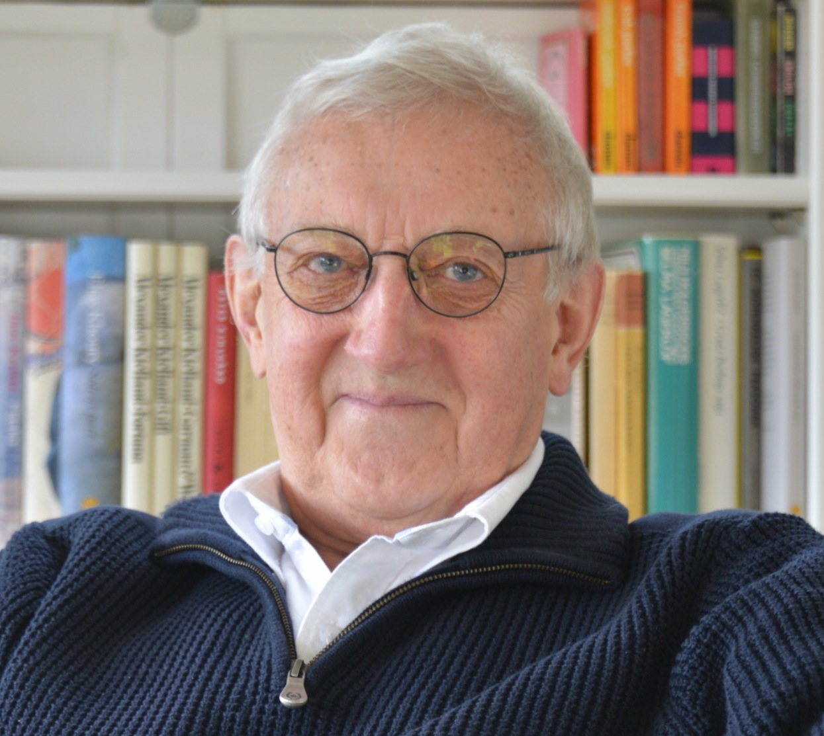

e-mail: Torgny.Svenberg@ki.se

Picture of John Arderne to be published beside the abstract!

