RETAINED FOREIGN BODIES- A rare case of “ Removal of surgical blade as Retained Foreign Body from abdomen 5 years after Surgery”.

Rajneesh Kumar , Ankur Hastir, Jaspreet Singh Walia

Abstract
Foreign bodies forgotten or missed in abdomen include cotton sponges, artery forceps or other instruments, pieces of broken instruments or irrigation sets and rare tubes. Presence of retained surgical blade as foreign body is uncommon and significant patient safety challenge. Most common etiologies for presence of such foreign bodies are accidental, traumatic or iatrogenic. Most common surgically retained foreign body is the laparotomy sponge. We report the management of a case with a rare foreign body in the abdomen i.e. surgical blade and repair of congenital diaphragmatic hernia. A 38 yrs female reported to us with X-ray lumbo-sacral spine showing radio-opaque object in abdomen. We further investigated the patient and CT scan abdomen revealed –A metallic foreign body in the left hypochondrium just beneath the left lobe of liver; it was seen in close proximity to the transverse colon gut loops and left Diaphragmatic Eventration hernia –herniation of stomach, large bowel loop and omental fat into left hemithorax. Traditionally, diaphragmatic hernia was repaired by laparotomy and foreign body was removed after exact localization on C-arm
Introduction
Error in medicine is common and may cause harm . However, isolating the factors underlying specific types of errors has proved to be formidable task. The types of errors that occur widely because of extreme complexity and heterogeneity of the tasks involved in medical care. Forgotten or missed foreign bodies, such as cotton sponges, gauze or instruments, after any surgical procedures are considered a misadventure and is associated with several legal problems. Foreign bodies can be opaque or non opaque, can be ingested, inserted into body cavities and can be result of penetrating trauma or iatrogenic injury. Most common etiologies for presence of such foreign bodies are accidental, traumatic-intentional or iatrogenic . The retention of sponges and instruments considered by many to be avoidable, and when it occurs, it can attract wide, critical press coverage. Yet these errors occur. Although the incidence has not been determined, estimates suggest that such errors occur in 1 of every 1000-1500 intra abdominal operations .Incidence of retained surgical foreign bodies after abdominal operations is a low and likely underreported .These foreign bodies may be detected acutely (i.e., during the immediate postoperative period), produce serious early or intermediate-term postoperative complications, or remain dormant for months or even years postoperatively .So far literature has reported the presence of various blunt and sharp objects like sewing needles, hypodermic needles, acupuncture needles, glass pieces and wooden pieces, retained sponges are few of the blunt objects reported so far. Sharp objects can cause injury to pleura, lungs, great vessels, and diaphragm and can migrate into abdominal cavity resulting in injury to visceral organs. Because of widespread use, surgical sponge is the most common encountered foreign body after open abdomen surgery (10). When not recognized or incorrectly diagnosed retained foreign bodies can lead to significant harm to the patients, including various complications and even mortality (11). The term “gossypiboma” denotes a mass of cotton retained in the body after any intervention. This term is derived from the Latin gossypium for the “cotton” and Swahili word boma for “a place of concealment”. Data concerning the incidence of gossypiboma tend to fluctuate and its incidence is difficult to estimate because of a low reporting rate lest medico-legal implications . Since abdomen and pelvis are the most common sites for retained foreign bodies, this review focuses on gastrointestinal complications related to retained surgical sponges, instruments, and other objects.

“Risk factors included a change in nursing personnel during surgery, excessive loss of blood, lack of complete count of sponges and instruments, fatigue of the surgical team from the lengthiness or lateness of the procedure and urgency of the surgery, obesity, unexpected intra-operative developments, the involvement of multiple surgical teams, and the performance of more than 1 major procedure at a time”(McLeod & Bohnen, 2004).The 3 most important factors identified were: “emergency surgery, unplanned change in the operation, and body mass index”.
Instrumentation should be counted for open cavity procedures, once at the beginning and once at the end of a surgical procedure. If a sponge or instrument is unaccounted for in the final count, a radiological exam and manual exploration should be performed .
We herein, report the management of a case with a rare foreign body in abdomen i.e. Surgical blade after 5 years and repair of congenital diaphragmatic hernia by laparotomy.
Case Report
A 38yrs. Female reported an orthopedic surgeon for backache and she was advised X-rays for lumbo-sacral spine: AP and lateral view. To his surprise on X-ray a radiopaque shadow was seen and patient was referred to us. Patient had an interesting history of Cholecystectomy 5years back. As per history of patient she was taken up for laparoscopic cholecystectomy under spinal anesthesia at some hospital and according to her she developed dysponia on insertion of trocars and CO2 insufflation , followed by swollen chest wall, neck and face and crackling sounds were present underneath skin i.e. Surgical emphysema she developed. Patient was conscious during the process and according to her, Trocars were taken out and laparoscopic procedure was abandoned. Surgeon/ anesthetist gave multiple stab incisions over chest and abdomen, and more likely during the process surgical blade might have slipped from scalpel and was sucked into abdomen. She was shifted to another hospital which was better equipped for management of dysponea and surgical emphysema. Where next day open cholecystectomy was done and she was discharged after 5 days and stitches were removed after8-9 days. Postoperative period was unremarkable and for the last 5years she was symptom free, as there is no history of dysponea, dyspepsia or digestive symptoms including intermittent pain, vomiting or dysphagia suggestive of diaphragmatic hernia. Exactly we also don’t know the sequence of events of retained foreign body i.e. Surgical blade. She had no history of trauma or any other pulmonary disease.
Patient was further investigated to achieve the diagnosis through a simple chest X-ray and CT scan. In this case chest X-ray shows a radio opaque shadow and gas and organs are seen over the diaphragm and CT scan abdomen revealed –A metallic foreign body in the left hypochondrium just beneath the left lobe of liver, it was seen in close proximity to the transverse colon gut loops and left Diaphragmatic Eventration hernia –herniation of stomach, large bowel loop and omental fat into left hemithorax.
Preoperative evaluation was unremarkable. On admission into operating room, patient was monitored with ECG, noninvasive blood pressure and pulse oximetre. Anasthesia was induced by 4.0mg of midazolam and 5mg of Scoline, muscles were paralyzed by 50mg of atracurium. Endotracheal intubation 7.0mm was placed into trachea to a depth of 20 cm. from front teeth. Pure oxygen was used to mechanically ventilate the lungs.
Through midline incision starting from epigastrium abdomen was opened. Stomach, omentum, colon and left lobe of liver were gently and cautiously pulled into abdomen. Left lobe of liver has to be separated from diaphragm and brought back to abdomen. The defect was 7cm x 5cm in left diaphragm. Then we used c-arm for exact localization of foreign body. To our surprise surgical blade was completely entrapped in the omentum which was retrieved.
Diaphragmatic hernia was repaired with 1.0 Prolene interrupted sutures. The repair defect was buttressed by a polypropylene mesh which was secured with 2.0 prolene thread. Chest drain was inserted to the left thoracic cavity at the end of procedure. Minimal intra operative bleeding occurred and the total duration was about 70 minutes. The nasogastric tube was removed the day after surgery. The chest drain was removed and eating was resumed on postoperative day 2. A chest radiograph showed that lung was expanded. Patient was discharged 4th day after surgery.
Discussion
Retained foreign bodies locations can be anywhere in tracheobronchial tree, gastrointestinal tract, pleural cavity, peritoneal cavity, and in various other locations have been subject of many reports and reviews. Sharp Foreign body like surgical blade have been rarely mentioned in literature, as it was located in the immediate proximity of major vessels, colon or stomach, and all sharp foreign bodies should be extracted, lest they penetrate and can cause bleeding or damage to organs.
Abdominal and pelvic cavities are the most frequent locations of retained surgical foreign bodies, account for nearly one-half of all retained foreign bodies . Presence of foreign body in thoracic cavity is very uncommon. Most etiologies for the presence of such foreign bodies are accidental, traumatic-intentional or iatrogenic .However leaving blunt foreign bodies in the chest (either in the pleural cavity or extrapleurally) predispose the patient to the risk of potential infection in future and can even result in full-blown empyema in some of these patients .Open thoracotomy and Vedio-assisted thoracoscopy are recommended treatment modalities used for removal of foreign bodies from the thorax.
The Authors reported that the mortality rate from objects left in the abdomen ranged as high as25% and almost 20% of the cases were discovered during autopsy. Sponges were found up to 30 years after surgery.
No experimental evidence addresses directly the problem of retained foreign bodies after surgery, but these events occur because of faulty processes of care in the OT and poor communication between assistant nurses and doctors. Examples of faulty processes of care include inadequate or incomplete wound explorations, poorly performed sponge and instrument counts, and incomplete, inadequate, or misread intraoperative radiographs. With the advent of laparoscopy faulty process of care must be defined in terms no more of open abdomen surgery but of the laparoscopic technique. In a case –control study designed to identify risk factors for retained items, several patient and procedure characteristics were examined. Of the 8 risk factors the Authors identified (emergency operation, unexpected change of operation, more than 1 surgical team involved, change in nursing staff during procedure, body mass index, volume of blood loss, female sex, and surgical counts). 3 significant risk factors were emergency surgery, unplanned change in the operation and increased body mass index . In addition to above factors, fatigue in the surgical team due to lengthiness or lateness of the procedure and urgency of surgery are the risk factors.
Clinical manifestations of Retained foreign bodies are due to a multifactorial interaction between the following elements: nature of FB; presence of infection; various patient factors; and the precise location of the FB . Most frequent encountered symptoms are nonspecific abdominal pain and intestinal obstructio.Removal of FB results in less severe manifestations while internal erosion may lead to more significant complications, including abscess, fistula formation, and intestinal obstruction. Inadvertent retention of a foreign body in the abdomen often requires another surgery to recover the material. This increases morbidity and mortality. Foreign bodies retained in the peritoneal cavity after surgeries are rarely documented owing to medical, legal and other reasons. Each such incidence acquires major importance because of excessive media hype now a day which can jeopardize the reputation of a surgeon amongst his professional colleagues and public at large. What happens as in the present case when there is reversal of events i.e. all clinical and radiological features point toward the suspicion of retained intra abdominal foreign body but on reoperation no foreign body is found?

This case is being reported to emphasize the fact that even when there is high index of suspicion for a retained intraabdominal FB, the reoperation may be carried out by explaining the indication of resurgery different rather than retained foreign body, as incisional hernia in the present case, to avoid unnecessary embarrassment . In spite of the diagnostic and therapeutic difficulties, the presence of a FB inside the patient can be easily proved and the patient may litigate the responsible surgeon because this is an avoidable problem and surgeon will face charges of negligence.
As sponge is most common retained foreign body ,to prevent glossypiboma-related troubles, the operating room team must pay thorough attention to detail, surgical sponges should always be counted at least twice, one by one ( once preoperatively and once postoperatively), radiopaque filaments should be used, the surgeon should completely explore the abdominal cavity before closing the peritoneum, and if there is doubt about the count of sponges, intraoperative X-ray must be performed .Inspection of abdominal cavity prior to closure should be routine in all patients, with particular attention to patients defined to be in groups at high risk for FB. Retained instruments or sponges often become concealed within the fatty tissues of the abdomen or pelvis and can be very difficult to find, even upon very detailed wound exploration .To prevent such concealment of FB there should be clear verbal communication between the operating surgeon(s) and the operating room staff regarding precise number and location of each intra-abdominally placed sponge, instrument ,or other surgical objects. Visible writing board should be there in the operating room for count of all surgical objects before abdominal closure. Metallic instruments left postoperatively, while retained surgical sponges frequently cause a chronic progression of symptoms over months to years.
In addition to performing surgical counts, thoroughly exploring the surgical wound, and using radiofrequency tagged instruments/sponges, intraoperative detection of potential retained surgical FB may be performed by using abdominal radiography or ultrasonography(13,34,35).Although more effective than many of its alternatives, intraoperative imaging may be less reliable in the detection of surgical foreign bodies than previously believed(34).
Possibility of retained surgical items should be included in the differential diagnosis of any post operative patient who presents with pain, infection, or a palpable mass. Patient with retained FB may present with the findings of intraabdominal abscess formation, with associated Plain radiography, ultrasound, and even magnetic resonance imaging (MRI) have been used for diagnosis, but the computed tomography (CT) scan has emerged as the most reliable method of diagnosing retained items .The most specific sign for computed tomographic (CT) detection of a retained surgical sponge is the presence of gas bubbles within retained foreign body. In addition, FB have been detected by angiography, endoscopy, laparoscopy, or upon surgical re-exploration . An experienced radiologist is needed to differentiate retained FB from pathologic processes or iatrogenic ally placed objects that may resemble the appearance of various retained surgical objects .Such processes and objects include abscesses, hematomas, cystic lesions, surgical staple lines, as well as other surgically placed objects.
Transmural migration of retained FB may erode the intestinal lumen despite the absence of any concomitant bowel trauma. Migration of surgical sponge into bowel lumen is a rare cause of bowel obstruction. However, it should be considered in the differential diagnosis in a patient with a history of previous laparotomy who presents with non-specific abdominal complaints .

FIGURES OF DIAGNOSIS, REMOVAL OF SURGICAL BLADE AND REPAIR OF DIAPHRAGMATIC HERNIA
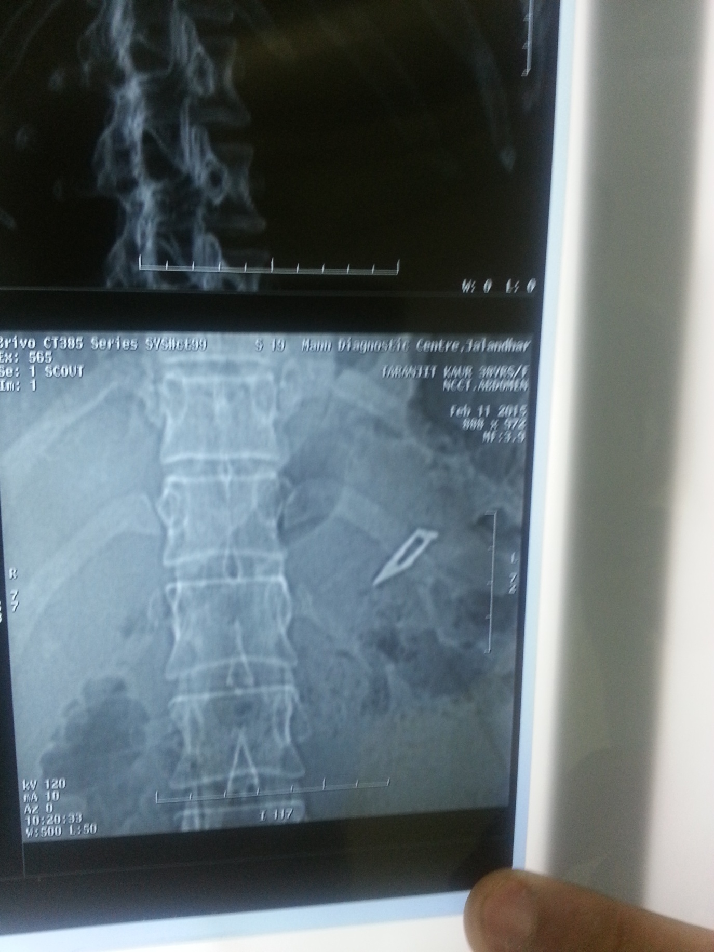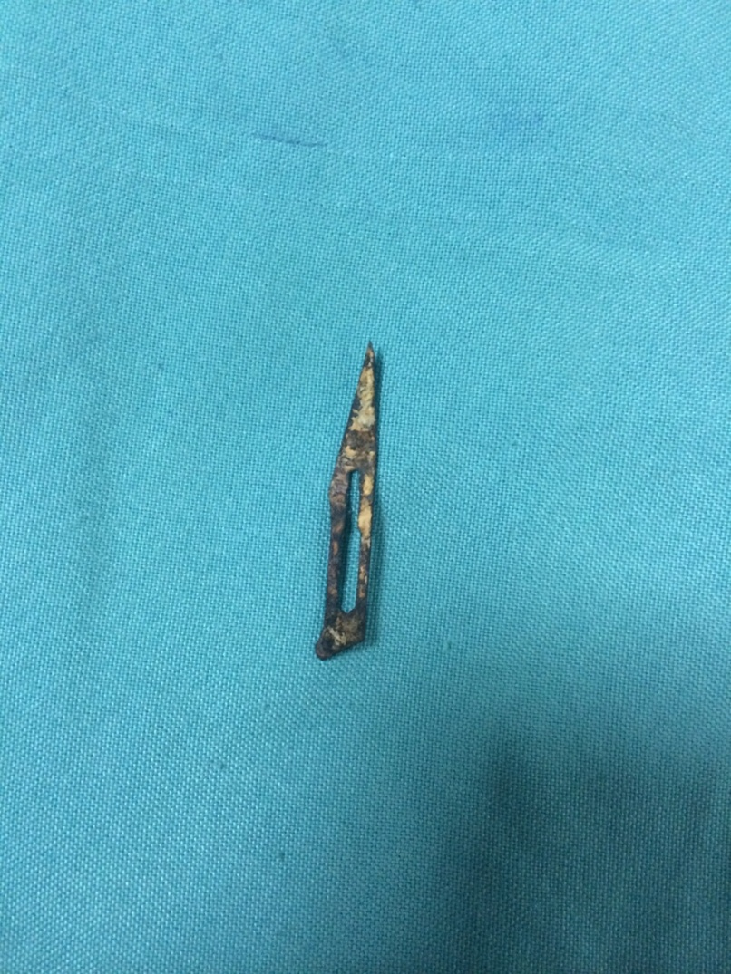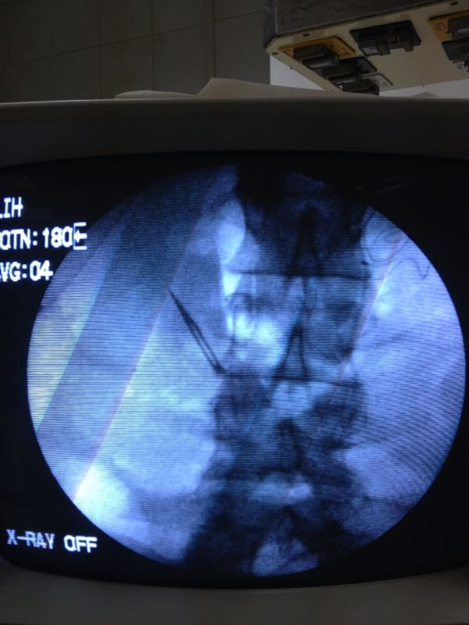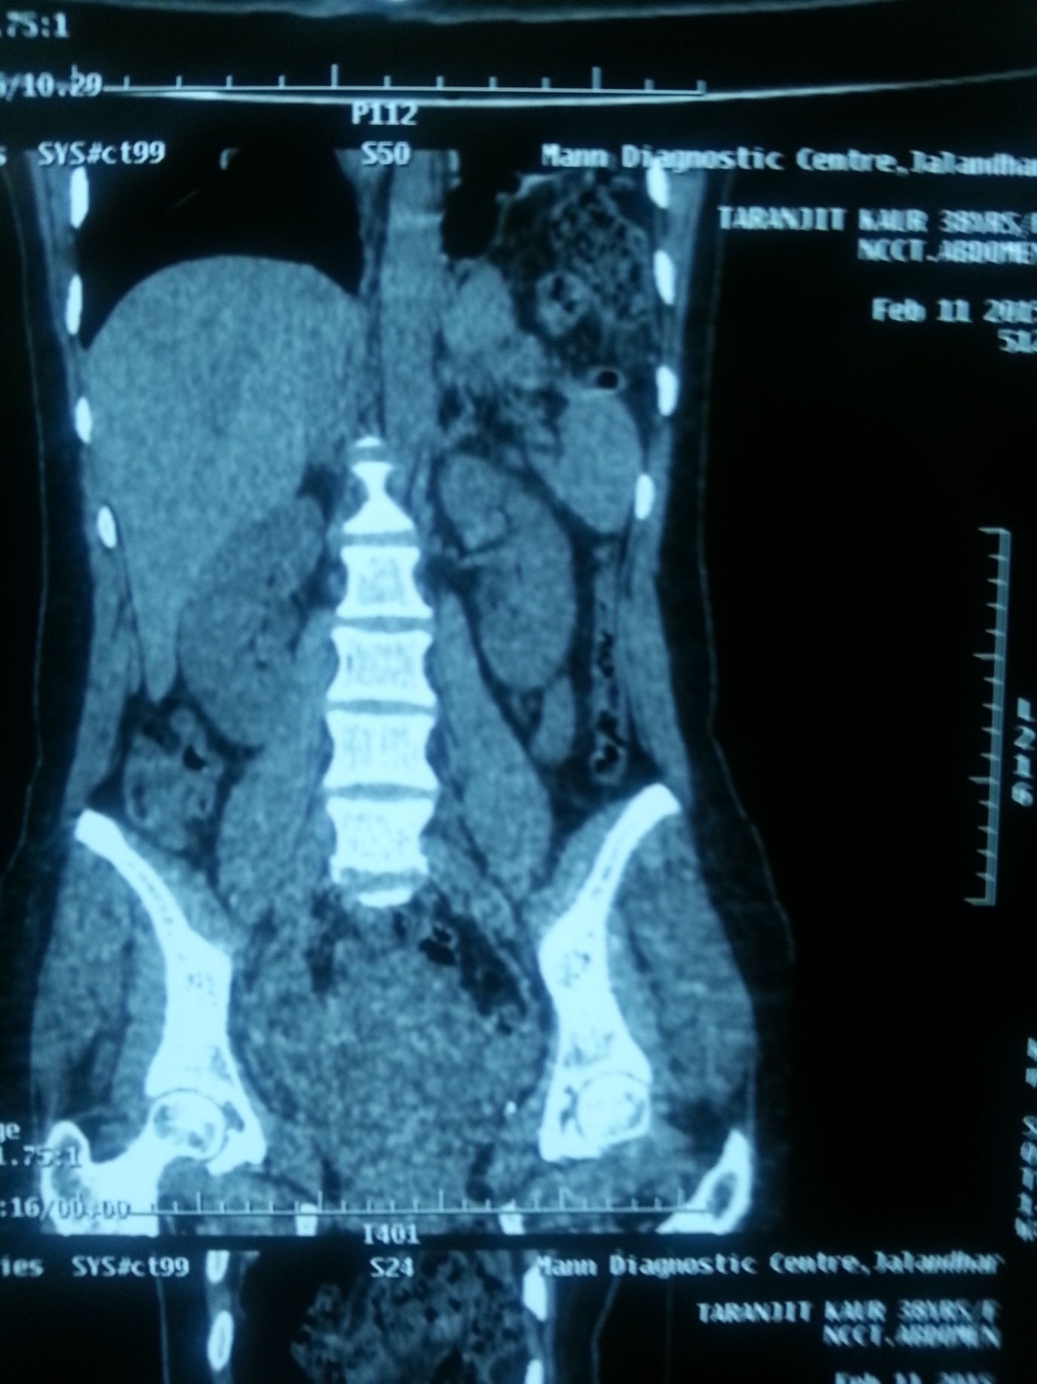
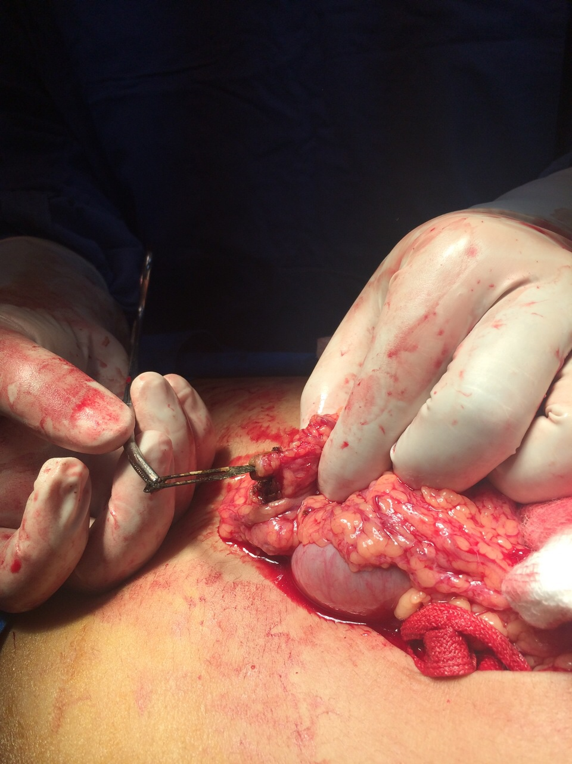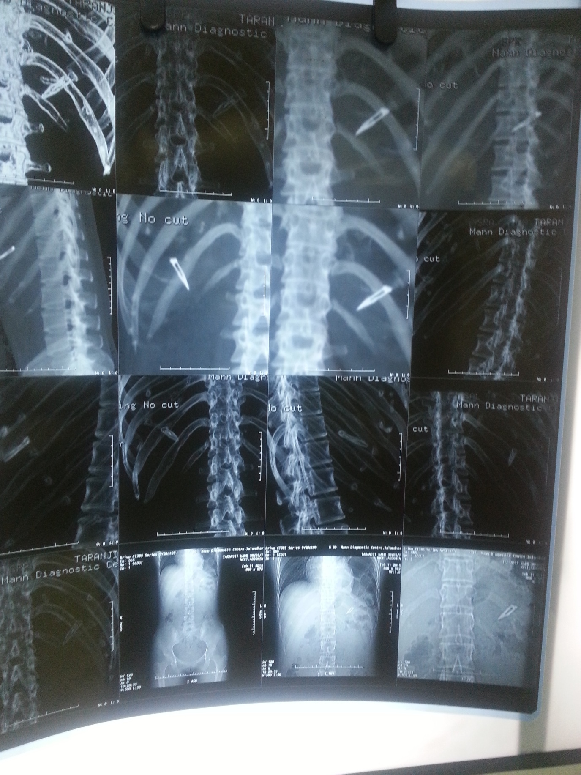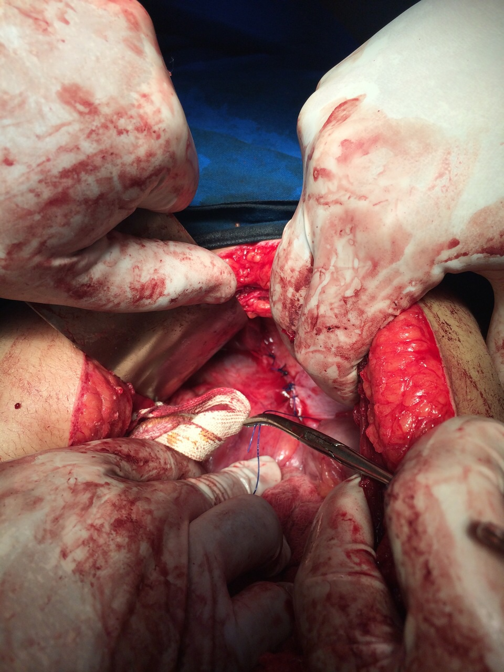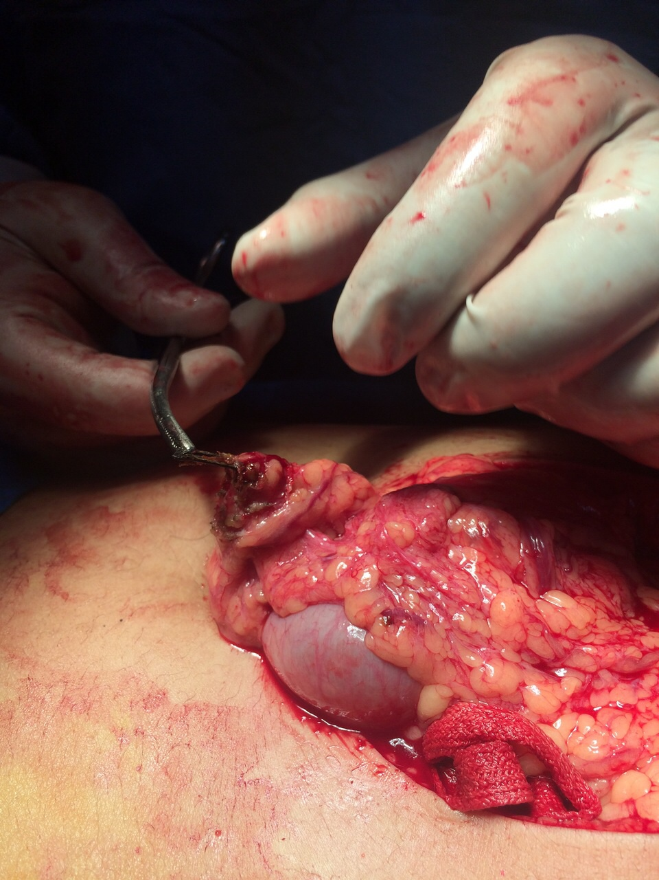

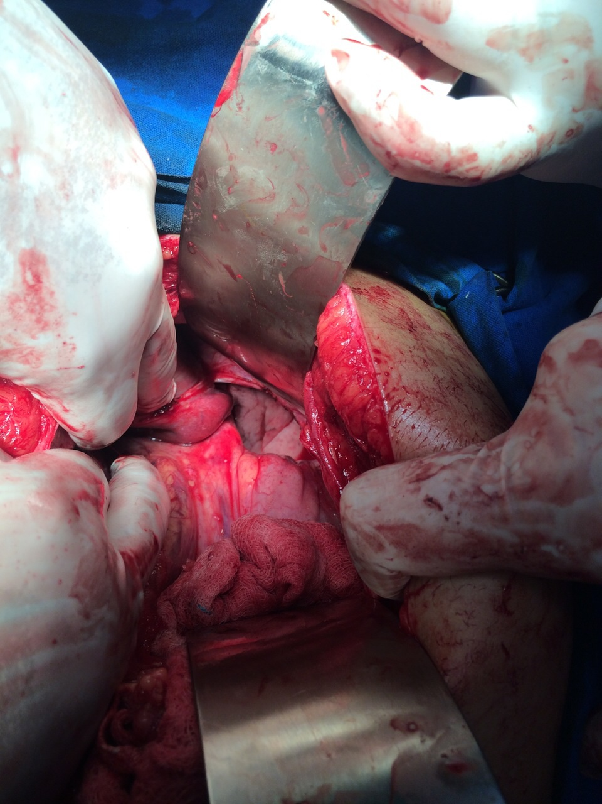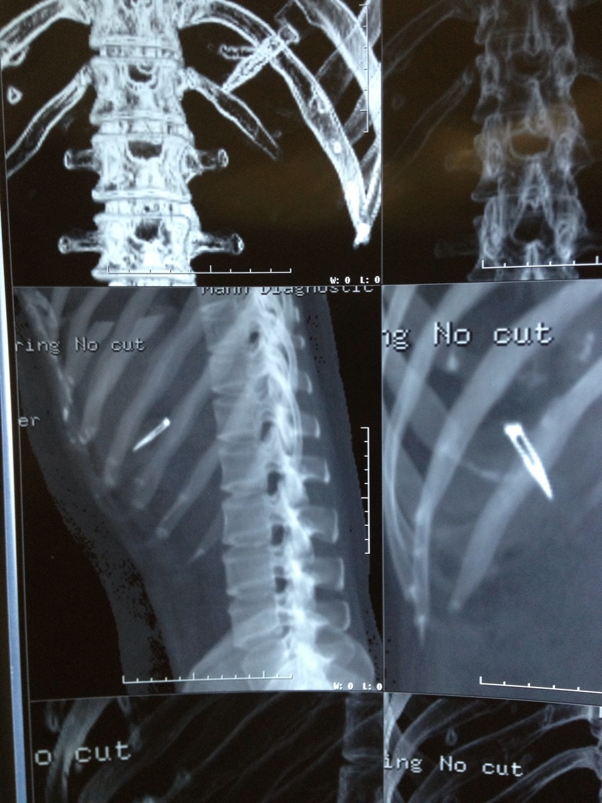

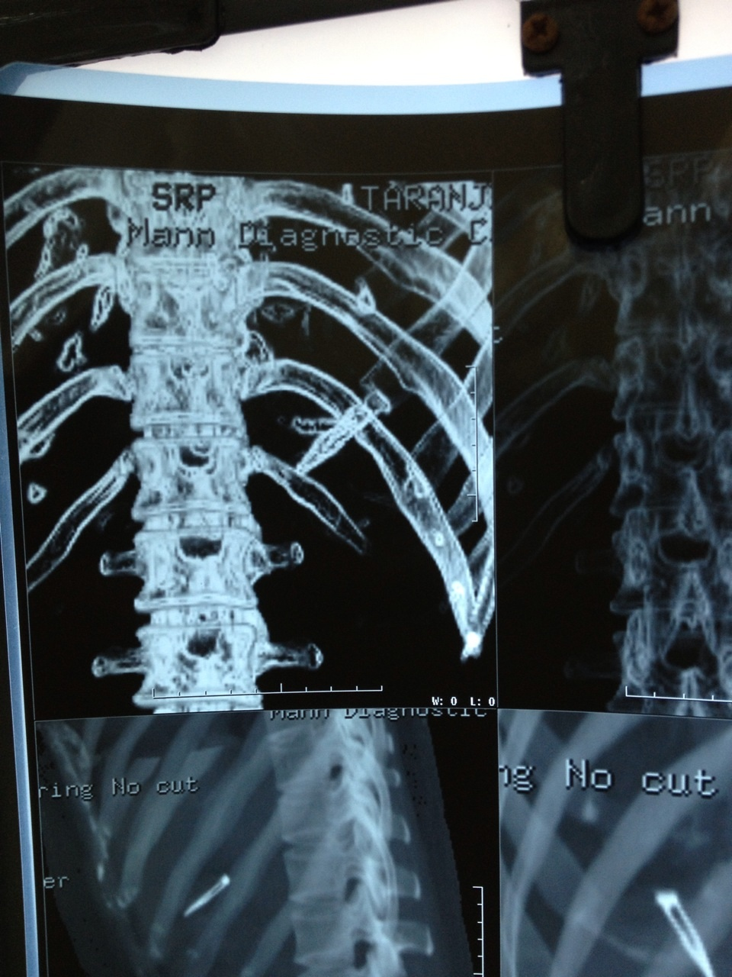

Conclusion
Foreign bodies can be opaque, can be ingested, inserted into body cavities and can be a result of penetrating trauma or iatrogenic injury. Retained surgical foreign body can lead to significant medical and legal problems between the patient and the doctor. It may be incorrectly diagnosed preoperatively, which can lead to unnecessary invasive diagnostic procedures and operations. Possible excuses given for sponge retention are emergency surgery, unexpected change in the surgical procedure, disorganization, hurried sponge counts, long operations, unstable patient condition, inexperienced staff, inadequate staff numbers, and patient with high body mass index; but these cannot be allowed to prevail. In spite of the diagnostic and therapeutic difficulties, the presence of a foreign body inside the patient can be easily proved and the patient may litigate the responsible surgeon because this is an avoidable problem and the surgeon will face charges of negligence.
Preoperative care nurses should practice well- defined counting methods for sponges and needles and other surgical devices. They should perform these actions “as a team” using good communication techniques. Both surgeons and nurses should evaluate new technologies (e.g., wands used by surgeons, counting systems used by nurses) that may improve the accuracy of their work. Radiologists and radiology technicians should provide their expertise in an efficient manner and develop systems for analysis of film and image quality in changing environments. They should work all together in order to provide tightly linked communication channels and well- organized processes of care. It’s a good practice to record all operations. Retained surgical foreign bodies continue to be underreported and poorly studied postoperative complications.
Despite near-universal implementation of protocols for surgical sponges, instruments, and needles, incidents of foreign bodies still occur. Gastrointestinal complications secondary to abdominal FB can be catastrophic and complex. In addition to instilling a higher index of suspicion, implementation of reliable institutional regulations and strict adherence to these regulations should be emphasized. Heightened surgical team awareness is important in reducing the incidence of human error, but additional prevention methods should also be considered, particularly in cases identified to be at higher risk for FB. Manual surgical instrument and sponge counting alone is not a reliable mechanism in eliminating foreign bodies. The implementation of passive radiofrequency identification tags which allow surgical sponges and instruments to be detectable inside body cavities with the use of a hand-held device may represent one solution in reducing the incidence of FB in high-risk cases. Another solution consists of liberal use of intraoperative radiography to verify the absence of FB in any procedure that is thought to be high-risk for FB or whenever surgical team suspicion for FB is present.

Dr.Rajneesh Kumar M.S; FAIS; FLCS; FMAS; FIAGES; FICS.
Associate Professor, Punjab Institute of Medical Sciences [PIMS]
Dr.Ankur Hastir, Assistant Professor, Deptt. of Surgery
Dr.Jaspreet Singh Walia Assistant professor, Deptt. of surgery
-------------------------------------------------------------------------------------

Department of Surgery,

Punjab Institute of Medical Sciences [PIMS], Garha Road, Jalandhar.-144001, Punjab , India.

Res. Add : 87- D, Dilbagh Nagar, 120-Feet Road, Jalandhar. Punjab.
E-mail: drrajneeshkumar@ymail.com
Cont. No : 091 -9814052513; 01812472688

