An In-silico Approach to Analyze HCV Genotype-specific Binding-site Variation and its Effect on Drug-Protein Interaction
Ramsha Khalid, Karachi, Pakistan
ABSTRACT
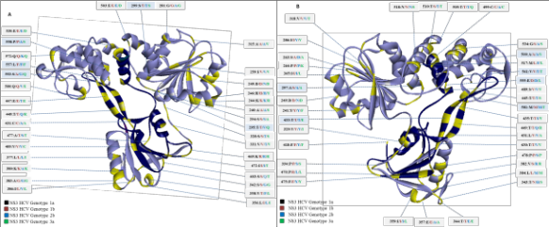
Genetic variation is a crucial feature of virus that greatly contributes in viral evolution, persistence, epidemiology, immune escape and development of antiviral drug resistance [1-4]. However; a systematic approach that can provide in-depth analysis of the genetic variations and insights on the effect of these respective variations on drug-protein interactions remains unraveled. Therefore, we present an in-silico approach to explore genotype specific amino acid variations and its substantial effect on drug-protein interaction. In these regards, we used NS3 helicase of Hepatitis C Virus (HCV) and fluoroquinolone as potential helicase inhibitors. Herein, we have investigated the genotype specific amino acid variations in NS3 HCV in genotype and subsequently, the effect of amino acid variations in genotype 1a, 1b, 2b and 3a in NS3 HCV on NS3-fluoroquinolone interaction. Methodology: We imported 687, 667, 101 and 248 nucleotide sequences of NS3 HCV genotypes 1a, 1b, 2b and 3a, respectively from Los Alamos database. 3D protein models for each genotype were constructed. Sequence and structural comparison of genotype-specific NS3 were performed followed by molecular docking.

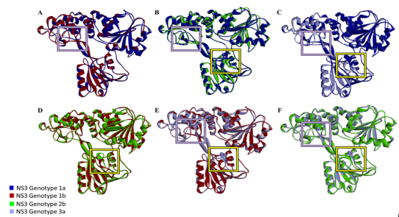
Figure 2: Superimposed structures of genotype-specific HCV NS3. Purple boxes indicate a change in the β-hairpin loop (amino acid 432-451), yellow boxes represent alpha helix (412-419).
Figure 1: Genotype-specific amino acid substitutions across HCV variants 1a, 1b, 2b, and 3a.

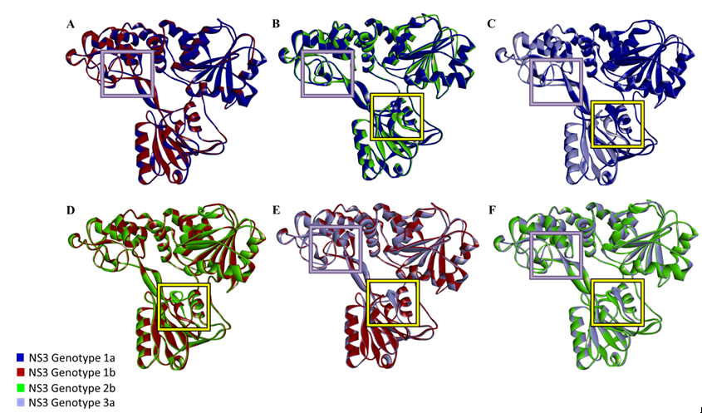
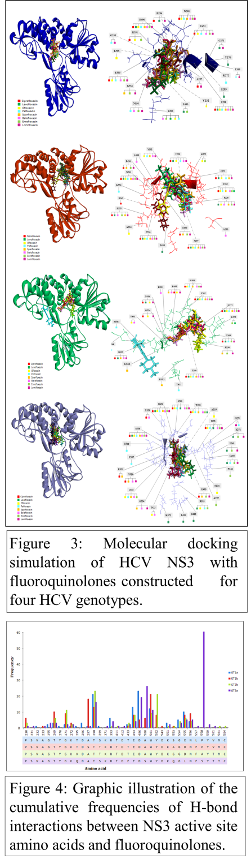
HCV NS3 genotype shows substantial sequence divergence with the identity score ranging from 80-93%. We found a total of 90 variable sites were determined via Multiple Sequence Alignment. The structures of the four HCV genotypes exhibit 98% structural similarity. Docking interactions varied significantly across the genotypes where genotype 3a exhibited maximum variations. In the light of the docking results, substitution of serine at positions 297 in genotype 1b, 500 and 558 in genotype 3a drastically increased the interactions. Conclusion: Therefore, we believe our approach can be easily extrapolated to include other viruses to study the clinical significance of genotype specific variations in drug-protein interactions.

References:
1. Grigoras, I., High variability and rapid evolution of a nanovirus. J Virol, 2010. 84(18): p. 9105-17.
2. Rubio, L., J. Guerri, and P. Moreno, Genetic variability and evolutionary dynamics of viruses of the family Closteroviridae. Front Microbiol, 2013. 4: p. 151.
3. Irwin, K.K., Antiviral drug resistance as an adaptive process. Virus Evol, 2016. 2(1): p. vew014.
4. Lauring, A.S. and R. Andino, Quasispecies theory and the behavior of RNA viruses. PLoS Pathog, 2010. 6(7): p. e1001005.
5. Frick, D.N., HCV Helicase: Structure, Function, and Inhibition, in Hepatitis C Viruses: Genomes and Molecular Biology, S.L. Tan, Editor. 2006: Norfolk (UK).

Authors Information:
Ramsha Khalid ¹, Muhammad Faraz Anwar ², Aanish Raees ³, Sadaf Naeem ¹, Syed Hani Abidi⁴ *, Syed Ali⁵*,
¹ Department of Biochemistry, University of Karachi, Pakistan, ²National Center of Proteomics, University of Karachi, Pakistan , ³ Medical College, Aga Khan University, Pakistan, ⁴ Department of Biological and Biomedical Sciences, Aga Khan University, Pakistan ,⁵ Department of Biological Sciences, Nazarbayev University School of Medicine, Nazarbayev University, Kazakhstan
*Corresponding Authors:
Syed Hani Abidi, Email: m.haniabidi@gmail.com, Syed Ali, Email: syed.ali@nu.edu.kz
Bibliography
Ramsha Khalid is an effective communicator with excellent planning, organizational, and negotiation strengths as well as the ability to lead, reach consensus, establish goals, and attain results. Ramsha’s expertise lies Bioinformatics and Molecular Biology. Ramsha’s research interests are focused on viral evolution and drug screening against oncogenic viruses. In the current study, we aim to establish an in-silco approach to analyze the effect of natural genotype-specific amino acid variations on 3D model of the protein and drug-protein interaction in absence of drug induced selection pressure, thus correlating sequence heterogeneity as well as structural architecture with variable response to selected drugs. This approach can be extended on to other viruses to study the clinical significance of genotype specific variations in drug-protein interactions.
Email: ramsha.khalid.rk@gmail.com
Contact number: 03362601538

