MD simulations of estrogen receptors (ER) and docking analysis of DPN analogues reveal insights about subtype-receptor selectivity.
M. Martinez-Archundia, B. Colin-Astudillo, J.B. García-Vázquez, J. Correa Basurto

Abstract
Estrogen (17β-estradiol) is essential for normal growth and differentiation in the mammary gland. In the last three decades previous investigations have revealed that estrogen receptor alpha (ERα) plays a critical role in breast cancer. More recently, observations regarding the widespread expression of ERβ-like proteins in normal and neoplastic mammary tissues have suggested that ERβ is involved in the mentioned pathology. Therefore, design of new drugs both steroidal and nonsteroidal that target ERβ represents a therapeutical promise to treat several diseases.
In this work, we have proposed a new set of compounds that target effectively the estrogen receptors, and particularly the ERβ. They were designed based on the chemical structure of the ERβ-selective agonist diarylpropionitrile (DPN), then, these potential ligands were submitted to in silico ADMET (absorption, distribution, metabolism, excretion, toxicity), from such analysis we could select the ones that showed better properties and they which were used for docking studies on ERα and Erβ, employing snapshots at 0 ns and 100 ns retrieve from Molecular Dynamics (MD) Simulations.
MD Simulations of the ligand binding domains (LBDs) of both estrogen receptors revealed important structural information and docking studies of the designed ligands provided useful information regarding the molecular basis in the binding of these ligands, for example, ligands that show polar functional groups, as well as aromatic groups, such as chlorobenzene exhibit higher affinity for ERα, whereas ligands that exhibit dinitrile functional groups, as well as ligands that show dinitrile groups combined with amino protonated groups ensure higher affinity and selectivity for ERβ. Moreover, from our structural results we could decipher structural differences between these nuclear receptors.

Image
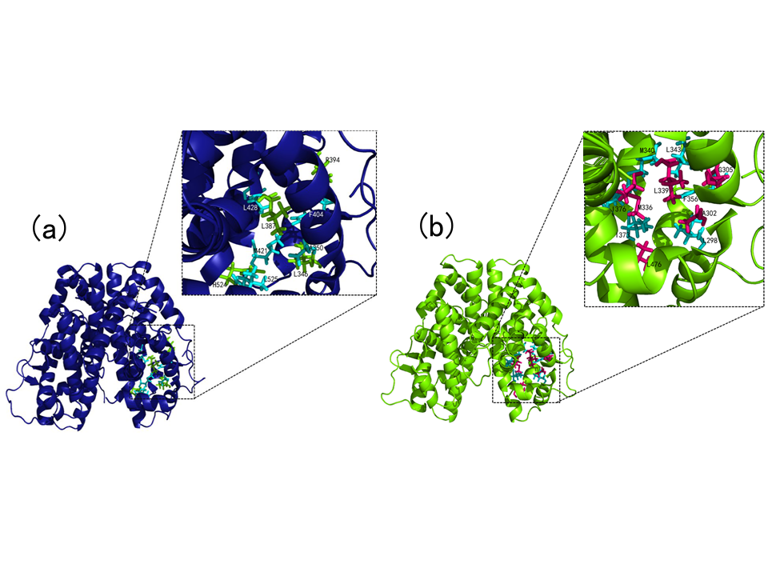
Figure. Binding sites at the Ligand binding domains (LBD) of estrogen receptors (a) LBD domain for ERα and (b) LBD domain for ERβ.
Recent Publications

- Martínez-Archundia M, Bello M, Correa-Basurto J.
Methods Mol Biol. 2018;1824:403-416
- Martinez-Archundia M, et al. Anticancer Agents Med Chem. 2017 Nov 29
- Martínez-Archundia M, et al. Chem Biol Drug Des. 2017 Nov;90(5):840-853. doi: 10.1111/cbdd.13005. Epub 2017 May 29.
- Martínez-Archundia M, Duclert Savatier N, Betton J.M, Alzari P.M, Nilges M, Malliavin, T.E. Biopolymers. 2016. 105(10):670-683.
- Mendez-Luna D., et al. J Biomol Struct Dyn. 2015. 33(10): 2161-2172.

 Biography
Dr. Marlet Martinez has a PhD in Polymers and Biopolymers from Universidad Politecnica de Catalunya, Barcelona and a Postdoc in Structural Bioinformatics from Institut Pasteur, Paris, France. Nowadays, Dr. Martinez works at the Laboratory of Molecular Modeling, Bioinformatics and drug design at the National Polytechnic Institute (IPN) in Mexico City where she carries out research on Structural Bioinformatics of diverse protein, Molecular dynamics simulations, docking analysis of potential ligands, drug design, among others. She has published about 17 publications in JCR articles, directed about five Master Degree Thesis in Pharmacology and Bioinformatics as well as two PhD thesis. Dr Martinez has been invited as lecturer by the Biophysical Society (USA), Argentinian Ministry of Education, Congress of International Drug Discovery Science and Technology
Email: marletm8@gmail.com
Phone: +52-5526950851

Notes/Comments:

