Juha M. Linnanto, PhD, University of Tartu, Institute of Physics, Laboratory of Biophysics, Estonia

Abstract
Statement of the Problem: Photosynthesis is the most important biological energy conservation pathway on the Earth. Photosynthetic organisms make use of solar energy to create free chemical energy that is used in their metabolic reactions. For light energy to be store by photosynthesis, it must first be absorbed by pigment molecules associated with the photosynthetic apparatus. The light-harvesting (LH) antenna systems collect sunlight and transfer excitation energy rapidly to the photosynthetic reaction centers, where the energy is trapped in an electron-transfer reaction. To investigate these processes both experimental and theoretical methods are needed. There are available only a few experimentally solved atomic-resolution LH structures. Thus, different computational methods together with experimental structural and spectroscopic information are needed to generate three-dimensional pigment-protein LH antenna model structures. The purpose of this study is to generate atomistic model for the LH2 antenna complex of Thermochromatium tepidum and to explain origin of the extraordinary splitting of so called B800 absorption band of the complex. Methods: Coming from the high protein sequence similarity between LH2 antennae of Thermochromatium tepidum and Phaesporillum molichianum (X-ray structure is known), homology modelling method was used to generate initial LH2 model. After that semiempirical quantum chemical method was used to optimized protein structure. And then density functional method was used to optimise local protein environment around the pigment molecules. At the end, absorption and circular dichroism spectra of the complex were calculated by using molecular exciton theory to verify quality of the model and to explain splitting of the B800 band. Finding: Origin of the splitting is two different conformations of pigment molecule. Conclusion & Significance: The study demonstrates that modern computational methods allow to produce high quality pigment-protein model structures. Also, it indicates that photosynthetic organisms are able to fine tuning the light-harvesting spectrum by modifying local protein geometry/structure.

Image
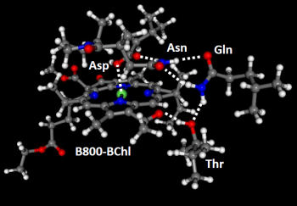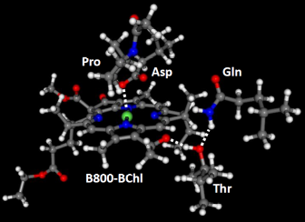
Figure 1: Two different B800-bacteriochlorophyll a conformers with local protein environments. Coordination bonds and hydrogen bonds are shown as dash lines.
Resent Publications
- Timpmann K, Linnanto JM, Yadav D, Kangur L, Freiberg A (2021) Hydrostatic high-pressure-induced denaturation of LH2 membrane proteins. The Journal of Physical Chemistry B, in press (https://doi.org/10.1021/acs.jpcb.1c05789).
- Jurček O, Nonappa, Kalenius E, Jurček P, Linnanto JM, Puttreddy R, Valkenier H, Houbenov N, Babiak M, Peterek M, Davis AP, Marek R, Rissanen K (2021) Hexagonal microparticles from hierarchical self-organization of chiral trigonal Pd₃L₆macrotetracycles. Cell Reports Physical Science 2:100303.
- Leiger K, Linnanto JM, Freiberg A (2020) Establishment of the Q_{y} absorption spectrum of chlorophyll a extending to near-infrared. Molecules 25:3796.
- Rätsep M, Linnanto JM, Freiberg A (2019) Higher order vibronic sidebands of chlorophyll a and bacteriochlorophyll a for enhanced excitation energy transfer and light harvesting. The Journal of Physical Chemistry B 123:7149-7156.
- Leiger K, Linnanto JM, Rätsep M, Timpmann K, Ashikhmin AA, Moskalenko AA, Fufina TY, Gabdulkhakov AG, Freiberg A (2019) Controlling photosynthetic excitons by selective pigment photooxidation. The Journal of Physical Chemistry B 123:29-38.
- Leiger K, Linnanto JM, Freiberg A (2017) Vibronic origin of the Q_{y} absorption tail of bacteriochlorophyll a verified by fluorescence excitation spectroscopy and quantum chemical simulations. The Journal of Physical Chemistry Letters 8:4231-4235.
- Nielsen J, Kulminskaya N, Bjerring M, Linnanto J, Rätsep M, Pedersen M, Lambrev P, Dorogi M, Garab G, Thomsen K, Jegerschöld C, Lindahl M, Frigaard N-U, Chr. Nielsen N (2016), In situ atomic-resolution structure of the baseplate antenna complex in Chlorobaculum tepidum. Nature communications 7:12454.


Biography
Juha Matti Linnanto is computational/theoretical chemist. His research interests cover various aspects of theory and modelling of electronic, optical, structural and transport properties of photosynthetic pigments, pigment-protein complexes, self-aggregates, dendrimers and metal-organic compounds. His computation competence includes classical molecular mechanic methods; molecular dynamic methods; semi-empirical quantum chemical methods; density functional methods; ab-initio methods; configuration interaction methods; time-dependent Hartree-Fock/density functional methods; and molecular exciton theory. Currently he is an associate professor (Laboratory of Biophysics) at the Institute of Physics of Tartu University.

