Title: Structural and functional characterization of mycolic acid methyl transferase A3 (MmaA3) enzyme of Mycobacterium tuberculosis.
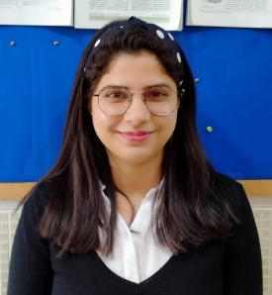
Name: Bhawna Chaudhary

TERI School of Advanced Studies (SAS), Institutional area, Vasant Kunj Delhi, India

Mycobacterium tuberculosis (Mtb) is the causative agent of tuberculosis (TB), which is a primary cause of mortality and morbidity worldwide. Mtb during course of time re-established themselves to evolve into Multi Drug Resistant Strains (MDR) and eXtensively Drug Resistant strains (XDR) Mtb have been concentrated on the unique chemical entities present in the cell envelope of this bacterium as it has been recognized as potential drug target. The cell wall of Mtb have a complex hydrophobic array of unique glycolipids and mycolic acids of which the mycolates are β-hydroxy fatty acids with a long α-alkyl side chain. The present study is mainly focussing on the cell wall of Mtb and more specifically the mycolate synthesis. Any structural alterations of mycolates impacts the virulence nature of Mtb. The mycolic acid biosynthesis pathway involves a series of enzymes and we are targeting the methyl transferase enzyme- MmaA3. During the synthesis of the cis-C₅₉-methoxy- and trans- C₆₀-methoxy-meroacids the MmaA3 enzyme introduces a methyl residue in the secondary alcohol compound which is crucial in mycolate synthesis. The mycolates thus generate virulent bacteria that are capable of evading host immune responses. This work aims to provide the structural information as how the enzyme MmaA3 functions to regulate the biosynthesis pathway of mycolic acid. This study will improve our understanding of the enzyme (MmaA3) mechanism of action, and administer a rational approach to design an inhibitor against this bacterium and offer an in-depth perspective on how the Mtb in the host cells develop drug resistance.

Biography
Bhawna Chaudhary has completed her Masters in Microbial Biotechnology from MDU, Haryana and now she is pursuing her PhD degree from TERI, School of Advanced Studies (SAS), India since 2017. She has experties in Proteomics and currently she is working on few proteins from Mtb. She has hands on experience in the purification of protein along with that she knows the Bioinformatics tools for modelling and docking studies of protein and so on.

Presenting author details:
Full name: Bhawna Chaudhary
Contact number: 9654108184
Linkdin account: tinadhoon1196@gmail.com
Session name: Frontiers in Structural Biology
Category: Poster Presentation

