Computational study of LH2 complexes from purple bacteria and its structural adaptation to the dark environments
Felipe Cardoso Ramos, Stefano Caprasecca, Lorenzo Cupellini and Benedetta Mennucci
Università di Pisa, Dipartimento di Chimica e Chimica Industriale (DCCI) – Molecolab Group
Pisa, Italy
periplasm

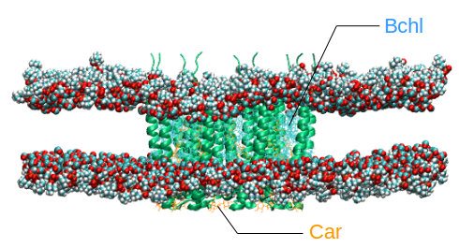
Abstract
A
Statement of the Problem: The light-harvesting apparatus of a typical purple photosynthetic bacteria is composed by the LH1 and LH2 complexes, which act together in the absorption and transfer of light energy to the photosynthetic reaction center (RC). The LH2 complexes are circular membrane proteins formed by nine dimeric apoproteins, the α and β chains, bound to one carotenoid (Car) molecule and three bacteriochlorophyll a (Bchl) molecules (B800, B850α and B850β). Purple bacteria express LH2 complexes with different αβ apoproteins depending on the light intensity, which allows them to adapt to the luminosity conditions. The species Rhodopseudomonas acidophila (Rps. acidophila), for example, produces LH2 complexes with absorption at 800 and 850 nm (B800-850) when in high light (HL) conditions, but when in low light (LL) conditions they are replaced by complexes that absorb at 800 and 820 nm (B800-820). Methodology & Theoretical Orientation: Here, we performed classical molecular dynamics (MD) simulations of LH2 complexes from purple bacteria in lipid membranes, aimed to generate atomistic models for these light-harvesting complexes, focusing on the genus Rhodopseudomonas. Findings: Analysing the trajectories obtained we verified that the size and the circular shape of complexes were well preserved along the simulations. In addition, our simulations were able to reproduce the main protein-pigments interactions described in the crystallographic structures. Conclusion & Significance: Through the simulation protocol applied it was possible to produce equilibrated models for entire HL and LL LH2 complexes in membranes. These models are currently being employing in hybrid quantum mechanics/molecular mechanics (QM/MM) calculations which will allow us to simulate the absorption spectra of the complexes. At the end of this study, we hope to provide detailed structural explanations about the occurrence of different spectra and contribute to the understanding of the molecular mechanisms that govern the purple bacteria adaptation to dark environments.
cytoplasm

B
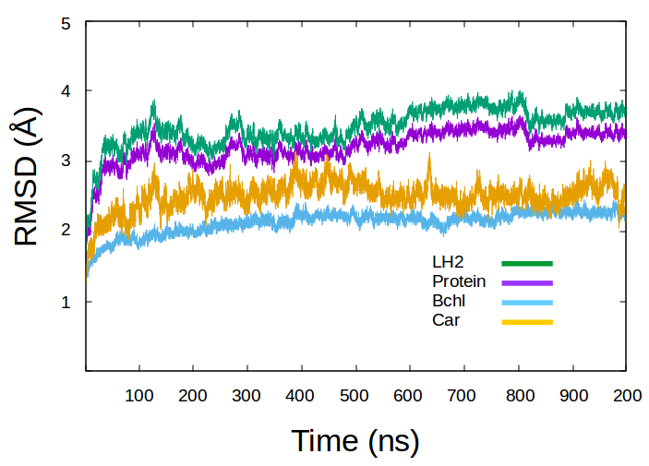

Figure 1: (A) A model structure for the HL LH2 complex from Rps. acidophila in a lipid bilayer generated by our MD simulations (lipid tails have been omitted for clarity). (B) The RMSD plot for the entire LH2 complex, as well as for its components over 200 ns.

Recent Publications
- Curutchet C, Mennucci B (2016). Quantum Chemical Studies of Light Harvesting. Chemical Reviews 117:294–343.
- Nottoli M, Jurinovich S, Cupellini L, Gardiner A T, Cogdell R, & Mennucci B (2018). The role of charge-transfer states in the spectral tuning of antenna complexes of purple bacteria. Photosynthesis Research X:1–12.
- Cupellini L, Jurinovich S, Campetella M, Caprasecca S, Guido C A, Kelly S M, Gardiner A T, Cogdell R, Mennucci B (2016). An ab initio description of the excitonic properties of LH2 and their temperature dependence. Journal of Physical Chemistry B 120:11348–11359.
- Southall J, Henry S L, Gardiner A T, Roszak A W, Mullen W, Carey A, Kelly S M, Northumberland C O P, Cogdell R J (2018). Photosynthesis Research 135:9–21.
- Moulisová V, Luer L Hoseinkhani S, Brotosudarmo T H P, Collins A M, Lanzani G, Blankenship R E, Cogdell R J (2009). Low Light Adaptation: Energy Transfer Processes in Different Types of Light Harvesting Complexes from Rhodopseudomonas palustris. Biophysical Journal 97:3019–3028.

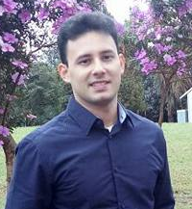

Biography
Felipe Ramos has experience with macromolecule chemistry, with emphasis on protein structure and function studies. During his Master's degree in Microbiology at São Paulo State University (Brazil), he developed experimental studies involving the biochemical and biophysical characterization of thermostable enzymes with application in bioethanol industry. He is currently a PhD student in Chemistry and Material Sciences at the University of Pisa (Italy) and develops his thesis under the guidance of professor Benedetta Mennucci. His research project is based on the use of classical and hybrid QM/MM simulations of LH2 complex from purple bacteria aiming to understand the mechanism of adaptation of these complexes to the light conditions.

Email: cfelip2@gmail.com / f.cardosoramos@studenti.unipi.it

Phone: +39 388 3581551 /
+39 050 2219001

Notes/Comments:

