Effects of Sarcolipin on Ca²⁺ pump SERCA1a enzymatic cycle studied by Normal Mode Analysis
Liliane Mouawad, Institut Curie, Thomas Barbot, CEA, France

Abstract (300 word limit)
The Ca²⁺ pump SERCA1a is a P-type ATPase, localized in the sarcoplasmic reticulum membrane of striated muscle cells. SERCA1a is involved in the contraction/relaxation process by fast pumping the cytoplasmic Ca²⁺ into the reticulum. Throughout its catalytic cycle, SERCA1a presents two major conformations: the E1 conformation where its Ca²⁺ channel is open toward the cytoplasm and the E2 conformation where this channel is open toward the lumen. This conformational transition is enhanced by ATP phosphorylation which occurs after Ca²⁺ binding by SERCA1a.
Sarcolipin (SLN), a transmembrane helix of 31 residues regulates SERCA1a by diminishing its affinity to Ca²⁺. The mechanism of this regulation is not elucidated yet despite the knowledge of the crystal structure (see figure). To decipher this mechanism, we performed Normal Mode Analysis (NMA), in the all-atom model on two systems, in the presence and the absence of SLN, in a POPC membrane and one layer of water for the soluble parts of the protein.
This analysis showed that both systems are prone to go toward the conformation of 2Ca²⁺.E1 more easily than toward that of E2. However, both transitions seem more difficult in the presence of SLN, because of some specific interactions with SERCA1a that result in additional fluctuations of SERCA1a-SLN. A long distance transmission of information (over 35 Å) within the protein was also observed, explaining the phosphorylation difficulty in the complex. These results provide new insights into the mechanism of the SERCA1a enzymatic cycle and its regulation by SLN.

Image
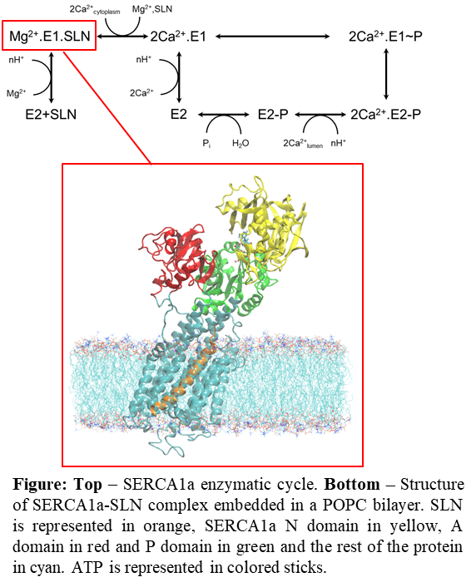
Recent Publications (minimum 5)
- Chaput L, Mouawad L (2017) Efficient conformational sampling and weak scoring in docking programs? Strategy of the wisdom of crowds. J Cheminform 9:37.
- Domingues MJ, Martinez‑Sanz J, Papon L, Larue L, Mouawad L, Bonaventure J (2017) Structure-based mutational analysis of ICAT residues mediating negative regulation of β-catenin co-transcriptional activity. PlosOne
DOI:10.1371/journal.pone.0172603
- Chaput L, Martinez‑Sanz J, Saettel N, Mouawad L (2016) Benchmark of four popular virtual screening programs: construction of the active/decoy dataset remains a major determinant of measured performance. J Cheminform 8:56.
- Chaput L, Martinez‑Sanz J, Quiniou E, Rigolet P, Saettel N, Mouawad L (2016) vSDC: a method to improve early recognition in virtual screening when limited experimental resources are available. J Cheminform 8:1.
- Quiniou E, Guichard P, Perahia D, Marco S, Mouawad L (2013) An atomistic view of microtubule stabilization by GTP Structure 21: 833–843.
- Martinez-Sanz J, Kateb F, Assairi L, Blouquit Y, Bodenhausen G, Abergel D, Mouawad L, Craescu CT (2010) Structure, dynamics and thermodynamics of the human centrin 2/hSfi1 complex. J. Mol. Biol. 395: 191–204.

 Biography (150 word limit)
Liliane Mouawad was always interested in understanding the mechanism of action of proteins or protein assemblies. This understanding may be based on either molecular simulations or on experiments like NMR. But her expertise is primarily in molecular dynamics simulations and more precisely in normal mode analysis (NMA). She has developed several methods going from the calculation of normal modes of very large systems or of images, to the calculation of the pathway between two protein conformations, or to the prediction of the compactness of a calcium-binding protein. Recently she was also involved in docking and virtual screening themes, where she has acquired enough expertise to develop a new consensus methodology to overcome some issues observed in these approaches.
Email: liliane.mouawad@curie.fr
Phone: +33-1-69-86-71-51

Notes/Comments:

