Automated Protocols for Macromolecular Crystallization at the MRC Laboratory of Molecular Biology
Fabrice Gorrec, MRC Laboratory of Molecular Biology, UK

Abstract (300 word limit)
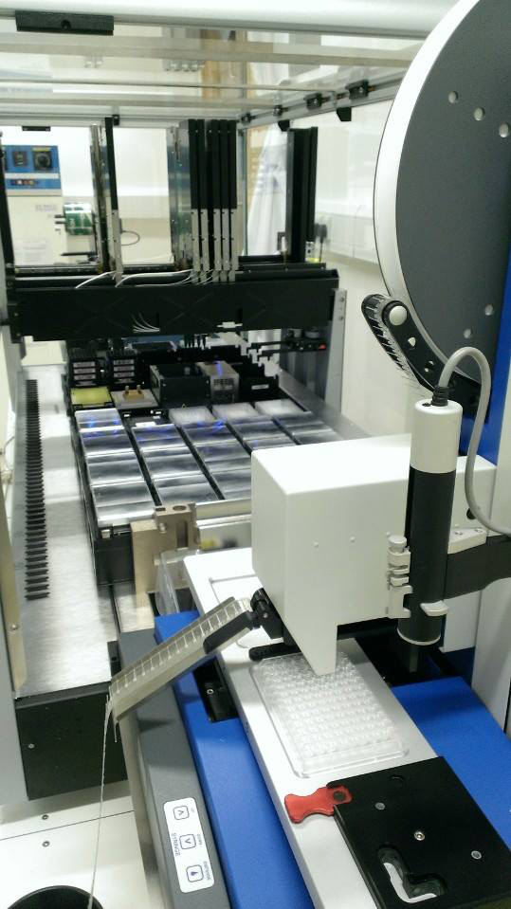
When high quality crystals are obtained that diffract X-rays, the crystal structure may be solved at near atomic resolution [1]. The conditions to crystallize proteins, DNAs, RNAs, and their complexes can however not be predicted [2]. Employing a broad variety of conditions is a way to increase the yield of quality diffraction crystals [3]. Two fully automated systems have been developed at the MRC Laboratory of Molecular Biology (Cambridge, England, MRC-LMB) that facilitate crystallization screening against 1,920 initial conditions by vapor diffusion in nanoliter droplets [4]. Semi-automated protocols have also been developed to optimize conditions by changing the concentrations of reagents, the pH, or by introducing additives that potentially enhance properties of the resulting crystals [5]. All the corresponding protocols will be described in detail and briefly discussed. Taken together, they enable convenient and highly efficient macromolecular crystallization in a multi-user facility, while giving the users control over key parameters of their experiments.

Image

Recent Publications (minimum 5)
- Blundell T L (2017) Protein crystallography and drug discovery: recollections of knowledge exchange between academia and industry. IUCr Journal 4:308-321.
- Gorrec F (2015) The MORPHEUS II protein crystallization screen. Acta Crystallographica F71:831-837.
- Gorrec F (2013) The current approach to initial crystallization screening of proteins is under-sampled. Journal of Applied Crystallography 46:795-797.
- Gorrec F, Löwe J (2018) Automated Protocols for Macromolecular Crystallization at the MRC Laboratory of Molecular Biology. Journal of Visualized Experiments. In press.
- McPherson A, Cudney B (2006) Searching for silver bullets: an alternative strategy for crystallizing macromolecules. Journal of Structural Biology 156:387-406.

 Biography (150 word limit)
Dr Fabrice Gorrec has participated in the development of innovative technologies applied to protein crystallization over 14 years, including microplates (e.g. TOPAZ®), liquid-handlers (e.g. Dragonfly®) and initial screens (e.g. MORPHEUS™). Since 2008, Fabrice is responsible for the crystallization facility at the MRC Laboratory of Molecular Biology (MRC-LMB, Cambridge, UK) where he invented and developed the 96-condition MORPHEUS protein crystallization screens.
Email: fabricegorrec@gmail.com
Phone: +44 (0) 1223 26 7807

