Rational design of a trispecific T-cell engager (TiTE) consisting of nanobodies 7D12 and anti-PD1 and HLA-B*3501 fused to an EBV epitope peptide for treatment of EGFR-related cancers

Mansour Poorebrahim, IRAN

Abstract (300 word limit)

The epidermal growth factor receptor (EGFR) is a cell-surface receptor belonging to ErbB family of tyrosine kinase and it plays a vital role in the regulation of cell proliferation, survival and differentiation. However; EGFR is aberrantly activated by various mechanisms like receptor overexpression, mutation, ligand-dependent receptor dimerization, ligand-independent activation and is associated with development of variety of tumors. Therefore, specific EGFR inhibition is one of the key targets for cancer therapy. Two major approaches have been developed and demonstrated benefits in clinical trials for targeting EGFR; monoclonal antibodies (mAbs) and tyrosine kinase inhibitors (TKIs). However, total cure of patients with EGFR-related cancers is still a field of challenge. Although use of bispecific T-cell engagers (BiTE) have previously introduced as interesting therapeutic platforms, patients with EGFR overexpression/mutation do not still profit from treatment with such antibodies. This might because of large size of BiTE antibodies, and thereby, their adverse properties. In this project, for the first time, a trispecific T-cell engager (TiTE) consisting of nanobodies 7D12 and anti-PD1 and an HLA-type (HLA-B*3501) fused to Epstein Barr virus (EBV) antigenic peptide was designed for treatment of EGFR-related cancers utilizing various computational approaches. However, few reports are available for design of trispecific killer engagers (TriKE). After analysis of HLA-B*3501 structure presenting EBV peptide, the main residues involved in interaction with T-cell receptors (TCR) were identified. To generate HLA-B*3501-EBV peptide fusion, the EBV peptide was inserted in a region of HLA-B*3501 that cause no significant change in its 3D structure. Subsequently, the nanobodies and engineered HLA-B*3501 were fused using Glycine linkers. By using optimal linkers, 3D structure of each nanobody and engineered HLA-B*3501 was preserved. Biological activity of this engager nanobody was validated in silico utilizing molecular docking studies and molecular dynamics simulations carried out by Haddock and Gromacs tools, respectively. This engineered TiTE can be highly capable of recruiting T-cells to the EGFR-related cancer cells and subsequently activate engaged T-cells against cancer cells.
Image
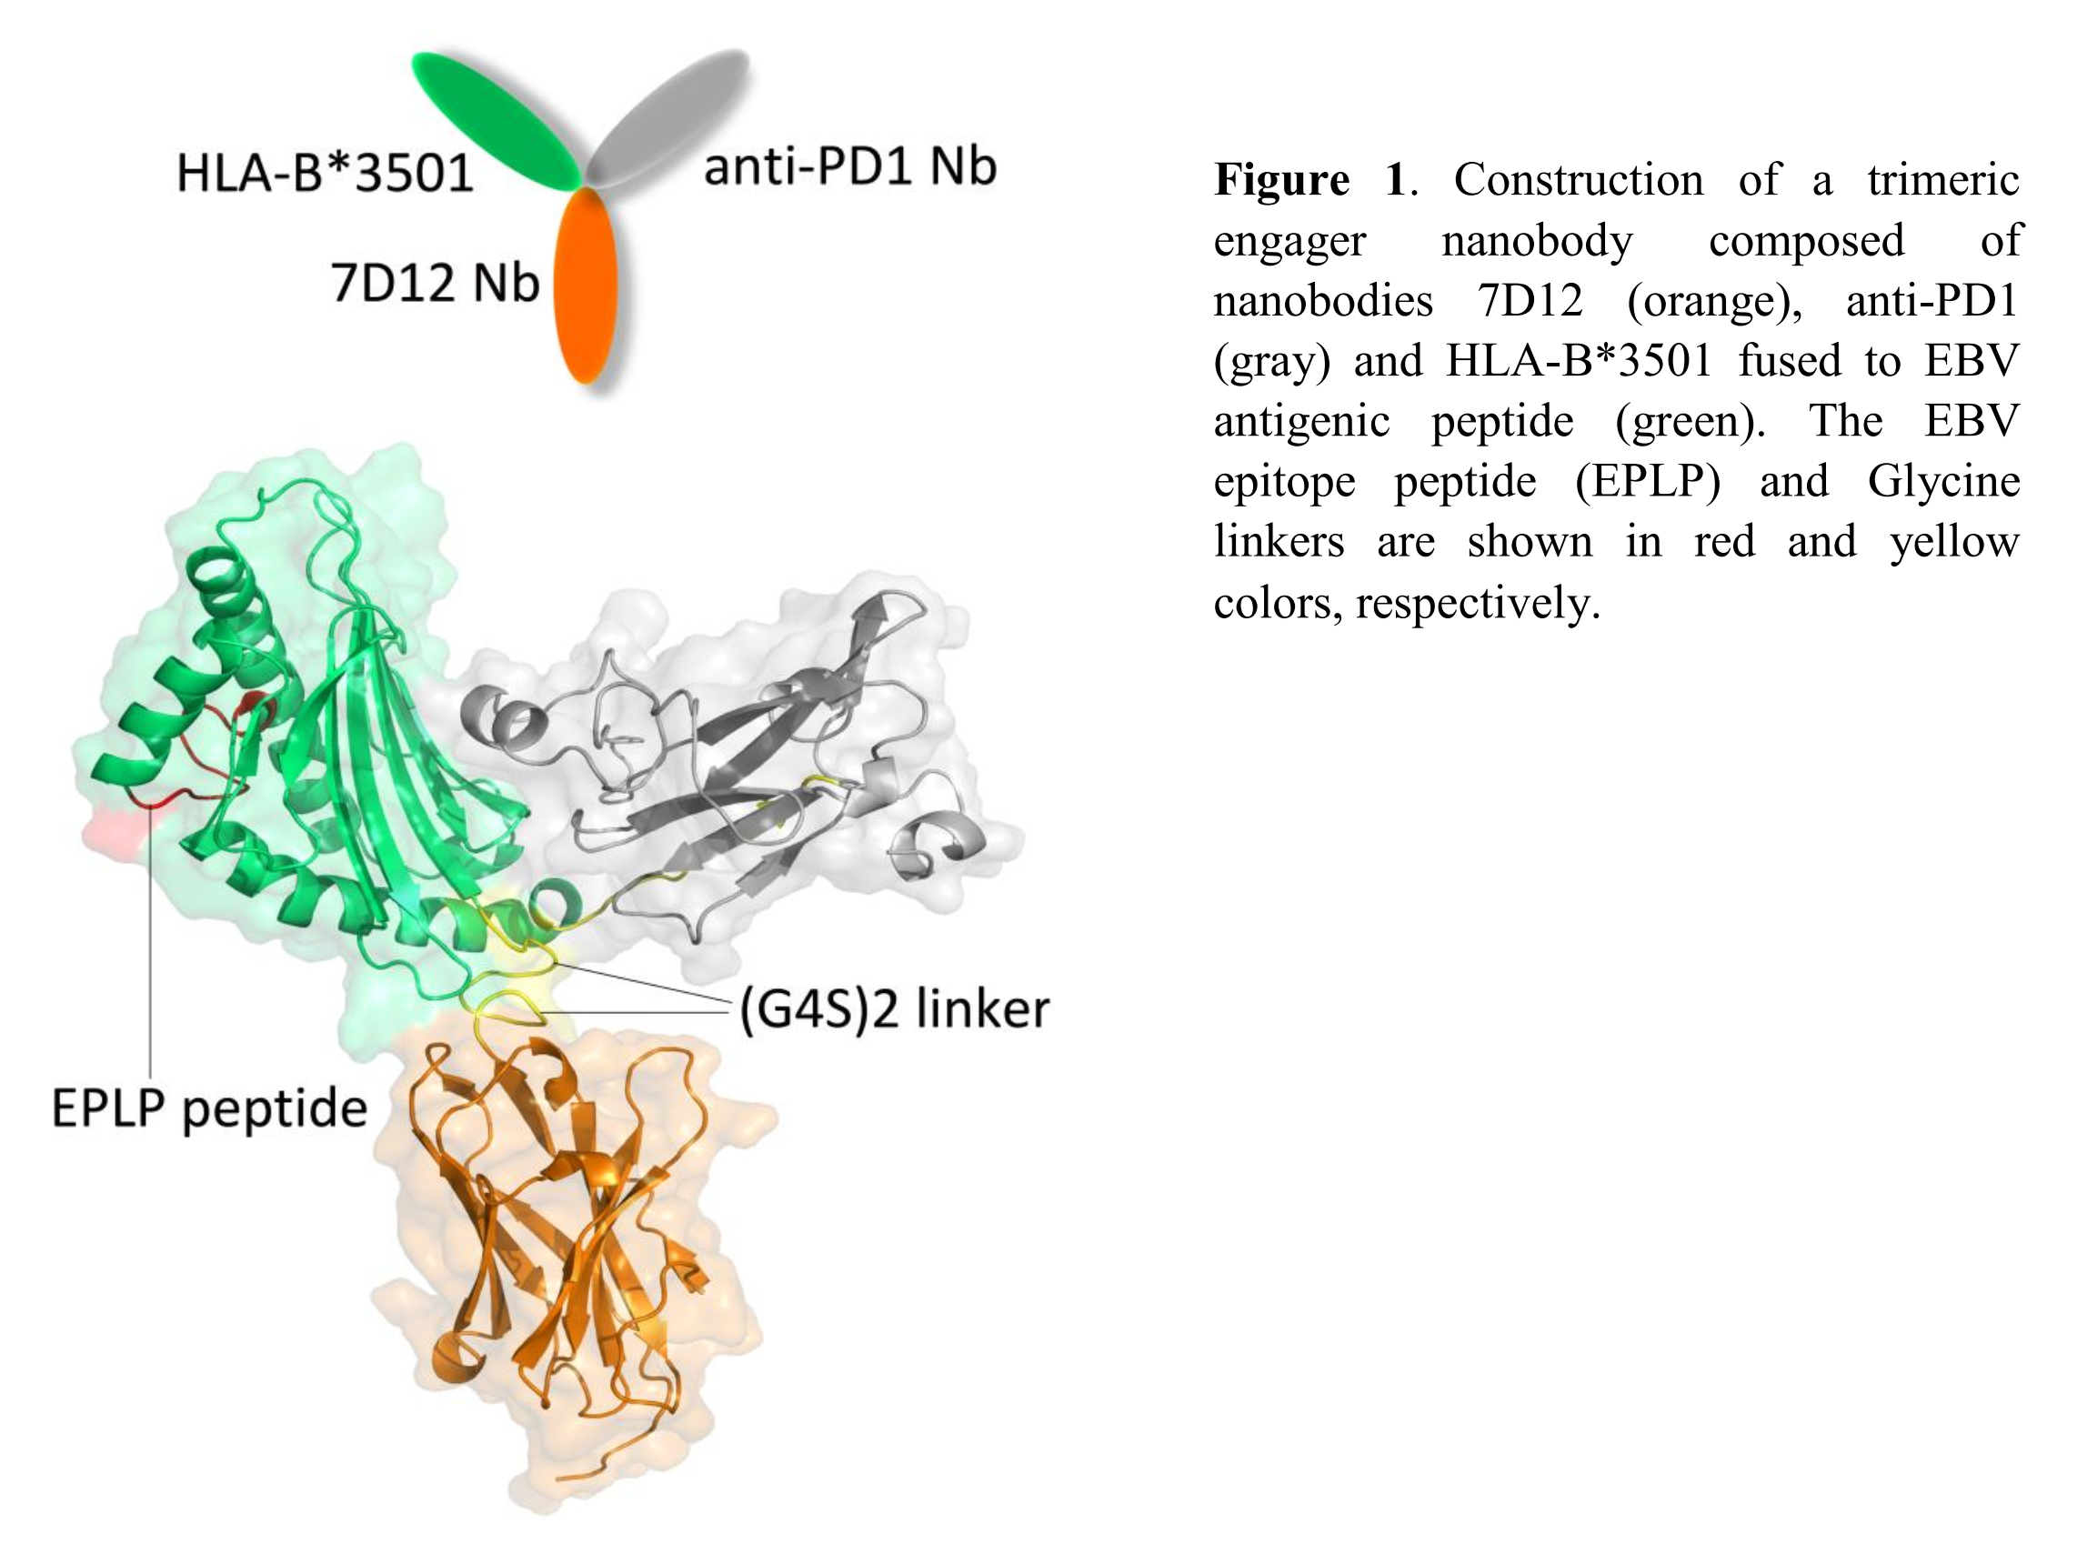

Recent Publications (minimum 5)
- Horita, S., et al. (2016). "High-resolution crystal structure of the therapeutic antibody pembrolizumab bound to the human PD-1." Scientific reports 6: 35297.
- Schmitz, K. R., et al. (2013). "Structural evaluation of EGFR inhibition mechanisms for nanobodies/VHH domains." Structure 21(7): 1214-1224.
- Tynan, F. E., et al. (2007). "AT cell receptor flattens a bulged antigenic peptide presented by a major histocompatibility complex class I molecule." Nature immunology 8(3): 268-276
4. Vallera, D. A., et al. (2016). "IL15 trispecific killer engagers (TriKE) make natural killer cells specific to CD33+ targets while also inducing persistence, in vivo expansion, and enhanced function." Clinical Cancer Research 22(14): 3440-3450.
5. Lutterbuese, R., et al. (2010). "T cell-engaging BiTE antibodies specific for EGFR potently eliminate KRAS-and BRAF-mutated colorectal cancer cells." Proceedings of the National Academy of Sciences 107(28): 12605-12610.

 Biography (150 words limit)
Mansour Poorebrahim is a PhD of Medical Biotechnology at Tehran University of Medical Sciences, Iran. He has expertise in structural biology, systems biology and drug design. His field of interest is to find novel therapeutic targets and design structure-based drugs, especially in cancers. His long-term plan is to design and develop engineered proteins and peptides for application as therapeutic agents in human cancers.
Email: mpoorebrahim@razi.tums.ac.ir

