Screening for P53-MDM2 Small Molecule Inhibitors: Cancer Therapeutic Target
Ameena M Ali, Matthew R Groves, Tad Holak and Alexander Dömling. Groningen University, Netherlands

Abstract (300 word limit)
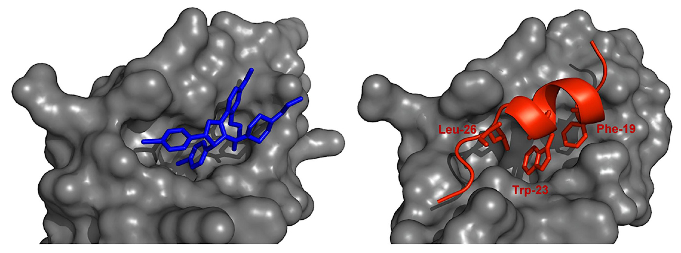
Statement of the Problem: p53 is the key tumor suppressor protein and the guardian of the genome. Mutation or deletion in TP53 gene, which encode p53 protein, is the main trigger for >50% of human cancer due to the protein’s central role in cell cycle checkpoints. This lead to over-expression of MDM2 and down regulation of mutated P53 in parallel. MDM2 (Mouse Double Minute 2, also named Hdm2 in humans) is an oncoprotein that negatively regulates the apoptotic function of p53 via transactivation inhibition in two manners: either by direct protein- protein interaction (PPI) or by targeting P53 to proteasome degradation through its E3 ligase activity. The purpose of this study is to design and optimize small molecules that block the PPI between P53 and MDM2 as a novel non-genotoxic target for anticancer drugs. Methodology & Theoretical Orientation: MDM2 protein was first expressed in inclusion bodies, refolded and then purified. Highly pure MDM2 was used for optimized compounds screening and analyzing their binding to MDM2. In order to achieve this goal protein was co-crystallized with the optimized compounds and their binding modes will be characterized by X-ray crystallography. Moreover, the binding kinetics of the same compounds was estimated using fluorescence polarization (FP) and microscale thermophoresis (MST). Findings: Some of the screened compounds showed a high binding affinity toward MDM2 with K_{d} values down to nanomolar values. Conclusion & Significance: We anticipate that our studies will result in further improvements in the affinity of the inhibitors targeting the MDM2: p53 interaction.
MDM2 Hydrophobic Pocket (grey) interacting with P53 peptide (red) via three hot spots amino acids (Leu26, Phe19, Trp23) in PPI manner.
**A Huart, T Hupp. 2013

Image

Recent Publications (minimum 5)
- Huang, Yijun et al. 2014. “Discovery of Highly Potent p53-MDM2 Antagonists and Structural Basis for Anti-Acute Myeloid Leukemia Activities.” ACS Chemical Biology 9(3): 802–11.
- Joerger, A. C., and A. R. Fersht. 2010. “The Tumor Suppressor p53: From Structures to Drug Discovery.” Cold Spring Harbor Perspectives in Biology 2(6): a000919–a000919.
- Römer, Lin et al. 2006. “p53 - A Natural Cancer Killer: Structural Insights and Therapeutic Concepts.” Angewandte Chemie - International Edition 45(39): 6440–60.
- Surmiak, Ewa et al. 2016. “A Unique Mdm2-Binding Mode of the 3-Pyrrolin-2-One- and 2-Furanone-Based Antagonists of the p53-Mdm2 Interaction.” ACS Chemical Biology 11(12): 3310–18.
- Twarda-Clapa, Aleksandra et al. 2017. “1,4,5-Trisubstituted Imidazole-Based p53–MDM2/MDMX Antagonists with Aliphatic Linkers for Conjugation with Biological Carriers.” Journal of Medicinal Chemistry: acs.jmedchem.7b00104.

 Biography (150 word limit)
Ameena M Ali is a PhD student in Drug Design Department at Groningen University since 2015. She conducts her structural biology and crystallography research under the supervision of Prof. Alexander Dömling and Dr. Matthew Groves. She became the main researcher in MDM2: P53 (PPI) inhibitor discovery and screening in 2016. Ameena was honored with a Master degree in Medical Biotechnology from the Arabian Gulf University, Kingdom of Bahrain in 2012, while she received her Bachelor degree in 2003 from Qatar University in Biological and Environmental Science with excellence. Most of her research work focused on diseases and treatment strategy development for critical diseases such as, point mutations in LDL gene, Diabetes Mellitus and Cancer.
Email: a.ali@rug.nl

Notes/Comments:

