Structural analysis of Vascular Endothelial Growth Factor receptors reveals drug-targetable allosteric sites regulating angiogenesis
Sandra Markovic-Mueller, Edward Stuttfeld, Dragana Avramovic, and Kurt Ballmer-Hofer
Paul Scherrer Institut, 5232-Villigen CH, and
H. Kaspar Binz, Molecular Partners, 8952-Schlieren CH

Abstract

Vascular Endothelial Growth Factors (VEGFs) regulate blood and lymph vessel development upon activation of three receptor tyrosine kinases (RTKs), VEGFR-1, -2, and -3. Partial structures of VEGFR/VEGF complexes based on single particle electron microscopy, small angle X-ray scattering, and X-ray crystallography revealed the location of VEGF binding and the spatial arrangement of individual receptor subdomains. Here we describe the structure of the full-length VEGFR-1 extracellular domain (ECD) in complex with VEGF-A at 4 Å resolution. We combined X-ray crystallography, single particle electron microscopy, and molecular modeling for structure determination and validation. The structure reveals the molecular details of ligand-induced receptor dimerization, in particular of homotypic receptor interactions in Ig-domains 4, 5, and 7. Functional analyses of ligand binding and receptor activation confirm the relevance of these homotypic contacts for receptor activation and identify them as allosteric regulatory sites of VEGFR-1.

Based on our structural data we also investigated the function of Ig-domains 4, 5 and 7 in VEGFR-2, the primary receptor driving angiogenesis and vasculogenesis in response to VEGF administration. The basic domain structure of VEGFR-2 is very similar to VEGFR-1, the ECD of both receptors consists of 7 Ig-domains, D1-D7. Mutagenesis studies based on the VEGFR-1structure confirmed that Ig-domains 4 and 7 fulfill an essential regulatory function in receptor activation and may thus represent putative targets for pharmacological intervention. We isolated highly specific antibodies and DARPins (Designed Ankyrin Repeat Proteins) specific for domains 4 or 7. A subset of these reagents efficiently blocked receptor activation and inhibited VEGF-dependent signaling in vitro in endothelial cell cultures. Most importantly, a domain 4-specific DARPin efficiently blocked vessel development also in vivo in a mouse angiogenesis model. In this model endothelial cell spheroids were implanted in matrigel into mice, and cell growth and vessel formation were monitored in the absence and presence of inhibitor. Our study thus revealed a novel approach for therapeutic targeting of aberrant blood vessel development.
Image
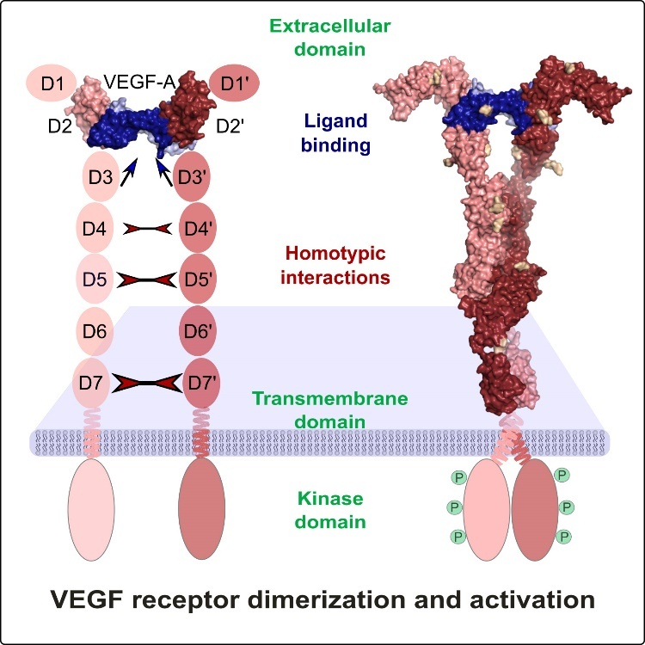
Recent Publications
1. Markovic-Mueller, S., Stuttfeld, E., Asthana, M., Weinert, T., Bliven, S., Goldie, K.N., Kisko, K., Capitani, G., and Ballmer-Hofer, K. (2017). Structure of the Full-length VEGFR-1 Extracellular Domain in Complex with VEGF-A. Structure 25, 341-352.
2. Leppänen, V.M., Tvorogov, D., Kisko, K., Prota, A.E., Jeltsch, M., Anisimov, A., Markovic-Mueller, S., Stuttfeld, E., Goldie, K.N., Ballmer-Hofer, K., and Alitalo, K. (2013). Structural and mechanistic insights into VEGF receptor 3 ligand binding and activation. Proc. Natl. Acad. Sci. USA 110, 12960-12965.
3. Brozzo, M.S., Bjelic, S., Kisko, K., Schleier, T., Leppänen, V.M., Alitalo, K., Winkler, F.K., and Ballmer-Hofer, K. (2012). Thermodynamic and structural description of allosterically regulated VEGF receptor 2 dimerization. Blood 119, 1781-1788.
4. Hyde, C.A., Giese, A., Stuttfeld, E., Abram, S.J., Villemagne, D., Schleier, T., Binz, H.K., and Ballmer-Hofer, K. (2012). Targeting the extracellular domains D4 and D7 of VEGFR-2 reveals allosteric receptor regulatory sites. Mol. Cell Biol. 32, 3802-3813.
5. Leppänen, V.M., Prota, A.E., Jeltsch, M., Anisimov, A., Kalkkinen, N., Strandin, T., Lankinen, H., Goldman, A., Ballmer-Hofer, K., and Alitalo, K. (2010). Structural determinants of growth factor binding and specificity by VEGF receptor 2. Proc. Natl. Acad. Sci. USA 107, 2425-2430.

 Biography
Kurt Ballmer-Hofer focused his research at PSI on the structural and functional analysis of receptor tyrosine kinases, in particular on Vascular Endothelial Growth Factor Receptors, VEGFRs. In collaboration with partner labs his team solved the structures of VEGF ligands, the ligand binding domain of VEGFR-2, and -3, and of the full-length extracellular domain of VEGFR-1 in complex with VEGF. The data of these studies led to the discovery of allosteric receptor regulatory sites in subdomains 4, 5 and 7. Antibodies and DARPins specifically binding to these domains showed strong inhibition of receptor activation and downstream signaling both in vitro and in vivo in angiogenesis model systems.
Email: kurt.ballmer-hofer@unibas.ch
Phone: +41-683 3905

Notes/Comments:

