Delivery methods for Free Electron Lasers: direct protein crystallization on solid supports economizes sample consumption in serial femtosecond crystallography
Nadia L. Opara^{a,b,c}, Isabelle Martielª, Stefan A. Arnold^{b,c}, Thomas Braun^{b,c,} Henning Stahlberg^{b,c,} and Celestino Padeste^{a,c}
ª Paul Scherrer Institute (PSI), 5232 Villigen PSI, Switzerland
^{b} Center for Cellular Imaging and NanoAnalytics (C-CINA), Biozentrum, University of Basel, 4058 Basel, Switzerland
^{c} Swiss Nanoscience Institute, University of Basel, 4056 Basel, Switzerland

Abstract
Classical crystallography methods based on synchrotrons usually require crystals of relatively large dimensions, i.e. above about 5 micrometers. The recent availability of X-ray free electron laser sources (XFELs) providing femtosecond X-ray pulses of ultrahigh brightness facilitate the investigation of nanocrystals. However, in this case data collection has to be performed in the mode of the serial crystallography in so-called diffraction-before-destruction regime because the probed area of the sample is completely destroyed after the interaction with ultraintense radiation. As thousands of crystals have to be provided sequentially to the XFEL beam, selection of an efficient sample delivery system is crucial to minimize protein consumption during data collection.
Delivery methods applied so far include steady streaming liquid jets [1,2] of the crystal suspension. The application of more viscous media like lipidic cubic phase (LCP) [3], agarose [4] or hyaluronic acid [5] matrices has also been demonstrated. However all these methods use significant amounts of the precious protein, which cannot be recovered even if not directly probed.
Recent developments of drop of demand methods [6] or fixed targets [1,7] allow overcoming this problem. But still, handling of the fragile crystals should be gentle or, at best, avoided.
Microfabricated silicon chips with ultrathin Si₃N₄ membranes provide the possibility to regularly position crystals on precisely defined spots by direct crystallization using classical vapor diffusion method [8]. The sample consumption is minimal since crystal growth takes place in nanoliter volume cavities. No additional sample transfer is needed, because X-rays are probing the crystals at the spot where they grew on the X-ray-transparent ultrathin amorphous silicon nitride membranes. Assembly with a second chip to form a hermetically sealed sandwich protects specimens from dehydration and facilitates in situ diffraction data collection at room temperature, as demonstrated in a synchrotron experiment providing high-resolution patterns [Fig. 1].

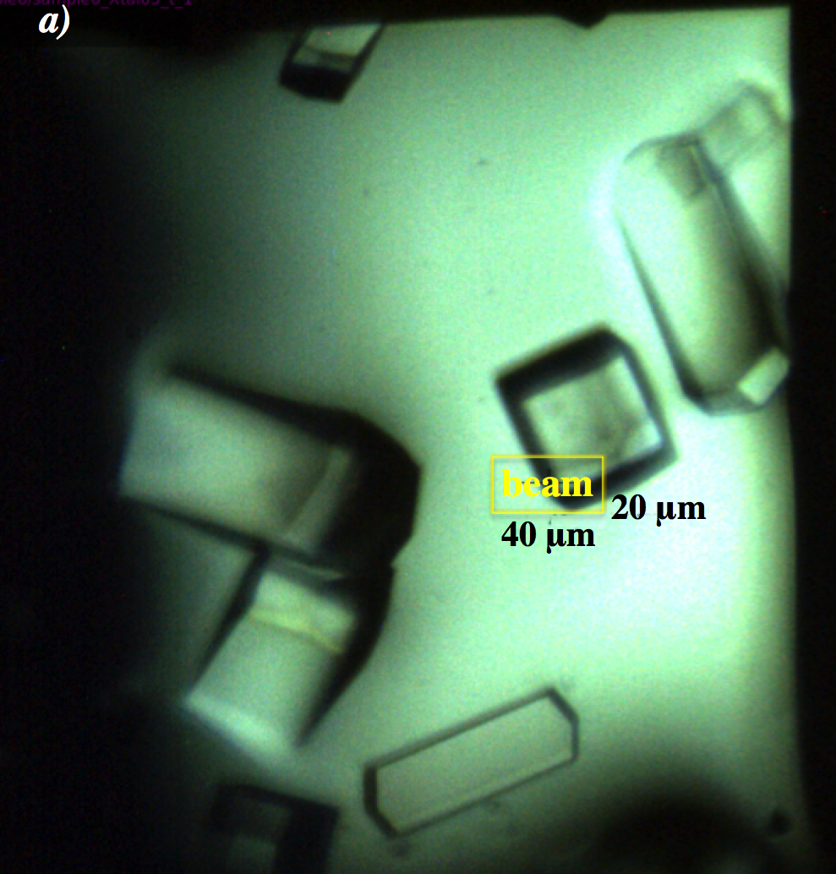
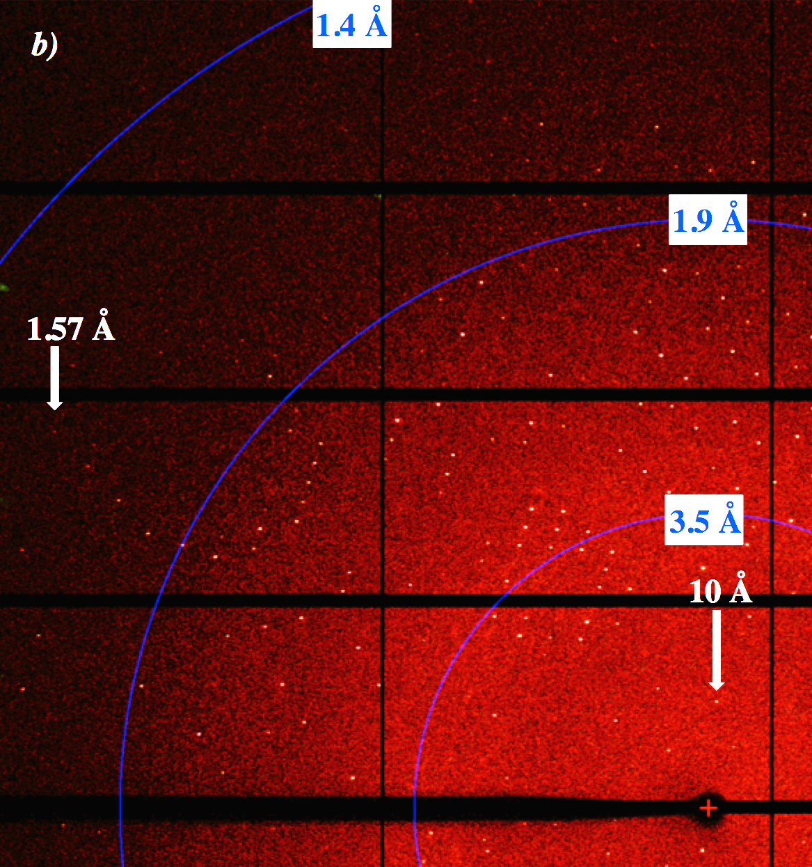

Figure 1 [8]: a) Lysozyme crystals enclosed in-between silicon nitride membranes and mounted on a synchrotron beamline goniometer. b) High resolution diffraction pattern obtained by in situ exposure with synchrotron radiation (SLS-PXI) from the crystal as indicated in a)
Recent Publications
- Muniyappan S et al. (2015) Recent advances and future prospects of serial crystallography using XFEL and synchrotron X-ray sources. Bio Design 3:2
- Steinke I et al. (2016) A liquid jet setup for x-ray scattering experiments on complex liquids at free-electron laser sources. Rev Sci Instrum. 87:063905
- Weierstall U et al. (2014) Lipidic cubic phase injector facilitates membrane protein serial femtosecond crystallography. Nat Commun. 5:3309
- Conrad CE et al. (2015) A novel inert crystal delivery medium for serial femtosecond crystallography. IUCrJ 2:421-30
- Sugahara M et al. (2016) Oil-free hyaluronic acid matrix for serial femtosecond crystallography. Sci Rep. 6:24484
- Fuller FD, et al. (2017) Drop-on-demand sample delivery for studying biocatalysts in action at X-ray free-electron lasers. Nature Methods, doi:10.1038/nmeth.4195
- Owen RL et al. (2017) Low-dose fixed-target serial synchrotron crystallography. Acta Cryst. D 73:373-378
- Opara N et al. (2017) Direct protein crystallization on ultrathin membranes for diffraction measurements at X-ray free electron lasers. (Accepted for publication, Journal of Applied Crystallography)

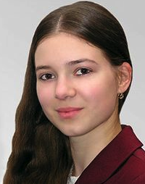 | Biography  Nadia Opara joined the CINA group at the Biozentrum University of Basel and the LMN at PSI in Switzerland in 2014 in the frame of SNI PhD school program to work on a project aiming at improving sample preparation methods for XFEL-based protein nano-crystallography. Beforehand she completed her bachelor studies in chemistry and a master program in molecular biotechnology at the Lodz University of Technology in Poland.

Email: nadia.opara@gmail.com
Phone: +41-767-58-62-57

Notes/Comments:

