Structural insights from aptamers with base modifications
Nebojsa Janjic, SomaLogic, Inc., U.S.A.

Abstract (300 word limit)
Statement of the Problem: The ability to fold into distinct three-dimensional structures is the basis of high affinity and specificity characteristic of aptamer binding to their targets. We have recently introduced base modifications that increase chemical diversity of functional groups front-loaded in randomized nucleic acid libraries from which aptamers are selected. Such modifications have allowed us to identify high-affinity aptamers to a large number of protein targets previously considered “difficult” with conventional nucleic acid libraries. At the same time, our ability to predict the structures of modified aptamers with conventional nucleic acid folding rules was severely compromised, suggesting new rules for folding. Methodology & Theoretical Orientation: We examined published structures of sixteen aptamers co-crystallized with their protein targets, including three aptamers with base modifications we reported recently. Findings: In contrast to small molecules, which are entirely encaged by aptamers, proteins present large surfaces with distinct features that are recognized by complementary surfaces on aptamers. The size of these interaction surfaces is comparable to those observed with antibodies, although for aptamers, the size range is wider on both small and large extremes. The highly flexible phosphodiester backbone allows assembly of known as well as novel nucleic acid motifs into precise three-dimensional structures that orient often discontiguous aptamer regions toward their protein targets in a manner that creates surfaces with exquisite shape complementarity. Base modifications with hydrophobic side chains allow occupancy of distinctly hydrophobic pockets on proteins and create novel structural elements that illustrate the profound role modified nucleotides play in both folding and binding. Conclusion & Significance: These observations provide compelling structural rationale for the observed high affinity and specificity with which aptamers recognize their protein targets, and show us that the lexicon of structural features accessible to nucleic acid ligands can be vastly expanded with chemical modifications of nucleic acid libraries.

Image
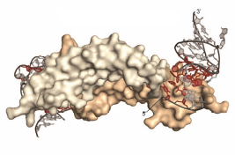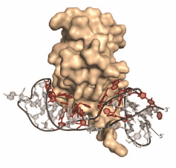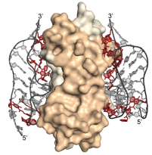
Crystal structures of PDGF-BB (left), IL-6 (middle) and NGF (right) bound to their respective modified aptamers. Modified nucleotides are shown in red.
Recent Publications (minimum 5)
- Davies DR, Gelinas AD, Zhang C, Rohloff JC et al. (2012) Unique motifs and hydrophobic interactions shape the binding of modified DNA ligands to protein targets. Proc Natl Acad Sci U S A 109:19971-19976.
- Gelinas AD, Davies DR, Edwards TE, Rohloff JC et al. (2014) Crystal structure of interleukin-6 in complex with a modified nucleic acid ligand. J Biol Chem 289:8720-8734.
- Jarvis TC, Davies DR, Hisaminato A, Resnicow DI et al. (2015) Non-helical DNA Triplex Forms a Unique Aptamer Scaffold for High Affinity Recognition of Nerve Growth Factor. Structure 23:1293-1304.
- Rohloff JC, Gelinas AD, Jarvis TC, Ochsner UA et al. (2014) Nucleic Acid Ligands With Protein-like Side Chains: Modified Aptamers and Their Use as Diagnostic and Therapeutic Agents. Mol Ther Nucleic Acids 3:e201.
- Gelinas, AD, Davies, DR, Janjic, N (2016) Embracing Proteins: Structural Themes In Aptamer:Protein Complexes. Curr. Rev. Struct. Biol. 36:122-132.

 Biography (150 word limit)
Nebojsa Janjic has been Chief Science Officer at SomaLogic, Inc. since January 2009. Prior to joining SomaLogic, Dr. Janjic was a founder and CSO at Replidyne, Inc., a biotechnology company focusing on the development of new small-molecule antibacterial agents. Prior to Replidyne, Dr. Janjic was senior director of drug discovery at NeXstar Pharmaceuticals, where his contributions include the discovery and early development of Macugen, the first aptamer to receive FDA approval and the first VEGF inhibitor developed for the treatment for macular degeneration. As CSO at SomaLogic, Dr. Janjic is involved in developing a new generation of modified aptamers and identifying opportunities for their use in science and medicine. Dr. Janjic received his bachelor's degree in molecular biology and Ph.D. in physical organic chemistry from the University of Washington in Seattle and completed his postdoctoral training at the Scripps Research Institute in La Jolla as a Cancer Research Institute Fellow.
Email: njanjic@somalogic.com
Phone: +1-303-625-9020

Notes/Comments:

