Atomic Force Microscopy of virus capsids uncover the interplay between mechanics, structure and function
Pedro J. de Pablo. Universidad Autonoma de Madrid, Spain.

Abstract (300 word limit)

The basic architecture of a virus consists of the capsid, a shell made up of repeating protein subunits, which packs, shuttles and delivers their genome at the right place and moment. Viral particles are endorsed with specific physicochemical properties, which confer to their structures certain meta-stability whose modulation permits fulfilling each task of the viral cycle. These natural designed capabilities have impelled using viral capsids as protein containers of artificial cargoes (drugs, polymers, enzymes, minerals) with applications in biomedical and materials sciences. Both natural and artificial protein cages (1) have to protect their cargo against a variety of physicochemical aggressive environments, including molecular impacts of highly crowded media, thermal and chemical stresses, and osmotic shocks. Viral cages stability under these ambiences depend not only on the ultimate structure of the external capsid, which rely on the interactions between protein subunits, but also on the nature of the cargo. During the last decade our lab has focused on the study of protein cages with Atomic Force Microscopy (AFM) (figure 1). We are interested in stablishing links of their mechanical properties with their structure and function. In particular, mechanics provide information about the cargo storage strategies of both natural and virus-derived protein cages (2,3). Mechanical fatigue has revealed as a nanosurgery tool to unveil the strength of the capisd subunit bonds (4). We also interrogated the electrostatics of individual protein shells (5). Our AFM-fluorescence combination provided information about DNA diffusing out cracked-open protein cages in real time (6).
Image
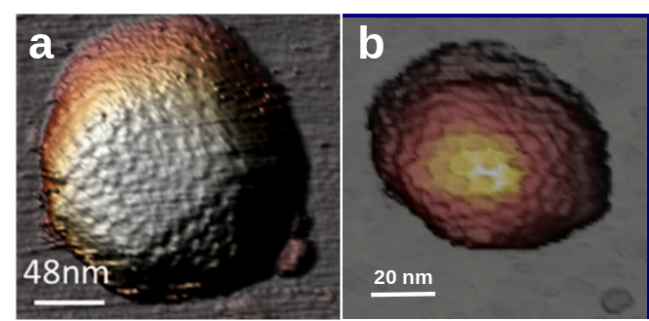

Figure 1. Human adenovirus (a) and P22 phage (b) particles images obtained with AFM
Recent Publications (minimum 5)
[1] Llauró et al. Nanoscale, 2016, 8, 9328.
[2] Hernando-Pérez et al. Small, 2012, 8, 2336.
[3] Ortega-Esteban et al. ACS Nano, 2015, 9, 10826.
[4] Hernando-Pérez et al. Nature Communications, 2014, 5, 4520.
[5] Hernando-Pérez et al. Nanoscale, 2015, 7, 17289.
[6] Ortega-Esteban et al. ACS Nano, 2015, 9, 10571.

 Biography (150 word limit)
Pedro J. de Pablo has his expertise in the application of Atomic Force Microscopy to the investigation of individual viruses. He studied Condensed Matter Physics at the Universidad Autonoma de Madrid and worked with a variety of molecular wires, including carbon nanotubes and DNA during his PhD. Then he moved for a postoc in the Vrije Universiteit to apply AFM to the study of molecular motors (kinesin) and viruses. He stablished his own group back in Madrid, where during the last 10 years has been applying AFM to unveil the structure-function interplay of viruses by measuring thir physical properties, such as mechanics and electrostatics.
Email: p.j.depablo@uam.es
Phone: +1-111-111-1111

Notes/Comments:

