Does the dynamics of their transmembrane domain qualify bitopic membrane proteins as substrates for intramembrane proteolysis?
Christina Scharnagl, Technical University of Munich, Germany

Abstract
Integral membrane proteins facilitate communication between the inside of the cell and its exterior. Their transmembrane domains (TMDs) support a diversity of biological functions and exhibit sequence-dependent conformational dynamics on multiple size and time scales. Membrane proteins are notoriously difficult to study by experimental methods. Molecular dynamics (MD) simulations provide a powerful tool of high spatial and temporal resolution that effectively complements experimental methods. Here we focus on the conformational dynamics of the TMD of the amyloid precursor protein (APP). APP is enzymatically hydrolyzed within its TMD by γ-secretase (GSEC), forming toxic Aβ peptides regarded as molecular cause of Alzheimer's disease (AD). Besides APP, GSEC cleaves ~100 single-span membrane proteins within their TMDs, however without obvious consensus sequence. Finding the link between the molecular architecture of the substrate TMDs and cleavage is, therefore, of upmost importance. Because unfolding is obvious to expose the scissile bond, it seems plausible that the TMD itself is optimized for local helix unwinding. However, this view was challenged by our experiments and MD simulations. Our results suggest an alternative model where reaching a cleavage-competent state involves multiple conformational transitions of the substrate/enzyme complex where global conformational plasticity of the substrate TMD is a key determinant. In a first step, we compare the conformational flexibility of a large number of substrate and non-substrate TMDs, as well as TMDs carrying missense mutations related to early onset AD. Knowing the key-dynamical motifs will help to identify new substrates and to elucidate the physiological functions of the protease in the brain and other organs. This work is part of a collaborative research program (https://www.i-proteolysis.de/).

Substrate processing by γ-secretase. The intramembrane protease is a protein complex hydrolyzing substrates within their trans-membrane domains. Transmembrane domain dynamics might be involved in recognition, binding and reorganization steps funnelling the enzyme/substrate complex towards the conformation conducive for cleavage.

Recent Publications
- Langosch C, Scharnagl C, Steiner H, Lemberg M (2015) Understanding intramembrane proteolysis: from protein dynamics to reaction kinetics. Trends Biochem. Sci. 40:318-327.
- Scharnagl C, Pester O, Hornburg P, Hornburg D, Götz A, Langosch D (2014) Side-chain to main-chain hydrogen bonding controls intrinsic backbone dynamics of the amyloid precursor protein transmembrane helix. Biophys. J. 106: 1318-1329.
- Pester O, Götz A, Multhaup G, Scharnagl C, Langosch D (2013) The cleavage domain of the amyloid precursor protein transmembrane helix does not exhibit above-average backbone dynamics. ChemBioChem 14:1943-1948.
- Pester O, Barrett P, Hornburg D, Hornburg P, Pröbstle R, Widmaier S, Kutzner C, Dürrbaum M, Kapurniotu A, Sanders CR, Scharnagl C, Langosch D (2013) The backbone dynamics of the amyloid precursor protein transmembrane helix provides a rationale for the sequential cleavage mechanism of γ-secretase. J. Am. Chem. Soc. 135: 1317-1329.
- Ried C, Scharnagl C, Langosch D (2015) Entrapment of water at the transmembrane helix-helix interface of quiescin sulfhydryl oxidase 2. Biochemistry 55: 1287-1290.

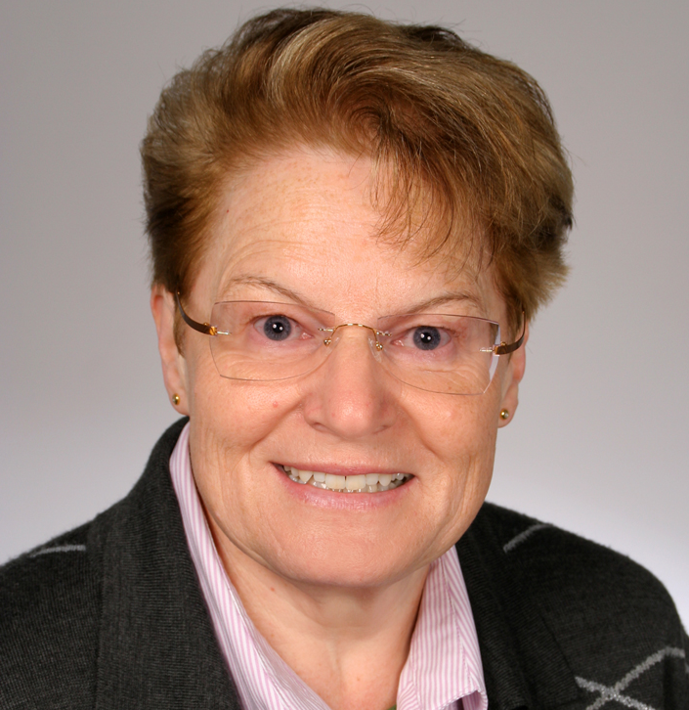 Biography
Christina Scharnagl has her expertise in molecular dynamic simulations of membrane proteins. Her work focuses on biophysical principles of the interdependence of transmembrane helix dynamics, helix-helix binding, and helix-lipid interactions. In silico modelling and advanced computational analysis are closely connected to experimental work in research collaborations in order to interpret and guide the experiments and to validate the simulations. The aim of the joint efforts is to understand the impact of these phenomena on multiple biological processes, such as membrane fusion and intramembrane proteolysis.
Email: christina.scharnagl@tum.de
Phone: +49-8161-71-3557

