Mechanism for PIP2 activation of TRP channels
Vlastimil Zima, Ivan Barvik
Division of Biomolecular Physics, Institute of Physics, Faculty of Mathematics and Physics,
Charles University, 12116 Prague, Czech Republic.

Transient receptor potential (TRP)-related channels are a large, diverse superfamily of proteins consisting of up to 28 members in mammals (1). TRP channels are activated by diverse cellular and environmental signals. Inhibition of TRP channels expressed on nociceptive neurons represents a viable therapeutic pain target (2-3). The recent high-resolution structures captured TRP channels in different conformations (4-5). All TRP channels form functional tetramers, with each subunit consisting of six transmembrane segments (S1-S6) flanked by amino- and carboxyl-terminal cytosolic domains. The S1-S4 helices form isolated sensor domains arranged radially around the periphery of the central-ion conducting pore, which is lined with four S5-S6 domains. The central cavity involved in the ion permeation exhibits major constrictions at the selectivity filter, as well as at the lower gate. The proximal C-terminal region represents the only cytosolic region of sequence conserved among TRP channels. This region can be divided into three sections: the six-amino acid TRP box; a variable region, historically known as the “TRP domain”; and a poly-basic region proposed that constitutes the PIP2 binding site (6-7). The putative PIP2 binding region contains three to nine positively charged amino acids and, typically, one or more aromatic amino acids (7). Here, we use bioinformatics tools, sequence and structural alignments, homology modeling and molecular dynamics simulations to propose a detail molecular mechanism, how TRP channels are activated by PIP2. We describe pathways through which the signal is transmitted from peripheral binding sites of PIP2 up to the lower gate of TRP channels. Evolutionary conserved amino acids that serve as key switches during transitions between closed and open states of TRP channels are identified.

Acknowledgments

This work was supported by the Czech Science Foundation (grant no. 17-04236S).

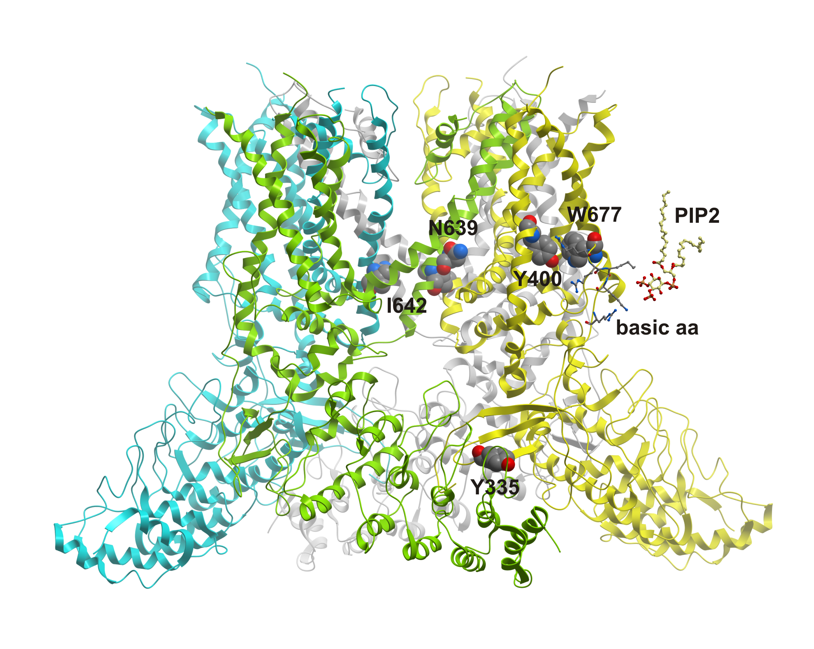
References

1. Fleig A and Penner R (2004) The TRPM ion channel subfamily: molecular, biophysical and functional features. Trends in Pharmacological Science 25: 633-639

2. Jardin I et al. (2017) TRPs in Pain Sensation. Frontiers in Physiology 8: 392

3. Juany S and Szallasi A (2017) Transient Receptor Potential (TRP) Channels in Drug Discovery: Old Concepts & New Thoughts. Pharmaceuticals 10: 64

4. Huynh KW et al. (2015) Structure of the full-length TRPV2 channel by cryo-EM. Nature Communications 7: 11130

5. Zubcevic L. et al. (2016) Cryo-electron microscopy structure of the TRPV2 ion channel. Nature Structural & Molecular Biology 23: 180-186

6. Rohacs T (2015) Phosphoinositide regulation of TRPV1 revisited. Pflugers Arch – Eur J Physiol 467: 1851-1869

7. Ufret-Vincenty CA et al. (2011) Localization of the PIP2 Sensor of TRPV1 Ion Channels. J. Biol. Chem. 286: 9688-9698

 Ivan Barvík, Ph.D. is now the assistant professor at the Institute of Physics of Charles University. He is interested in computer modeling of biomolecules (bioinformatics, homology modeling, molecular docking, rational drug design, molecular dynamics simulations, quantum chemical calculations), high performance computing & parallelization (OpenMP, MPI, CUDA) and numerical methods.

Email: ibarvik@karlov.mff.cuni.cz
Phone: +420 221 911 450

Notes/Comments:

