Title: Discovering Drug Seeds by Practical NMR Strategies
Steven LaPlante, INRS-IAF, Quebec, CANADA

Abstract
Statement Small molecule drugs continue to be crucial for combating diseases. This presentation will convey the critical role NMR has been playing for discovering the seeds for new drugs starting from substrate peptides, high-throughput screens and fragment-based screens. Central to all the examples was the need to better understand the properties of small molecules when free in solution and to decipher the various types of binding to macromolecules. To do so, appropriate NMR methods/strategies were developed to prioritize quality ligands for downfield medicinal chemistry purposes. Examples will be shown where NMR strategies revealed compound solution behavior (solubility, aggregation, atropisomer chirality), exposed target protein features (folding and changes), and determined stoichiometric binding attributes.

Image
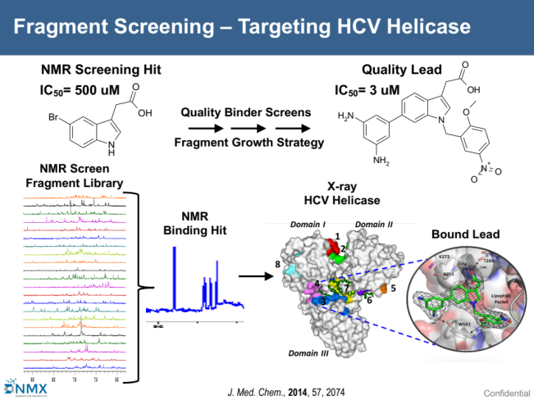
Publications
1. NMR strategies to support medicinal chemistry workflows for primary structure determination. Bioorganic & Medicinal Chemistry Letters, (2017) 27, 242-247.
2. The Rise of Academia-Pharma Partnerships for Discovering New Chemical Matter for Future Drugs, EC Microbiology 4.5 (2016): 756-758.
3. Conformation-Based Restrictions and Scaffold Replacements in the Design of HCV Polymerase Inhibitors: Discovery of Deleobuvir (BI 207127), J. Med. Chem., (2014) 57, 1845-1854. Special HCV therapies issue.
4. Ligand Bioactive Conformation Plays a Critical Role in the Design of Drugs That Target the Hepatitis C Virus NS3 Protease, J. Med. Chem., (2014) 57, 1777-1789. Special HCV therapies issue.
5. Integrated Strategies for Identifying Leads that Target the NS3 Helicase of the Hepatitis C Virus, J. Med. Chem., (2014) 57, 2074-2090. Special HCV therapies issue.


Biography:
Steven LaPlante is a faculty member at the University of Quebec INRS-IAF, founder of NMX Research and Solutions, visiting scientist at the Broad Institute and consultant at Harvard Medical School and other institutions. He is a senior biophysical medicinal chemist with +20 years of drug design experience in the pharmaceutical industry. He has a proven track record of creating innovative solutions to chemical and biological challenges. He is an NMR specialist who developed novel fragment-, structure- and property-based strategies that led to drug candidates and advanced drugs for HCV and HIV.
Email:steven.laplante@iaf.inrs.ca
- Full Name: Steven LaPlante
- Mobile Number: 1-514-914-8501
- Linked In: linkedin.com/in/stevenlaplante
- Session Name/ number:
- Category: Oral presentation
- Date of Birth: Nov. 21, 1961
- Postal Address: INRS, 531, boulevard des Prairies, Laval, Quebec, H7V 1B7, Canada

